UNITED STATES

SECURITIES AND EXCHANGE COMMISSION

Washington, D.C. 20549

FORM 10-Q

☒ Quarterly Report pursuant to Section 13 or 15(d) of the Securities Exchange Act of 1934

For the quarterly period ended: December 31, 2020

☐ Transition report pursuant to Section 13 or 15(d) of the Securities Exchange Act of 1934

Commission File Number: 1-33026

Commvault Systems, Inc.

(Exact name of registrant as specified in its charter)

Delaware |  |  |  |  | 22-3447504
(State or other jurisdiction of |  |  |  |  | (I.R.S. Employer
incorporation or organization) |  |  |  |  | Identification No.)
 |  |  | 1 Commvault Way
 |  | Tinton Falls, New Jersey 07724
 | (Address of principal executive offices, including zip code)
 | (732) 870-4000
 |  | (Registrant’s telephone number, including area code)
 | Securities registered pursuant to Section 12(b) of the Act:
Title of each class |  |  | Trading Symbol(s) |  | Name of each exchange on which registered
Common Stock |  |  | CVLT |  | The NASDAQ Stock Market
Preferred Stock Purchase Rights |  |  |  |  | The NASDAQ Stock Market

Indicate by check mark whether the registrant (1) has filed all reports required to be filed by the Section 13 or 15(d) of the Securities Exchange Act of 1934 during the preceding 12 months (or for such period that the Registrant was required to file such reports), and (2) has been subject to such filing requirements for the past 90 days. Yes x No ☐

Indicate by check mark whether the registrant has submitted electronically every Interactive Data File required to be submitted pursuant to Rule 405 of Regulation S-T (§232.405 of this chapter) during the preceding 12 months (or for such shorter period that registrant was required to submit such files.) Yes x No ☐

Indicate by check mark whether the registrant is a large accelerated filer, an accelerated filer, a non-accelerated filer, a smaller reporting company or an emerging growth company. See definition of “large accelerated filer”, "accelerated filer", "smaller reporting company" and "emerging growth company" in rule 12b-2 of the Exchange Act. (Check one):

Large accelerated filer x Accelerated filer ☐ Non-accelerated filer ☐ Smaller reporting company

Emerging growth company ☐

If an emerging growth company, indicate by check mark if the registrant has elected not to use the extended transition period for complying with any new or revised financial accounting standards provided pursuant to Section 13 (a) of the Exchange Act

Indicate by check mark whether the registrant is a shell company (as defined in Rule 12b-2 of the Exchange Act). Yes ☐ No x

☐

☐

As of January 27, 2021, there were 46,997,616 shares of the registrant’s common stock, $0.01 par value, outstanding.

1

COMMVAULT SYSTEMS, INC.

FORM 10-Q

INDEX

Part I – FINANCIAL INFORMATION |  |  |  |  |  |  |  | Page
Item 1. | Financial Statements and Notes
 | Unaudited Consolidated Balance Sheets as of December 31, 2020 and March 31, 2020 |  |  |  |  |  |  | 1
 | Unaudited Consolidated Statements of Operations for the three and nine months ended December 31, 2020 |  |  |  |  |  |  | 2
 | and 2019
 | Unaudited Consolidated Statements of Comprehensive Income (Loss) for the three and nine months ended |  |  |  |  |  |  | 3
 | December 31, 2020 and 2019
 | Unaudited Consolidated Statements of Stockholders’ Equity for the three and nine months ended December |  |  |  |  |  |  | 4
 | 31, 2020 and 2019
 | Unaudited Consolidated Statements of Cash Flows for the nine months ended December 31, 2020 and 2019 |  |  |  |  |  |  | 6
 | Notes to Consolidated Financial Statements (unaudited) |  |  |  |  |  |  | 7
Item 2. | Management’s Discussion and Analysis of Financial Condition and Results of Operations |  |  |  |  |  |  | 17
Item 3. | Quantitative and Qualitative Disclosures about Market Risk |  |  |  |  |  |  | 28
Item 4. | Controls and Procedures |  |  |  |  |  |  | 29
Part II – OTHER INFORMATION
Item 1. | Legal Proceedings |  |  |  |  |  |  | 30
Item 1A. | Risk Factors |  |  |  |  |  |  | 30
Item 2. | Unregistered Sale of Equity Securities and Use of Proceeds |  |  |  |  |  |  | 30
Item 3. | Defaults Upon Senior Securities |  |  |  |  |  |  | 30
Item 4. | Mine Safety Disclosures |  |  |  |  |  |  | 30
Item 5. | Other Information |  |  |  |  |  |  | 30
Item 6. | Exhibits |  |  |  |  |  |  | 31
SIGNATURES |  |  |  |  |  |  |  | 32

2

Commvault Systems, Inc.

Consolidated Balance Sheets

(In thousands, except per share data)

(Unaudited)

 |  | December 31, |  |  | March 31,
ASSETS |  | 2020 |  |  | 2020
Current assets:
Cash and cash equivalents | $ | 377,569 |  | $ | 288,082
Restricted cash |  | — |  |  | 8,000
Short-term investments |  | 10,845 |  |  | 43,645
Trade accounts receivable, net |  | 190,651 |  |  | 146,990
Other current assets |  | 27,570 |  |  | 26,969
Total current assets |  | 606,635 |  |  | 513,686
Property and equipment, net |  | 113,079 |  |  | 114,519
Operating lease assets |  | 23,709 |  |  | 15,009
Deferred commissions cost |  | 35,306 |  |  | 31,394
Intangible assets, net |  | — |  |  | 46,350
Goodwill |  | 112,435 |  |  | 112,435
Other assets |  | 14,415 |  |  | 11,683
Total assets | $ | 905,579 |  | $ | 845,076
LIABILITIES AND STOCKHOLDERS’ EQUITY
Current liabilities:
Accounts payable | $ | 622 |  | $ | 307
Accrued liabilities |  | 102,924 |  |  | 87,051
Current portion of operating lease liabilities |  | 8,346 |  |  | 7,699
Deferred revenue |  | 247,544 |  |  | 233,497
Total current liabilities |  | 359,436 |  |  | 328,554
Deferred revenue, less current portion |  | 108,280 |  |  | 92,723
Deferred tax liabilities, net |  | 807 |  |  | 849
Long-term operating lease liabilities |  | 17,561 |  |  | 8,808
Other liabilities |  | 5,424 |  |  | 2,238
Commitments and contingencies
Stockholders’ equity:
Preferred stock, $0.01 par value: 50,000 shares authorized, no shares issued and outstanding |  | — |  |  | —
Common stock, $0.01 par value: 250,000 shares authorized, 46,835 shares and 46,011 shares issued and |  | 466 |  |  | 458
outstanding at December 31, 2020 and March 31, 2020, respectively |  | 466 |  |  | 458
Additional paid-in capital |  | 1,041,073 |  |  | 978,659
Accumulated deficit |  | (618,068) |  |  | (553,790)
Accumulated other comprehensive loss |  | (9,400) |  |  | (13,423)
Total stockholders’ equity |  | 414,071 |  |  | 411,904
Total liabilities and stockholders’ equity | $ | 905,579 |  | $ | 845,076

See accompanying unaudited notes to consolidated financial statements

1

Commvault Systems, Inc.

Consolidated Statements of Operations

(In thousands, except per share data)

(Unaudited)

 |  | Three Months Ended December 31, |  |  |  |  |  |  | Nine Months Ended December 31,
 |  |  | 2020 |  |  | 2019 |  |  | 2020 |  |  | 2019
Revenues:
Software and products | $ |  | 88,625 |  | $ | 76,631 |  | $ | 237,488 |  | $ | 208,900
Services |  |  | 99,367 |  |  | 99,720 |  |  | 294,643 |  |  | 297,236
Total revenues |  |  | 187,992 |  |  | 176,351 |  |  | 532,131 |  |  | 506,136
Cost of revenues:
Software and products |  |  | 6,916 |  |  | 8,077 |  |  | 20,666 |  |  | 22,938
Services |  |  | 21,496 |  |  | 22,446 |  |  | 59,096 |  |  | 67,546
Total cost of revenues |  |  | 28,412 |  |  | 30,523 |  |  | 79,762 |  |  | 90,484
Gross margin |  |  | 159,580 |  |  | 145,828 |  |  | 452,369 |  |  | 415,652
Operating expenses:
Sales and marketing |  |  | 84,542 |  |  | 84,563 |  |  | 245,287 |  |  | 252,908
Research and development |  |  | 35,727 |  |  | 30,503 |  |  | 97,824 |  |  | 77,310
General and administrative |  |  | 22,702 |  |  | 23,864 |  |  | 69,009 |  |  | 71,124
Restructuring |  |  | 11,618 |  |  | 2,021 |  |  | 19,709 |  |  | 18,951
Impairment of intangible assets |  |  | — |  |  | — |  |  | 40,700 |  |  | —
Depreciation and amortization |  |  | 2,323 |  |  | 5,356 |  |  | 12,441 |  |  | 10,681
Total operating expenses |  |  | 156,912 |  |  | 146,307 |  |  | 484,970 |  |  | 430,974
Income (loss) from operations |  |  | 2,668 |  |  | (479) |  |  | (32,601) |  |  | (15,322)
Interest income |  |  | 167 |  |  | 786 |  |  | 759 |  |  | 4,270
Income (loss) before income taxes |  |  | 2,835 |  |  | 307 |  |  | (31,842) |  |  | (11,052)
Income tax expense |  |  | 1,162 |  |  | 957 |  |  | 5,373 |  |  | 3,528
Net income (loss) | $ |  | 1,673 |  | $ | (650) |  | $ | (37,215) |  | $ | (14,580)
Net income (loss) per common share:
Basic | $ |  | 0.04 |  | $ | (0.01) |  | $ | (0.80) |  | $ | (0.32)
Diluted | $ |  | 0.03 |  | $ | (0.01) |  | $ | (0.80) |  | $ | (0.32)
Weighted average common shares outstanding:
Basic |  |  | 47,013 |  |  | 46,028 |  |  | 46,575 |  |  | 45,586
Diluted
Diluted |  |  | 48,013 |  |  | 46,028 |  |  | 46,575 |  |  | 45,586

See accompanying unaudited notes to consolidated financial statements

2

Commvault Systems, Inc.

Consolidated Statements of Comprehensive Income (Loss)

(In thousands)

(Unaudited)

 | Three Months Ended December 31, |  |  |  |  |  |  | Nine Months Ended December 31,
 |  | 2020 |  |  | 2019 |  |  | 2020 |  |  | 2019
Net income (loss) | $ | 1,673 |  | $ | (650) |  | $ | (37,215) |  | $ | (14,580)
Other comprehensive income (loss):
Foreign currency translation adjustment |  | 2,285 |  |  | 960 |  |  | 4,023 |  |  | (205)
Comprehensive income (loss) | $ | 3,958 |  | $ | 310 |  | $ | (33,192) |  | $ | (14,785)

See accompanying unaudited notes to consolidated financial statements

3

Commvault Systems, Inc.

Consolidated Statements of Stockholders’ Equity

(In thousands)

(Unaudited)

 |  |  |  |  |  |  | Additional |  |  |  |  |  | Accumulated
 | Common Stock |  |  |  |  |  |  |  |  |  |  |  | Other
 |  |  |  |  |  |  | Paid – In |  |  | Accumulated |  |  | Comprehensive
 | Shares |  |  | Amount |  |  |  |  |  |  |  |  |  |  |  | Total
 |  |  |  |  |  |  | Capital |  |  | Deficit |  |  | Loss |  |  | Total
Balance as of September 30, 2020 | 46,685 |  | $ | 464 |  | $ | 1,023,459 |  | $ | (592,762) |  | $ | (11,685) |  | $ | 419,476
Stock-based compensation |  |  |  |  |  |  | 22,037 |  |  |  |  |  |  |  |  | 22,037
Share issuances related to stock-based | 851 |  |  | 9 |  |  | 1,723 |  |  |  |  |  |  |  |  | 1,732
compensation
Repurchase of common stock | (701) |  |  | (7) |  |  | (6,146) |  |  | (26,979) |  |  |  |  |  | (33,132)
Net income |  |  |  |  |  |  |  |  |  | 1,673 |  |  |  |  |  | 1,673
Other comprehensive income |  |  |  |  |  |  |  |  |  |  |  |  | 2,285 |  |  | 2,285
Balance as of December 31, 2020 | 46,835 |  | $ | 466 |  | $ | 1,041,073 |  | $ | (618,068) |  | $ | (9,400) |  | $ | 414,071

 |  |  |  |  |  |  | Additional |  |  |  |  |  | Accumulated
 | Common Stock |  |  |  |  |  |  |  |  |  |  |  | Other
 |  |  |  |  |  |  | Paid – In |  |  | Accumulated |  |  | Comprehensive
 | Shares |  |  | Amount |  |  |  |  |  |  |  |  |  |  |  | Total
 |  |  |  |  |  |  | Capital |  |  | Deficit |  |  | Loss |  |  | Total
Balance as of March 31, 2020 | 46,011 |  | $ | 458 |  | $ | 978,659 |  | $ | (553,790) |  | $ | (13,423) |  | $ | 411,904
Stock-based compensation |  |  |  |  |  |  | 61,572 |  |  |  |  |  |  |  |  | 61,572
Share issuances related to stock-based | 1,525 |  |  | 15 |  |  | 6,988 |  |  |  |  |  |  |  |  | 7,003
compensation
Repurchase of common stock | (701) |  |  | (7) |  |  | (6,146) |  |  | (26,979) |  |  |  |  |  | (33,132)
Cumulative effect change in accounting for ASU |  |  |  |  |  |  |  |  |  | (84) |  |  |  |  |  | (84)
2016-13
Net loss |  |  |  |  |  |  |  |  |  | (37,215) |  |  |  |  |  | (37,215)
Other comprehensive income |  |  |  |  |  |  |  |  |  |  |  |  | 4,023 |  |  | 4,023
Balance as of December 31, 2020 | 46,835 |  | $ | 466 |  | $ | 1,041,073 |  | $ | (618,068) |  | $ | (9,400) |  | $ | 414,071

4

Commvault Systems, Inc.

Consolidated Statements of Stockholders’ Equity

(In thousands)

(Unaudited)

 |  | Additional |  | Accumulated
Common Stock |  | Additional |  | Other
 |  | Paid – In | Accumulated | Comprehensive
Shares | Amount | Paid – In | Accumulated | Comprehensive | Total
Shares | Amount | Capital | Deficit | Loss | Total

Balance as of September 30, 2019 Stock-based compensation
Share issuances related to business combination

Share issuances related to stock-based compensation

Net loss

Other comprehensive income Balance as of December 31, 2019

45,409 |  | $ | 452 |  | $ | 916,899 |  | $ | (532,504) |  | $ | (12,733) |  | $ | 372,114
 |  |  |  |  |  | 18,974 |  |  |  |  |  |  |  |  | 18,974
 |  |  |  |  |  | 1,616 |  |  |  |  |  |  |  |  | 1,616
1,088 |  |  | 11 |  |  | 24,608 |  |  |  |  |  |  |  |  | 24,619
 |  |  |  |  |  |  |  |  | (650) |  |  |  |  |  | (650)
 |  |  |  |  |  |  |  |  |  |  |  | 960 |  |  | 960
46,497 |  | $ | 463 |  | $ | 962,097 |  | $ | (533,154) |  | $ | (11,773) |  | $ | 417,633

 |  | Additional |  | Accumulated
Common Stock |  | Additional |  | Other
 |  | Paid – In | Accumulated | Comprehensive
Shares | Amount | Paid – In | Accumulated | Comprehensive | Total
Shares | Amount | Capital | Deficit | Loss | Total

Balance as of March 31, 2019 | 45,582 |  | $ | 454 |  | $ | 887,907 |  | $ | (485,490) |  | $ | (11,568) |  | $ | 391,303
Stock-based compensation |  |  |  |  |  |  | 48,581 |  |  |  |  |  |  |  |  | 48,581
Share issuances related to business |  |  |  |  |  |  | 1,616 |  |  |  |  |  |  |  |  | 1,616
combination
Share issuances related to stock-based | 1,745 |  |  | 17 |  |  | 30,927 |  |  |  |  |  |  |  |  | 30,944
compensation
Repurchase of common stock | (830) |  |  | (8) |  |  | (6,934) |  |  | (33,084) |  |  |  |  |  | (40,026)
Net loss |  |  |  |  |  |  |  |  |  | (14,580) |  |  |  |  |  | (14,580)
Other comprehensive loss |  |  |  |  |  |  |  |  |  |  |  |  | (205) |  |  | (205)
Balance as of December 31, 2019 | 46,497 |  | $ | 463 |  | $ | 962,097 |  | $ | (533,154) |  | $ | (11,773) |  | $ | 417,633

See accompanying unaudited notes to consolidated financial statements

5

Commvault Systems, Inc.

Consolidated Statements of Cash Flows

(In thousands)

(Unaudited)

 |  | Nine Months Ended December 31,
 |  | 2020 |  |  | 2019
Cash flows from operating activities
Net loss | $ | (37,215) |  | $ | (14,580)
Adjustments to reconcile net loss to net cash provided by operating activities:
Depreciation and amortization |  | 13,379 |  |  | 11,618
Noncash stock-based compensation |  | 61,572 |  |  | 48,581
Amortization of deferred commissions cost |  | 13,747 |  |  | 13,150
Impairment of operating lease assets |  | 1,304 |  |  | 2,195
Impairment of intangible asset |  | 40,700 |  |  | —
Changes in operating assets and liabilities:
Trade accounts receivable |  | (38,970) |  |  | 12,735
Operating lease assets and liabilities, net |  | (719) |  |  | (512)
Other current assets and Other assets |  | 6,955 |  |  | 5,586
Deferred commissions cost |  | (15,946) |  |  | (11,352)
Accounts payable |  | 273 |  |  | (1,726)
Accrued liabilities |  | 484 |  |  | (2,018)
Deferred revenue |  | 10,719 |  |  | (6,262)
Other liabilities |  | 2,964 |  |  | (1,407)
Net cash provided by operating activities |  | 59,247 |  |  | 56,008
Cash flows from investing activities
Purchase of short-term investments |  | — |  |  | (32,800)
Proceeds from maturity of short-term investments |  | 32,800 |  |  | 98,150
Purchase of property and equipment |  | (5,994) |  |  | (1,911)
Business combination, net of cash acquired |  | — |  |  | (157,495)
Net cash provided by (used in) investing activities |  | 26,806 |  |  | (94,056)
Cash flows from financing activities
Repurchase of common stock |  | (33,132) |  |  | (40,026)
Proceeds from stock-based compensation plans |  | 7,003 |  |  | 30,944
Net cash used in financing activities |  | (26,129) |  |  | (9,082)
Effects of exchange rate — changes in cash |  | 21,563 |  |  | (837)
Net increase (decrease) in cash, cash equivalents and restricted cash |  | 81,487 |  |  | (47,967)
Cash, cash equivalents and restricted cash at beginning of period |  | 296,082 |  |  | 327,992
Cash, cash equivalents and restricted cash at end of period | $ | 377,569 |  | $ | 280,025

See accompanying unaudited notes to consolidated financial statements

6

Commvault Systems, Inc

Notes to Consolidated Financial Statements - Unaudited

(In thousands, except per share data)

- Basis of Presentation

Commvault Systems, Inc. and its subsidiaries ("Commvault," "we," "us," or "our") is a provider of data protection and information management software applications and products. We develop, market and sell a suite of software applications and services, globally, that provides our customers with data protection solutions. We also provide our customers with a broad range of professional and customer support services.

The consolidated financial statements of Commvault as of December 31, 2020 and for the three and nine months ended December 31, 2020 and 2019 are unaudited, and in the opinion of management, include all adjustments (consisting only of normal recurring adjustments) necessary for a fair presentation of the results for the interim periods. Accordingly, they do not include all of the information and footnotes required by U.S. generally accepted accounting principles (“U.S. GAAP”) for complete financial statements and should be read in conjunction with the financial statements and notes in our Annual Report on Form 10-K for fiscal 2020. The results reported in these financial statements should not necessarily be taken as indicative of results that may be expected for the entire fiscal year.

The preparation of financial statements and related disclosures in conformity with U.S. GAAP requires management to make judgments and estimates that affect the amounts reported in our consolidated financial statements and the accompanying notes. We base our estimates and judgments on historical experience and on various other assumptions that we believe are reasonable under the circumstances. The amount of assets and liabilities reported in our balance sheets and the amounts of revenues and expenses reported for each of our periods presented are affected by estimates and assumptions, which are used for, but not limited to, the accounting for revenue recognition, income taxes and related reserves, and goodwill and purchased intangible assets. Actual results could differ from those estimates.

- Summary of Significant Accounting Policies

Recently Adopted Accounting Standards

 |  |  | Effect on the Consolidated Financial
Standard | Description | Effective Date | Statements (or Other Significant
Standard | Description | Effective Date | Matters)

Accounting Standards The standard amends guidance on the
Update ("ASU") No. 2016- impairment of financial instruments. The
13 (Topic 326), Financial ASU estimates credit losses based on
Instruments-Credit Losses expected losses and provides for a
simplified accounting model for purchased
financial assets with credit deterioration.
The standard requires a modified
retrospective basis adoption through a
cumulative-effect adjustment to retained
earnings as of the beginning of the period
of adoption.

We adopted this new standard as of April 1, 2020, using the modified retrospective method recognized as of the date of initial application.

The adoption of this new standard resulted in an $84 thousand cumulative effect on our unaudited consolidated financial statements related to an adjustment to our allowance for doubtful accounts.

Under the new standard, we assess credit losses on accounts receivable by taking into consideration past collection experience, credit quality of the customer, age of the receivable balance, current economic conditions, and forecasts that affect the collectability of the reported amount.

7

Table of Contents

Commvault Systems, Inc

Notes to Consolidated Financial Statements - Unaudited (continued)

(In thousands, except per share data)

Recently Issued Accounting Standards Not Yet Adopted
Standard | Description | Effective Date | Effect on the Consolidated Financial
 |  |  | Statements (or Other Significant
 |  |  | Matters)
ASU No. 2019-12 (Topic | In December 2019, the Financial | The standard will be effective We are currently evaluating the impact
740), Income Taxes | Accounting Standards Board ("FASB") | for us beginning April 1, | of this standard in our consolidated
 | issued a new standard to simplify the | 2021, with early adoption | financial statements, including
 | accounting for income taxes. The guidance permitted. |  | accounting policies, processes, and
 | eliminates certain exceptions related to the |  | systems.
approach for intraperiod tax allocation, the
methodology for calculating income taxes
in an interim period, and the recognition of
deferred tax liabilities for outside basis
differences related to changes in
ownership of equity method investments
and foreign subsidiaries. The guidance
also simplifies aspects of accounting for
franchise taxes and enacted changes in
tax laws or rates, and clarifies the
accounting for transactions that result in a
step-up in the tax basis of goodwill.

Concentration of Credit Risk

We grant credit to customers in a wide variety of industries worldwide and generally do not require collateral. Credit losses relating to these customers have historically been minimal.

Sales through our distribution agreement with Arrow Enterprise Computing Solutions, Inc. (“Arrow”) totaled 36% and 37% of total revenues for the nine months ended December 31, 2020 and 2019, respectively. Arrow accounted for approximately 33% and 31% of total accounts receivable as of December 31, 2020 and March 31, 2020, respectively.

Fair Value of Financial Instruments

The carrying amounts of our cash and cash equivalents, accounts receivable, accounts payable and accrued expenses approximate their fair values due to the short-term maturity of these instruments. Our short-term investments balance consists of U.S. Treasury Bills with maturities of one year or less. We account for our short-term investments as held to maturity.

The following table summarizes the composition of our financial assets and liabilities measured at fair value on a recurring basis at

December 31, 2020 and March 31, 2020:

 | December 31, 2020 |  |  | Level 1 |  |  | Level 2 |  | Level 3 |  |  |  | Total
 | Short-term investments |  |  | $ | — |  | 10,999 |  |  | — |  | $ | 10,999
 | March 31, 2020 |  |  | Level 1 |  |  | Level 2 |  | Level 3 |  |  |  | Total
 | Short-term investments |  |  | $ | — |  | 44,484 |  |  | — |  | $ | 44,484

8

Table of Contents

Commvault Systems, Inc

Notes to Consolidated Financial Statements - Unaudited (continued)

(In thousands, except per share data)

- Revenue

We derive revenues from two primary sources: software and products, and services. Software and products revenue includes our software and integrated appliances that combine our software with hardware. Services include customer support (software updates and technical support), consulting, assessment and design services, installation services, customer education and Commvault software-as-a-service, which is branded as Metallic.

We sell both perpetual and term-based licenses of our software. We refer to our term-based software licenses as subscription arrangements. We do not customize our software and installation services are not required. The software is delivered before related services are provided and is functional without professional services, updates and technical support. We have concluded that our software licenses (both perpetual and subscription) are functional intellectual property that is distinct as the user can benefit from the software on its own. Software revenue for both perpetual and subscription licenses is typically recognized when the software is delivered and/or made available for download as this is the point the user of the software can direct the use of, and obtain substantially all of the remaining benefits from the functional intellectual property. We do not recognize software revenue related to the renewal of subscription software licenses earlier than the beginning of the new subscription period.

We also sell appliances that integrate our software with hardware and address a wide-range of business needs and use cases, ranging from support for remote or branch offices with limited IT staff up to large corporate data centers. Revenue related to appliances is recognized when control of the appliances passes to the customer; typically upon delivery.

Services revenue includes revenue from customer support and other professional services. Customer support includes software updates on a when-and-if-available basis, telephone support, integrated web-based support and bug fixes or patches. Commvault sells its customer support contracts as a percentage of net software purchases the support is related to. Customer support revenue is recognized ratably over the term of the customer support agreement, which is typically one year.

Our other professional services include consulting, assessment and design services, installation services and customer education. Customer education services include courses taught by our instructors or third-party contractors. Revenue related to other professional services and customer education services is typically recognized as the services are performed. In fiscal 2020 Commvault launched Metallic, which is a Commvault software-as-a-service offering. Revenue from Metallic is recognized ratably as services revenue.

Most of our contracts with customers contain multiple performance obligations. For these contracts, we account for individual performance obligations separately if they are distinct. The transaction price is allocated to the separate performance obligations on a relative standalone selling price basis. Standalone selling prices of software and appliances are typically estimated using the residual approach. Standalone selling prices of services are typically estimated based on observable transactions when these services are sold on a standalone basis.

9

Table of Contents

Commvault Systems, Inc

Notes to Consolidated Financial Statements - Unaudited (continued)

(In thousands, except per share data)

Our typical performance obligations include the following:

Performance Obligation When Performance Obligation When Payment is How Standalone Selling Price is
is Typically Satisfied Typically Due Typically Estimated

Software and Products Revenue

Software Licenses Upon shipment or made available for download
(point in time)

Within 90 days of shipment Residual approach
except for certain subscription
licenses which are paid for over
time

Appliances | When control of the appliances passes to the | Within 90 days of delivery | Residual approach
 | customer; typically upon delivery
Customer Support Revenue
Software Updates | Ratably over the course of the support contract | At the beginning of the contract | Observable in renewal transactions
 | (over time) | period
Customer Support | Ratably over the course of the support contract | At the beginning of the contract | Observable in renewal transactions
 | (over time) | period
Other Services Revenue
Other Professional | As work is performed (over time) | Within 90 days of services being | Observable in transactions without
Services (except for |  | performed | multiple performance obligations
education services)
Education Services | When the class is taught (point in time) | Within 90 days of services being | Observable in transactions without
 |  | performed | multiple performance obligations
Software-as-a-service | Ratably over the course of the contract (over time) | Annual or monthly payments | Observable in transactions without
(Metallic) |  |  | multiple performance obligations

Disaggregation of Revenue

We disaggregate revenue from contracts with customers into the nature of the products and services and geographical regions. The geographic regions that are tracked are the Americas (United States, Canada, Latin America), EMEA (Europe, Middle East, Africa) and APJ (Australia, New Zealand, Southeast Asia, China). We operate in one segment.

 |  |  |  | Three Months Ended December 31, 2020
 |  | Americas |  | EMEA |  | APJ |  | Total
Software and Products Revenue | $ | 43,636 | $ | 33,374 | $ | 11,615 | $ | 88,625
Customer Support Revenue |  | 53,488 |  | 25,808 |  | 10,386 |  | 89,682
Other Services Revenue |  | 5,031 |  | 3,332 |  | 1,322 |  | 9,685
Total Revenue | $ | 102,155 | $ | 62,514 | $ | 23,323 | $ | 187,992

 |  |  |  | Three Months Ended December 31, 2019
 |  | Americas |  | EMEA |  | APJ |  | Total
Software and Products Revenue | $ | 40,291 | $ | 29,107 | $ | 7,233 | $ | 76,631
Customer Support Revenue |  | 57,856 |  | 22,237 |  | 10,438 |  | 90,531
Other Services Revenue |  | 4,883 |  | 2,673 |  | 1,633 |  | 9,189
Total Revenue | $ | 103,030 | $ | 54,017 | $ | 19,304 | $ | 176,351

10

Table of Contents

Commvault Systems, Inc

Notes to Consolidated Financial Statements - Unaudited (continued)

(In thousands, except per share data)

 |  |  |  | Nine Months Ended December 31, 2020
 |  | Americas |  | EMEA |  | APJ |  | Total
Software and Products Revenue | $ | 133,522 | $ | 74,232 | $ | 29,734 | $ | 237,488
Customer Support Revenue |  | 162,903 |  | 74,029 |  | 30,840 |  | 267,772
Other Services Revenue |  | 13,938 |  | 8,971 |  | 3,962 |  | 26,871
Total Revenue | $ | 310,363 | $ | 157,232 | $ | 64,536 | $ | 532,131

 |  |  |  | Nine Months Ended December 31, 2019
 |  | Americas |  | EMEA |  | APJ |  | Total
Software and Products Revenue | $ | 107,375 | $ | 71,922 | $ | 29,603 | $ | 208,900
Customer Support Revenue |  | 173,450 |  | 65,810 |  | 30,756 |  | 270,016
Other Services Revenue |  | 14,179 |  | 8,035 |  | 5,006 |  | 27,220
Total Revenue | $ | 295,004 | $ | 145,767 | $ | 65,365 | $ | 506,136

Information about Contract Balances

Amounts collected in advance of services being provided are accounted for as Deferred revenue. Nearly all of our Deferred revenue balance is related to services revenue, primarily customer support contracts.

In some arrangements we allow customers to pay for term-based software licenses and products over the term of the software license. Amounts recognized as revenue in excess of amounts billed are recorded as Unbilled receivables. Unbilled receivables, which are anticipated to be invoiced in the next twelve months, are included in Accounts receivable on the Consolidated Balance Sheets. Long-term unbilled receivables are included in Other assets. The opening and closing balances of our Accounts receivable, Unbilled receivables, and Deferred revenues are as follows:

 |  |  |  | Unbilled |  | Unbilled |  | Deferred |  | Deferred
 |  | Accounts |  | Unbilled |  | Unbilled |  | Revenue |  | Revenue
 |  | Accounts |  | Receivable |  | Receivable |  | Revenue |  | Revenue
 |  | Receivable |  | (current) |  | (long-term) |  | (current) |  | (long-term)
Opening Balance as of March 31, 2020 | $ | 129,856 | $ | 17,134 | $ | 7,857 | $ | 233,497 | $ | 92,723
Increase, net |  | 39,467 |  | 4,194 |  | 1,952 |  | 14,047 |  | 15,557
Ending Balance as of December 31, 2020 | $ | 169,323 | $ | 21,328 | $ | 9,809 | $ | 247,544 | $ | 108,280

The increase in Accounts receivable (inclusive of Unbilled receivables) is a result of an increase in software and products revenue relative to the fourth quarter of the prior year. The increase in Deferred revenue is primarily the result of an increase in deferred customer support revenue related to software and products revenue transactions and customer support renewals during the third quarter of fiscal 2021. Deferred revenue also increased as a result of the weakening US dollar.

The amount of revenue recognized in the period that was included in the March 31, 2020 balance of deferred revenue was $57,062 and $212,790 for the three and nine months ended December 31, 2020. The vast majority of this revenue consists of customer support arrangements. The amount of software and products revenue recognized in the three and nine months ended December 31, 2020 related to performance obligations from prior periods was not significant.

11

Table of Contents

Commvault Systems, Inc

Notes to Consolidated Financial Statements - Unaudited (continued)

(In thousands, except per share data)

Remaining Performance Obligations

In addition to the amounts included in deferred revenue as of December 31, 2020, $48,227 of revenue may be recognized from remaining performance obligations, of which approximately $11,000 was related to software and products. We expect the majority of this software and products revenue to be recognized during the three months ended March 31, 2021. The vast majority of the services revenue is related to other professional services which may be recognized over the next twelve months but is contingent upon a number of factors, including customers’ needs and schedules.

- Goodwill and Intangible Assets, Net

Goodwill

There were no additions, impairments or any other changes to the carrying amount of goodwill during the three and nine months ended December 31, 2020.

Intangible assets, net

Intangible assets subject to amortization as of December 31, 2020 are as follows:

 |  | Gross Carrying |  |  | Accumulated |  |  | Impairment Charge |  |  | Net Carrying Value
 |  | Amount |  |  | Amortization |  |  |  |  |  | Net Carrying Value
Developed technology | $ | 49,000 |  | $ | (9,800) |  | $ | (39,200) |  | $ | —
Customer relationships |  | 3,000 |  |  | (1,500) |  |  | (1,500) |  |  | —
Total intangible assets, net | $ | 52,000 |  | $ | (11,300) |  | $ | (40,700) |  | $ | —

Amortization expense from acquired intangible assets was $5,650 for the nine months ended December 31, 2020 and $2,825 for the three and nine months ended December 31, 2019.

Our intangible assets (developed technology and customer relationships) were acquired in connection with the Hedvig, Inc. ("Hedvig") transaction. The most material of these assets was the developed technology. The value of this asset was attributable to forecasted incremental revenues directly attributable to this technology. While we have successfully integrated this technology into our existing HyperScale technology, we have not met our forecasts for standalone sales of this acquired technology. During the second quarter of fiscal year 2021 we identified an indicator of impairment and concluded that the carrying values of the developed technology and customer relationships acquired in connection with the Hedvig transaction were not recoverable on an undiscounted basis. As a result, we remeasured the fair value of these assets and concluded their value was de minimis. We recorded a $ 40,700 impairment charge in the accompanying Consolidated Statements of Operations for the three months ended September 30, 2020. These non-recurring fair value measurements were categorized as Level 3, as significant unobservable inputs were used in the valuation analysis. Key assumptions used in the valuation include forecasts of revenue and expenses over an extended period, the useful life of the asset, tax rates, and estimated costs of debt and equity capital to discount the projected cash flows. Certain of these assumptions involve significant judgment and are based on management’s estimate of current and forecasted market conditions.

12

Table of Contents

Commvault Systems, Inc

Notes to Consolidated Financial Statements - Unaudited (continued)

(In thousands, except per share data)

5. Net Income per Common Share

 | Three Months Ended December |  |  |  |  |  |  | Nine Months Ended December
 |  |  | 31, |  |  |  |  |  | 31,
 |  | 2020 |  |  |  | 2019 |  |  | 2020 |  |  | 2019
Net income (loss) | $ | 1,673 |  |  | $ | (650) |  | $ | (37,215) |  | $ | (14,580)
Basic net income (loss) per common share:
Basic weighted average shares outstanding |  | 47,013 |  |  |  | 46,028 |  |  | 46,575 |  |  | 45,586
Basic net income (loss) per common share | $ | 0.04 |  |  | $ | (0.01) |  | $ | (0.80) |  | $ | (0.32)
Diluted net loss per common share:
Basic weighted average shares outstanding |  | 47,013 |  |  |  | 46,028 |  |  | 46,575 |  |  | 45,586
Dilutive effect of stock options and restricted stock units |  | 1,000 |  |  |  | — |  |  | — |  |  | —
Diluted weighted average shares outstanding |  | 48,013 |  |  |  | 46,028 |  |  | 46,575 |  |  | 45,586
Diluted net income (loss) per common share | $ | 0.03 |  |  | $ | (0.01) |  | $ | (0.80) |  | $ | (0.32)

The diluted weighted-average shares outstanding exclude outstanding stock options, restricted stock units, performance restricted stock units and shares to be purchased under the employee stock purchase plan totaling 1,049 and 5,459 for the three months ended December 31, 2020 and 2019, respectively, and 5,160 and 4,952 for the nine months ended December 31, 2020 and 2019 because the effect would have been anti-dilutive.

- Commitments and Contingencies

From time to time, we are subject to claims in legal proceedings arising in the normal course of business. We do not believe that we are currently party to any pending legal action that could reasonably be expected to have a material adverse effect on our business or operating results.

- Capitalization

During the three months ended December 31, 2020, we repurchased $33.1 million of common stock (700,694 shares). There were no repurchases of common stock during the first half of fiscal year 2021. As of December 31, 2020, $166,868 remained in our current stock repurchase authorization which expires on March 31, 2022.

Subsequent event

Our Board has approved, and we intend to execute, a capital allocation policy that provides for the repurchase of $200,000 of our common stock for the period from February 1, 2021 through the end of our 2022 fiscal year, plus the use of approximately 75% of our free cash flow for additional repurchases during fiscal year 2022.

13

Table of Contents

Commvault Systems, Inc

Notes to Consolidated Financial Statements - Unaudited (continued)

(In thousands, except per share data)

- Stock Plans

The following table presents the stock-based compensation expense included in Cost of services revenue, Sales and marketing, Research and development, General and administrative expenses and Restructuring expenses for the three and nine months ended December 31, 2020 and 2019. Stock-based compensation is attributable to stock options, restricted stock units, performance based awards and the employee stock purchase plan.

 |  | Three Months Ended |  |  |  |  | Nine Months Ended December
 |  | December 31, |  |  |  |  |  |  | 31,
 |  | 2020 |  |  | 2019 |  |  | 2020 |  |  |  | 2019
Cost of services revenue | $ | 945 |  | $ | 635 |  | $ | 2,351 |  |  | $ | 2,023
Sales and marketing |  | 9,714 |  |  | 9,128 |  |  | 25,906 |  |  |  | 24,133
Research and development |  | 6,203 |  |  | 5,222 |  |  | 17,722 |  |  |  | 9,226
General and administrative |  | 4,021 |  |  | 3,280 |  |  | 13,735 |  |  |  | 11,517
Restructuring |  | 1,154 |  |  | 709 |  |  | 1,858 |  |  |  | 1,682
Stock-based compensation expense | $ | 22,037 |  | $ | 18,974 |  | $ | 61,572 |  |  | $ | 48,581

As of December 31, 2020, there was $137,420 of unrecognized stock-based compensation expense related to restricted stock unit awards that is expected to be recognized over a weighted-average period of 2.05 years. We account for forfeitures as they occur. To the extent that awards are forfeited, stock-based compensation will be different from our current estimate.

Stock option activity was not significant in the nine months ended December 31, 2020.

Restricted Stock Units

Restricted stock unit activity for the nine months ended December 31, 2020 is as follows:

 |  |  | Number of |  |  | Weighted-
Non-vested Restricted Stock Units |  |  |  |  |  | Average Grant
 |  |  | Awards |  |  | Date Fair Value
Non-vested as of March 31, 2020 |  |  | 3,237 |  | $ | 50.47
 | Awarded |  | 2,005 |  |  | 41.01
 | Vested |  | (1,314) |  |  | 51.17
 | Forfeited |  | (230) |  |  | 51.37
Non-vested as of December 31, 2020 |  |  | 3,698 |  | $ | 45.09

The weighted-average fair value of restricted stock units awarded was $43.70 and $41.01 per unit during the three and nine months ended December 31, 2020, and $46.21 and $46.60 per unit during the three and nine months ended December 31, 2019. The weighted-average fair value of awards includes the awards with a market condition described below.

Awards with a Market Condition

In the nine months ended December 31, 2020, we granted 299 market performance stock units to certain executives. The vesting of these awards is contingent upon us meeting certain total shareholder return ("TSR") levels as compared to the Russell 3000 market index over the next three years. The awards vest in three annual tranches and have a maximum potential to vest at 200% (598 shares) based on TSR performance. The related stock-based compensation expense is determined based on the estimated fair value of the underlying shares on the date of grant and is recognized using the accelerated method over the vesting term. The estimated fair value was calculated using a Monte Carlo simulation model. The fair value of the awards granted during the nine months ended December 31, 2020 was $36.76 per unit. The awards are included in the restricted stock unit table above.

14

Table of Contents

Commvault Systems, Inc

Notes to Consolidated Financial Statements - Unaudited (continued)

(In thousands, except per share data)

Employee Stock Purchase Plan

The Employee Stock Purchase Plan (the "Purchase Plan") is a shareholder approved plan under which substantially all employees may purchase Commvault’s common stock through payroll deductions at a price equal to 85% of the lower of the fair market values of the stock as of the beginning or the end of the six-month offering periods. An employee’s payroll deductions under the Purchase Plan are limited to 10% of the employee’s salary and employees may not purchase more than $25 of stock during any calendar year. Employees purchased 129 shares in exchange for $4,652 of proceeds in the nine months ended December 31, 2020 and 136 shares in exchange for $4,833 in the nine months ended December 31, 2019. The total expense associated with the Purchase Plan was $2,528 for the nine months ended December 31, 2020 and $2,243 for the nine months ended December 31, 2019.

- Income Taxes

Income tax expense was $5,373 in the nine months ended December 31, 2020 compared to expense of $3,528 in the nine months ended December 31, 2019. In the fourth quarter of fiscal 2020, we recorded a current tax benefit of approximately $10,000 which represented our estimate of the net operating loss carryback resulting from the CARES Act. In the first quarter of fiscal 2021, we recorded an adjustment of $3,200 to reduce the current benefit of the net operating loss carryback benefit we will realize from the CARES Act. In fiscal 2018, we determined that it was more likely than not that we will not realize the benefits of our gross deferred tax assets and therefore recorded a valuation allowance to reduce the carrying value of these gross deferred tax assets, net of the impact of the reversal of taxable temporary differences, to zero. Our position remains unchanged with respect to the realizability of our deferred tax assets as of December 31, 2020.

- Restructuring

Our restructuring plan, initiated in the first quarter of fiscal 2019, is aimed to increase efficiency in our sales, marketing and distribution functions as well as reduce costs across all functional areas. These restructuring charges relate primarily to severance and related costs associated with headcount reductions, stock-based compensation related to modifications of existing unvested awards granted to certain employees impacted by the restructuring plan and lease abandonment charges.

For the three and nine months ended December 31, 2020 and 2019, restructuring charges were comprised of the following:

 | Three Months Ended December 31, |  |  |  |  |  |  | Nine Months Ended December 31,
 |  | 2020 |  |  | 2019 |  |  | 2020 |  |  | 2019
Employee severance and related costs | $ | 9,852 |  | $ | 1,167 |  | $ | 16,547 |  | $ | 15,074
Lease impairments and related costs ⁽¹⁾ |  | 612 |  |  | 145 |  |  | 1,304 |  |  | 2,195
Stock-based compensation |  | 1,154 |  |  | 709 |  |  | 1,858 |  |  | 1,682
Total restructuring charges | $ | 11,618 |  | $ | 2,021 |  | $ | 19,709 |  | $ | 18,951

- Lease impairment charges for the three and nine months ended December 31, 2020 relate to one and six offices, respectively. Lease impairment charges for the three and nine months ended December 31, 2019 relate to two and five offices, respectively.

15

Table of Contents

Commvault Systems, Inc

Notes to Consolidated Financial Statements - Unaudited (continued)

(In thousands, except per share data)

Restructuring accruals

The activity in our restructuring accruals for the nine months ended December 31, 2020 is as follows:

 |  | Total
Balance as of March 31, 2020 | $ | 2,531
Employee severance and related costs |  | 16,547
Payments |  | (13,243)
Balance as of December 31, 2020 | $ | 5,835

16

Item 2 - Management’s Discussion and Analysis of Financial Condition and Results of Operations

You should read the following discussion and analysis along with our consolidated financial statements and the related notes included elsewhere in this quarterly report on Form 10-Q. The statements in this discussion regarding our expectations of our future performance, liquidity and capital resources, and other non-historical statements are forward-looking statements. These forward-looking statements are subject to numerous risks and uncertainties, including, but not limited to, the risks and uncertainties described under “Risk Factors” in our Annual Report on Form 10-K for the fiscal year ended March 31, 2020. Our actual results may differ materially from those contained in or implied by any forward-looking statements.

Overview

Commvault is a leading provider of data protection and information management software applications and related services. Commvault was incorporated in 1996 as a Delaware corporation. The Commvault software platform is an enterprise level, integrated data and information management solution, built from the ground up on a single platform and unified code base. All software functionality share the same back-end technologies to deliver the benefits of a holistic approach to protecting, managing, and accessing data. The software addresses many aspects of data management in the enterprise, while providing scalability and control of data and information. We also sell appliances that integrate the Commvault software with hardware and address a wide-range of business needs and use cases, ranging from support for remote or branch offices with limited IT staff up to large corporate data centers. Commvault also provides customers with a broad range of professional services that are delivered by our worldwide support and field operations.

Sources of Revenues

We derive a significant portion of our total revenues from sales of licenses of our software applications and related appliance products. We do not customize our software or products for a specific end-user customer. We sell our software applications and products to end-user customers both directly through our sales force and indirectly through our global network of value-added reseller partners, systems integrators, corporate resellers and original equipment manufacturers. Our software and products revenue was 45% and 41% of our total revenues for the nine months ended December 31, 2020 and 2019, respectively.

Our total software and products revenue in any particular period is, to a certain extent, dependent upon our ability to generate revenues from large customer software and products deals. Larger deals (transactions greater than $0.1 million) represented 69% and 64% of our total software and products revenue in the nine months ended December 31, 2020 and 2019, respectively.

Software and products revenue generated through indirect distribution channels accounted for over 90% of total software and products revenue in both the nine months ended December 31, 2020 and 2019. Software and products revenue generated through direct distribution channels accounted for less than 10% of total software and products revenue in both the nine months ended December 31, 2020 and 2019. The dollar value of software and products revenue generated through indirect distribution channels increased $28.4 million in the nine months ended December 31, 2020 compared to the nine months ended December 31, 2019. The dollar value of software and products revenue generated through direct distribution channels increased $0.1 million in the nine months ended December 31, 2020 compared to the nine months ended December 31, 2019. Deals initiated by our direct sales force are sometimes transacted through indirect channels based on end-user customer requirements, which are not always in our control and can cause this overall percentage split to vary from period-to-period. As such, there may be fluctuations in the dollars and percentage of software and products revenue generated through our direct distribution channels from time-to-time. We believe that the growth of our software and products revenue, derived from both our indirect channel partners and direct sales force, are key attributes to our long-term growth strategy. We will continue to invest in both our channel relationships and direct sales force in the future, but we continue to expect more revenue to be generated through indirect distribution channels over the long term. The failure of our indirect distribution channels or our direct sales force to effectively sell our software applications could have a material adverse effect on our revenues and results of operations.

We also have a non-exclusive distribution agreement covering our North American commercial markets and our U.S. Federal Government market with Arrow Enterprise Computing Solutions, Inc. ("Arrow"), a subsidiary of Arrow Electronics, Inc. Pursuant to this distribution agreement, Arrow's primary role is to enable a more efficient and effective distribution channel for our products and services by managing our reseller partners and leveraging their own industry experience. We generated 36% and 37% of our total revenues through Arrow in the nine months ended December 31, 2020 and 2019, respectively. If Arrow were to discontinue or reduce the sales of our products,

17

or if our agreement with Arrow was terminated, and if we were unable to take back the management of our reseller channel or find another North American distributor to replace Arrow, then it would have a material adverse effect on our future business.

Our services revenue was 55% of our total revenues for the nine months ended December 31, 2020 and 59% of our total revenues for the nine months ended December 31, 2019. Our services revenue is made up of fees from the delivery of customer support and other professional services, which are typically sold in connection with the sale of our software applications. Customer support agreements provide technical support and unspecified software updates on a when-and-if-available basis for an annual fee based on licenses purchased and the level of service subscribed. Other professional services include consulting, assessment and design services, implementation and post-deployment services and training, all of which to date have predominantly been sold in connection with the sale of software applications. Our newly launched software-as-a-service solution, branded Metallic, is also included in services revenue. Revenue from Metallic is recognized ratably over the contract period.

Foreign Currency Exchange Rates’ Impact on Results of Operations

Sales outside the United States were 48% of our total revenue for the nine months ended December 31, 2020 and 49% of our total revenue for the nine months ended December 31, 2019. The results of our non-U.S. operations are translated into U.S. dollars at the average exchange rates for each applicable month in a period. To the extent the U.S. dollar weakens against foreign currencies, the translation of these foreign currency denominated transactions generally results in increased revenue, operating expenses and income from operations for our non-U.S. operations. Similarly, our revenue, operating expenses and net income will generally decrease for our non-U.S. operations if the U.S. dollar strengthens against foreign currencies.

Using the average foreign currency exchange rates from the three months ended December 31, 2019, our software and products revenue would have been lower by $2.8 million, our services revenue would have been lower by $2.5 million, our cost of sales would have been lower by $0.6 million and our operating expenses would have been lower by $1.7 million from non-U.S. operations for the three months ended December 31, 2020. Using the average foreign currency exchange rates for the nine months ended December 31, 2019, our software and products revenue would have been lower by $3.5 million, our services revenue would have been lower by $2.9 million, our cost of sales would have been lower by $0.8 million and our operating expenses would have been lower by $1.5 million from non-U.S. operations for the nine months ended December 31, 2020.

In addition, we are exposed to risks of foreign currency fluctuation primarily from cash balances, accounts receivables and intercompany accounts denominated in foreign currencies and are subject to the resulting transaction gains and losses, which are recorded as a component of General and administrative expenses. We recognized net foreign currency transaction losses of $0.5 million and $ 1.7 million for the three and nine months ended December 31, 2020, respectively. We recognized net foreign currency transaction losses of $0.1 million and $0.2 million for the three and nine months ended December 31, 2019, respectively.

18

Critical Accounting Policies

Our condensed consolidated financial statements are prepared in accordance with U.S. GAAP. The preparation of these condensed consolidated financial statements requires us to make estimates and assumptions that affect the reported amounts of assets, liabilities, revenue, costs and expenses and related disclosures. We base our estimates on historical experience and on various other assumptions that we believe to be reasonable under the circumstances. In many instances, we could have reasonably used different accounting estimates, and in other instances changes in the accounting estimates are reasonably likely to occur from period-to-period. Accordingly, actual results could differ significantly from the estimates made by our management. To the extent that there are material differences between these estimates and actual results, our future financial statement presentation, financial condition, results of operations and cash flows will be affected.

In many cases, the accounting treatment of a particular transaction is specifically dictated by GAAP and does not require management’s judgment in its application, while in other cases, significant judgment is required in selecting among available alternative accounting standards that allow different accounting treatment for similar transactions. We consider these policies requiring significant management judgment to be critical accounting policies. These critical accounting policies are:

- Revenue Recognition;

- Accounting for Income Taxes

- Goodwill and Purchased Intangible Assets

There have been no significant changes in our critical accounting policies during the nine months ended December 31, 2020 as compared to the critical accounting policies and estimates disclosed in “Management’s Discussion and Analysis of Financial Condition and Results of Operations - Critical Accounting Policies” included in our Annual Report on Form 10-K for the year ended March 31, 2020.

19

Results of Operations

Three months ended December 31, 2020 compared to three months ended December 31, 2019

Revenues (in millions)
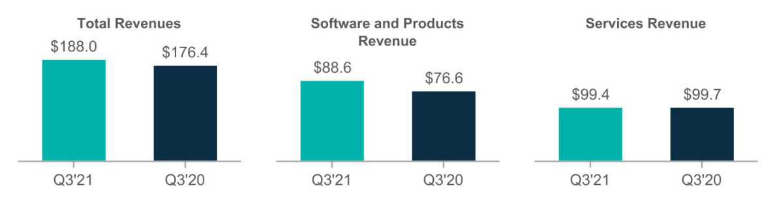

–Total revenues increased $11.6 million, or 7%.

- Software and products revenue represented 47% of our total revenue in the three months ended December 31, 2020 and 43% of our total revenue in the three months ended December 31, 2019.

- Larger deal revenue (deals greater than $0.1 million) represented 68% of our software and products revenue in the three months ended December 31, 2020 and 66% of our software and products revenue in the three months ended December 31, 2019.

–Software and products revenue increased $12.0 million, or 16%, as a result of the following:

    - An increase of $9.5 million, or 19%, in larger deal revenue.

    - An increase of 3% in the volume of larger deal revenue transactions from 182 deals for the three months ended December 31, 2019 to 187 deals for the three months ended December 31, 2020.

    - The average dollar amount of larger deal revenue transactions was approximately $322 thousand and $279 thousand for the three months ended December 31, 2020 and 2019, representing a 15% increase respectively.

    - An increase of $2.5 million in transactions less than $0.1 million.

– Services revenue represented 53% of our total revenue in the three months ended December 31, 2020 and 57% of our total revenue in the three months ended December 31, 2019. Services revenue decreased $0.3 million primarily due to the following:

  - A decrease of $0.8 million in revenue from customer support agreements.

  - Partially offset by an increase of $0.5 million of revenue from Metallic, our SaaS based offering

We track software and products revenue on a geographic basis. The geographic regions that are tracked are the Americas (United States, Canada, Latin America), EMEA (Europe, Middle East, Africa) and APJ (Australia, New Zealand, Southeast Asia, China, Japan). Americas, EMEA and APJ represented 49%, 38% and 13% of total software and products revenue, respectively, for the three months ended December 31, 2020. Software and products revenue increased year over year by 8% in the Americas, 15% in EMEA and 61% in APJ.

- The increase in Americas software and products revenue was primarily the result of a 10% increase in larger deal transactions revenue driven by an increase in the volume of larger deal transactions.

- EMEA software and products revenue increased as a result of a 23% increase in revenue on deals under $0.1 million. Using exchange rates from the prior year, the increase in software and products revenue would have been 8%.

- The increase in APJ was the result of larger deal transactions increasing more than two times over the prior year period, partially offset by a decrease in deals under $0.1 million. Using exchange rates from the prior year, the increase in software and products revenue would have been 52%.

Our software and products revenue in EMEA and APJ is subject to changes in foreign exchange rates as more fully discussed above in the “Foreign Currency Exchange Rates’ Impact on Results of Operations” section.

20

Cost of Revenues and Gross Margin ($ in millions)
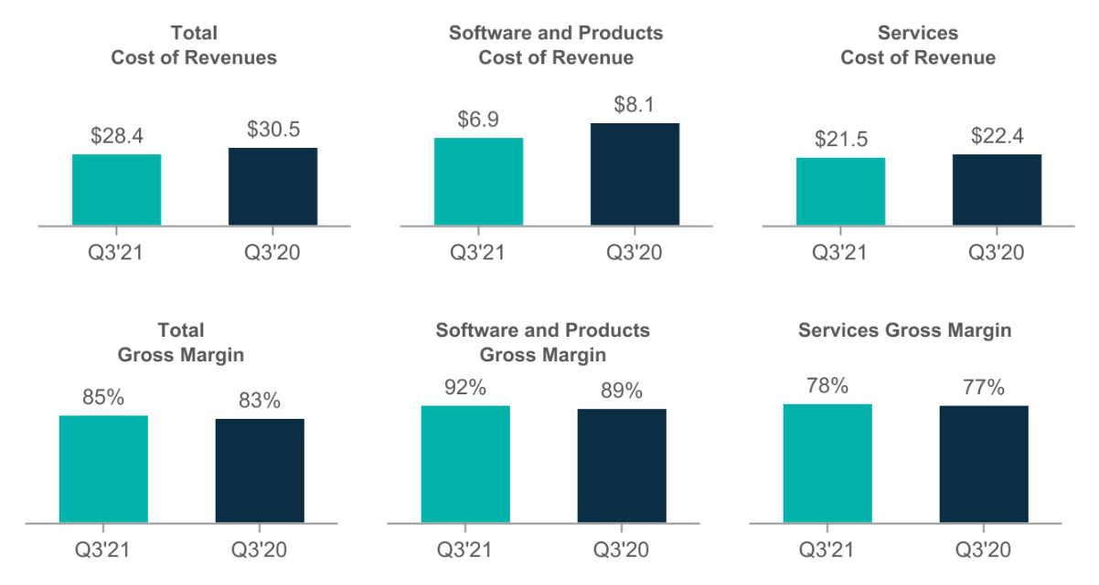

– Total cost of revenues decreased $2.1 million, and represented 15% of our total revenues for the three months ended December 31, 2020 compared to 17% for the three months ended December 31, 2019.

– Cost of software and products revenue decreased $1.2 million, and represented 8% of our total software and products revenue for the three months ended December 31, 2020 compared to 11% for the three months ended December 31, 2019. The decrease is the result of reduced sales of hardware associated with our appliance as well as reduced software royalties associated with sales of HyperScale appliances and software. Beginning with the launch of HyperScale X, we will transition to a software only model. HyperScale X also has reduced software royalties relative to prior versions of HyperScale.

– Cost of services revenue decreased $0.9 million, representing 22% of our total services revenue for the three months ended December 31, 2020 compared to 23% for the three months ended December 31, 2019. The decline in cost of services revenue is primarily related to a decrease in employee-related expenses attributable to our restructuring and reorganization initiatives.

21

Operating Expenses ($ in millions)
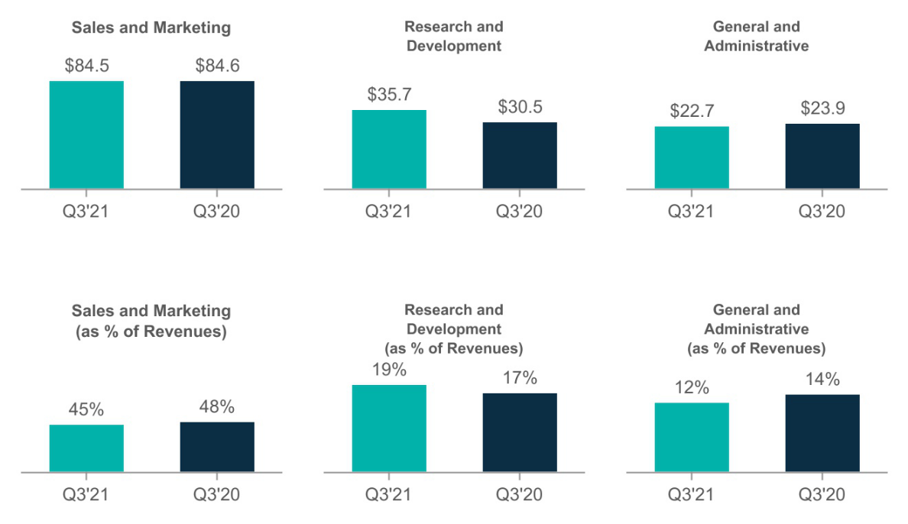

– Sales and marketing expenses remained relatively flat with a slight decrease of $0.1 million driven by:

  - Decrease in travel and related expenses as a result of COVID-19, partially offset by an increase in variable compensation associated with increased revenue.

– Research and development expenses increased $5.2 million, or 17%, as a result of an increase in employee compensation and related expenses attributable to the expansion of our engineering group.

  - Stock-based compensation increased $1.2 million compared to prior year.

  - Investing in research and development has been a priority for Commvault, and we anticipate continued spending related to the development of our data and information management software applications.

– General and administrative expenses decreased $1.2 million, or 5%, primarily due to the following:

  - Reduction related to non-recurring prior year expenses associated with Hedvig acquisition costs.

– Restructuring: Our restructuring plan is intended to increase efficiency in our sales, marketing and distribution functions as well as reduce costs across all functional areas. Restructuring expenses were $11.6 million and $2.0 million in the three months ended December 31, 2020 and 2019, respectively. These restructuring charges relate primarily to severance and related costs associated with headcount reductions as well as lease abandonment charges related to the closure of one office in the third quarter of fiscal year 2021 and two offices in the third quarter of fiscal 2020. These charges include $1.2 million and $0.7 million in the three months ended December 31, 2020 and 2019, respectively, of stock-based compensation related to modifications of existing awards granted to certain employees included in the restructuring. We cannot guarantee the restructuring program will achieve its intended result. Risks associated with this restructuring program also include additional unexpected costs, adverse effects on employee morale and the failure to meet operational and growth targets due to the loss of key employees, any of which may impair our ability to achieve anticipated results of operations or otherwise harm our business.

–Depreciation and amortization expense decreased $3.1 million, from $5.4 million in the three months ended December 31, 2019 to $2.3 million in the three months ended December 31, 2020, driven by the reduced amortization of intangible assets related to Hedvig due to their impairment in the second quarter of fiscal 2021.

22

Income Tax Expense

Income tax expense was $1.2 million in the three months ended December 31, 2020 compared to expense of $ 1.0 million in the three months ended December 31, 2019. The income tax expense for the three months ended December 31, 2020 relates primarily to current federal and foreign taxes.

Nine months ended December 31, 2020 compared to nine months ended December 31, 2019

Revenues (in millions)
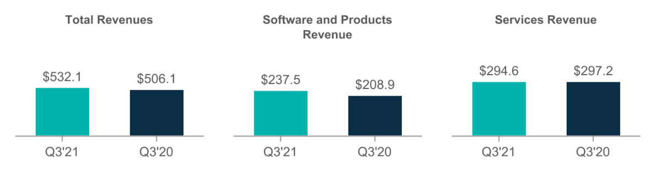

–Total revenues increased $26.0 million, or 5%.

- Software and products revenue represented 45% of our total revenue in the nine months ended December 31, 2020 and 41% of our total revenue in the nine months ended December 31, 2019.

- Larger deal revenue (deals greater than $0.1 million) represented approximately 69% of our software and products revenue in the nine months ended December 31, 2020 and 64% of our software and products revenue in the nine months ended December 31, 2019.

–Software and products revenue increased $28.6 million, or 14%, as a result of the following:

    - An increase of $29.3 million, or 22%, in larger deal revenue.

    - An increase of 6% in the number of larger deal revenue transactions and an increase of 15% in the average dollar amount of such transactions.

    - The average dollar amount of larger deal revenue transactions was approximately $344 thousand and $299 thousand for the nine months ended December 31, 2020 and 2019, respectively.

– Services revenue represented 55% of our total revenue in the nine months ended December 31, 2020 and 59% of our total revenue in the nine months ended December 31, 2019. Services revenue decreased $2.6 million, or 1%, primarily due to the following:

  - A decrease of $2.2 million in revenue from customer support agreements.

  - A decrease of $0.4 million in training and consulting services.

We track software and products revenue on a geographic basis. The geographic regions that are tracked are the Americas (United States, Canada, Latin America), EMEA (Europe, Middle East, Africa) and APJ (Australia, New Zealand, Southeast Asia, China, Japan). Americas, EMEA and APJ represented 56%, 31% and 13% of total software and products revenue, respectively, for the nine months ended December 31, 2020. Software and products revenue increased year over year by 24% in the Americas and 3% in EMEA; whereas APJ remained flat.

- The increase in Americas software and products revenue was primarily the result of a 32% increase in revenue from larger deal transactions compared to the nine months ended December 31, 2019.

- EMEA software and products revenue increased as a result of a 6% increase in revenue on deals under $0.1 million.

- Revenue from larger deal transactions in APJ increased by $2.9 million; whereas transactions under $0.1 million decreased by $2.7 million resulting in nominal growth.

23

Our software and products revenue in EMEA and APJ is subject to changes in foreign exchange rates as more fully discussed above in the “Foreign Currency Exchange Rates’ Impact on Results of Operations” section.

Cost of Revenues and Gross Margin ($ in millions)
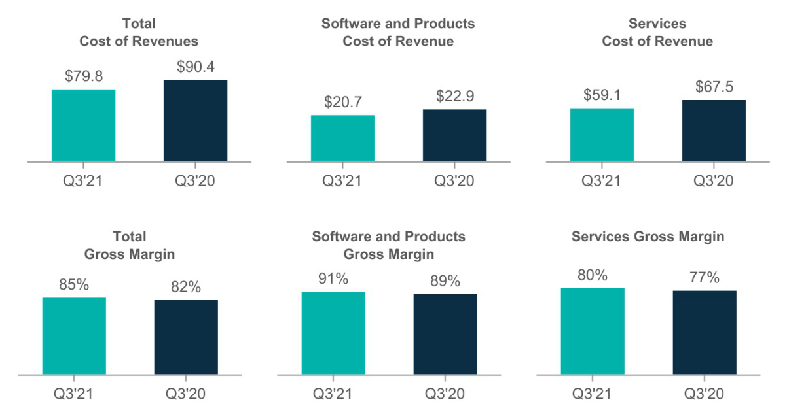

– Total cost of revenues decreased $10.6 million, and represented 15% of our total revenues for the nine months ended December 31, 2020 compared to 18% for the nine months ended December 31, 2019. Temporary salary cuts during the first half of fiscal year 2021 related to COVID-19 resulted in savings of $1.1 million in cost of revenues. The remaining decrease is primarily due to a decrease in employee-related expenses attributable to our restructuring and reorganization initiatives and a decrease in cost of sales associated with our appliance.

– Cost of software and products revenue decreased $2.2 million, and represented 9% of our total software and products revenue for the nine months ended December 31, 2020 compared to 11% for the nine months ended December 31, 2019. The decrease is the result of lower cost of sales associated with our appliance compared to the same period in the prior year.

– Cost of services revenue decreased $8.4 million, representing 20% of our total services revenue for the nine months ended December 31, 2020 compared to 23% for the nine months ended December 31, 2019. The decline in cost of services revenue is primarily related to a decrease in employee-related expenses attributable to our restructuring and reorganization initiatives. Additionally, there was a decrease in expenses associated with the delivery of professional services revenue as well as temporary salary cuts during the first half of fiscal year 2021 related to COVID-19.

24

Operating Expenses ($ in millions)
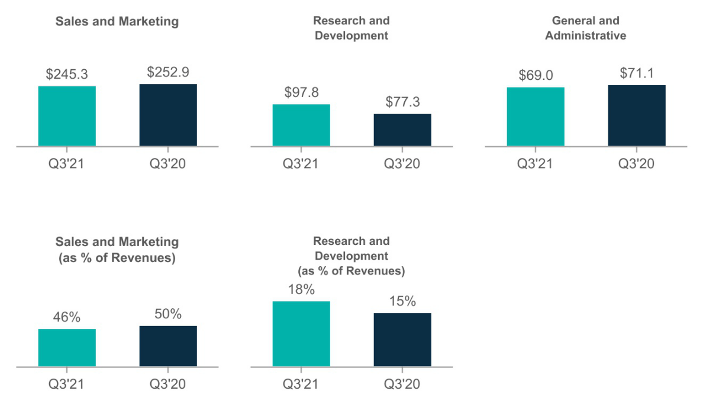

– Sales and marketing expenses decreased $7.6 million, or 3%, primarily due to the following:

  - Decreases related to the decline of travel and related expenses as a result of COVID-19.

  - Temporary salary cuts during the first half of fiscal year 2021 related to COVID-19

  - These declines were partially offset by an increase in variable compensation associated with increased revenue.

– Research and development expenses increased $20.5 million, or 27%, as a result of an increase in employee compensation and related expenses attributable to the expansion of our engineering group.

  - The increase is the result of additional headcount related to the acquisition of Hedvig including the stock-based compensation issued in connection with the transaction. Hedvig was acquired in October 2019; therefore, the prior year period includes only three months of such expenses compared to nine months during this period.

  - Additionally, certain Hedvig shareholders will receive cash payments totaling $14.1 million over the course of the 30 months following the date of acquisition, subject to their continued employment with the Company. While these payments are proportionate to these shareholders' ownership of Hedvig, under GAAP they are accounted for as compensation expense over the course of the 30 month service period. Research and development expenses in the nine months ended December 31, 2020 includes $4.2 million of expense related to this arrangement compared to $1.4 million in the nine months ended December 31, 2019.

  - These increases were partially offset by $1.7 million in savings related to temporary pay cuts in the first half of fiscal year 2021.

  - Investing in research and development has been a priority for Commvault, and we anticipate continued spending related to the development of our data and information management software applications.

– General and administrative expenses decreased $2.1 million, or 3%, primarily due to the following:

  - Reduction of non-recurring prior year expenses associated with a non-routine shareholder matter and Hedvig acquisition costs.

  - Temporary salary cuts during the first half of fiscal year 2021 related to COVID-19.

25

  - Partially offset by increases in legal expenses for intellectual property associated with ongoing litigation and foreign currency losses due to the weakening of the US dollar.

– Restructuring: Our restructuring plan is intended to increase efficiency in our sales, marketing and distribution functions as well as reduce costs across all functional areas. Restructuring expenses were $19.7 million and $19.0 million in the nine months ended December 31, 2020 and 2019, respectively. These restructuring charges relate primarily to severance and related costs associated with headcount reductions as well as lease abandonment charges related to the closure of six offices for the nine months ended December 31, 2020 and five offices in the nine months ended December 31, 2019. These charges include $1.9 million for the nine months ended December 31, 2020 and $1.7 million for the nine months ended December 31, 2019 of stock-based compensation related to modifications of existing awards granted to certain employees included in the restructuring. We cannot guarantee the restructuring program will achieve its intended result. Risks associated with this restructuring program also include additional unexpected costs, adverse effects on employee morale and the failure to meet operational and growth targets due to the loss of key employees, any of which may impair our ability to achieve anticipated results of operations or otherwise harm our business.

–Impairment of intangible assets: In the second quarter of fiscal year 2021, we recorded non-cash impairment charges of $40.7 million on the intangible assets (developed technology and customer relationships) acquired in connection with Hedvig, Inc. The charges were the result of a moderated view of acquisition assumptions.

–Depreciation and amortization expense increased $1.7 million, from $10.7 million in the nine months ended December 31, 2019 to $12.4 million in the nine months ended December 31, 2020, driven by the amortization of intangible assets acquired as a result of the Hedvig business combination in October 2019. The current year includes six months of amortization of these intangible assets as they were impaired in the second quarter of fiscal 2021; whereas prior year includes three months.

Income Tax Expense

Income tax expense was $5.4 million in the nine months ended December 31, 2020 compared to expense of $3.5 million in the nine months ended December 31, 2019. In the fourth quarter of fiscal 2020, we recorded a current tax benefit of approximately $10.0 million which represented our estimate of the net operating loss carryback resulting from the CARES Act. In the first quarter of fiscal 2021, we recorded an adjustment of $3.2 million to reduce the current benefit of the net operating loss carryback benefit we will realize from the CARES Act.

Liquidity and Capital Resources

As of December 31, 2020, our cash and cash equivalents balance of $377.6 million primarily consisted of cash. In addition, we have approximately $10.8 million of short-term investments invested in U.S. Treasury Bills. In recent fiscal years, our principal source of liquidity has been cash provided by operations.

As of December 31, 2020, the amount of cash and cash equivalents held outside of the United States by our foreign legal entities was approximately $176.5 million. These balances are dispersed across many international locations around the world. We believe that such dispersion meets the current and anticipated future liquidity needs of our foreign legal entities. In the event we needed to repatriate funds from outside of the United States, such repatriation would likely be subject to restrictions by local laws and/or tax consequences including foreign withholding taxes.

During the nine months ended December 31, 2020, we repurchased $33.1 million shares of our common stock under our share repurchase program. Under our stock repurchase program, repurchased shares are constructively retired and returned to unissued status. Our stock repurchase program has been funded by our existing cash and cash equivalent balances as well as cash flows provided by our operations. Our Board has approved, and we intend to execute, a capital allocation policy that provides for the repurchase of $200 million of our common stock for the period from February 1, 2021 through the end of our 2022 fiscal year, plus the use of approximately 75% of our free cash flow for additional repurchases during fiscal year 2022.

26

Our future stock repurchase activity is subject to the business judgment of our management and Board of Directors, taking into consideration our historical and projected results of operations, financial condition, cash flows and other anticipated capital requirements or investment alternatives. Our stock repurchase program reduces the dilutive impact on our common shares outstanding associated with stock option exercises and our previous public and private stock offerings through the repurchase of common stock.

Our summarized cash flow information is as follows (in thousands):

 | Nine Months Ended December 31,
 | 2020 |  |  |  | 2019
Net cash provided by operating activities | $ | 59,247 |  | $ | 56,008
Net cash provided by (used in) investing activities |  | 26,806 |  |  | (94,056)
Net cash used in financing activities |  | (26,129) |  |  | (9,082)
Effects of exchange rate-changes in cash |  | 21,563 |  |  | (837)
Net increase (decrease) in cash, cash equivalents and restricted cash | $ | 81,487 |  | $ | (47,967)
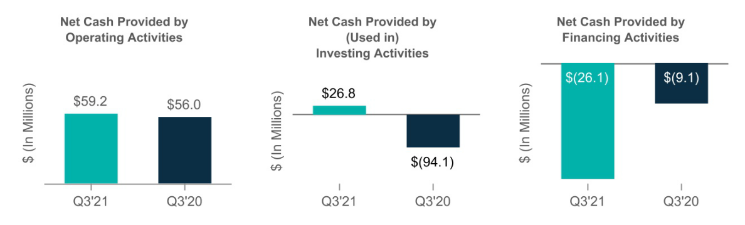

– Net cash provided by operating activities was impacted by net loss adjusted for the impact of non-cash charges, an increase in deferred revenue and partially offset by an increase in accounts receivable.

– Net cash provided by investing activities was related to net proceeds from the maturity of short-term investments of $32.8 million partially offset by $6.0 million of capital expenditures.

– Net cash used in financing activities was the result of $33.1 million of repurchases of common shares partially offset by $7.0 million of proceeds from the exercise of stock options and purchases of our stock under the Employee Stock Purchase Plan.

Working capital increased $62.1 million from $185.1 million as of March 31, 2020 to $247.2 million as of December 31, 2020. The net increase in working capital is primarily the result of cash flow from operations.

We believe that our existing cash, cash equivalents and our cash from operations will be sufficient to meet our anticipated cash needs for working capital, income taxes, capital expenditures and potential stock repurchases for at least the next twelve months. We may seek additional funding through public or private financings or other arrangements during this period. Adequate funds may not be available when needed or may not be available on terms favorable to us, or at all. If additional funds are raised by issuing equity securities, dilution to existing stockholders will result. If we raise additional funds by obtaining loans from third parties, the terms of those financing arrangements may include negative covenants or other restrictions on our business that could impair our operational flexibility, and would also require us to fund additional interest expense. If funding is insufficient at any time in the future, we may be unable to develop or enhance our products or services, take advantage of business opportunities or respond to competitive pressures, any of which could have a material adverse effect on our business, financial condition and results of operations.

27

Off-Balance Sheet Arrangements

As of December 31, 2020, we did not have off-balance sheet financing arrangements, including any relationships with unconsolidated entities or financial partnerships, such as entities often referred to as structured finance or special purpose entities.

Indemnifications

Certain of our software licensing agreements contain certain provisions that indemnify our customers from any claim, suit or proceeding arising from alleged or actual intellectual property infringement. These provisions continue in perpetuity along with our software licensing agreements. We have never incurred a liability relating to one of these indemnification provisions in the past and we believe that the likelihood of any future payout relating to these provisions is remote. Therefore, we have not recorded a liability during any period related to these indemnification provisions.

Impact of Recently Issued Accounting Standards

See Note 2 of the unaudited consolidated financial statements for a discussion of the impact of recently issued accounting standards.

Item 3 - Quantitative and Qualitative Disclosures about Market Risk

Interest Rate Risk

As of December 31, 2020, our cash and cash equivalents and short-term investments consisted primarily of cash and U.S. Treasury Bills. Due to the short-term nature of these investments, we are not subject to any material interest rate risk on these balances.

Foreign Currency Risk

Economic Exposure

As a global company, we face exposure to adverse movements in foreign currency exchange rates. Our international sales are generally denominated in foreign currencies and this revenue could be materially affected by currency fluctuations. Approximately 48% of our sales were outside the United States for the nine months ended December 31, 2020. Our primary exposures are to fluctuations in exchange rates for the U.S. dollar versus the Euro, and to a lesser extent, the Australian dollar, British pound sterling, Canadian dollar, Chinese yuan, Indian rupee, Korean won and Singapore dollar. Changes in currency exchange rates could adversely affect our reported revenues and require us to reduce our prices to remain competitive in foreign markets, which could also have a material adverse effect on our results of operations. Historically, we have periodically reviewed and revised the pricing of our products available to our customers in foreign countries and we have not maintained excess cash balances in foreign accounts.

Transaction Exposure

Our exposure to foreign currency transaction gains and losses is primarily the result of certain net receivables due from our foreign subsidiaries and customers being denominated in currencies other than the functional currency of the subsidiary. Our foreign subsidiaries conduct their businesses in local currency and we generally do not maintain excess U.S. dollar cash balances in foreign accounts.

Foreign currency transaction gains and losses are recorded in General and administrative expenses in the Consolidated Statements of Operations. We recognized net foreign currency transaction losses of $0.5 million and $1.7 million for the three and nine months ended December 31, 2020, respectively. We recognized net foreign transaction losses of $0.1 million and $0.2 million for the three and nine months ended December 31, 2019, respectively.

28

Item 4 - Controls and Procedures

Evaluation of Disclosure Controls and Procedures

Our management, with the participation of the Chief Executive Officer and Chief Financial Officer, has evaluated the effectiveness of our disclosure controls and procedures, as defined in Rules 13a-15(e) and 15d-15(e) of the Securities Exchange Act of 1934, as of December 31, 2020. Based on that evaluation, the Chief Executive Officer and Chief Financial Officer concluded that our disclosure controls and procedures were effective as of December 31, 2020.

Changes in Internal Control over Financial Reporting

There was no change in our internal control over financial reporting that occurred during the third quarter of fiscal 2021 that has materially affected, or is reasonably likely to materially affect, our internal control over financial reporting.

Inherent Limitations on Internal Controls

Our management, including our Chief Executive Officer and Chief Financial Officer, do not expect that our disclosure controls and procedures or our internal controls over financial reporting will prevent or detect all error and all fraud. A control system, no matter how well designed and operated, can provide only reasonable, not absolute, assurance that the control objectives of the control system are met. Further, the design of a control system must reflect the fact that there are resource constraints, and the benefits of controls must be considered relative to their costs. Because of inherent limitations in all control systems, no evaluation of controls can provide absolute assurance that all control issues and instances of fraud, if any, within the company have been detected. These inherent limitations include the realities that judgments in decision-making can be faulty, and that breakdowns can occur because of a simple error or mistake. Additionally, controls can be circumvented by the individual acts of some persons, by collusion of two or more people, or by management override of the controls. The design of any system of controls also is based in part upon certain assumptions about the likelihood of future events, and there can be no assurance that any design will succeed in achieving its stated goals under all potential future conditions. Over time, controls may become inadequate because of changes in conditions, or the degree of compliance with the policies or procedures may deteriorate. Because of inherent limitations in a cost-effective control system, misstatements due to error or fraud may occur and not be detected.

29

PART II. OTHER INFORMATION

Item 1. Legal Proceedings

From time to time, we are subject to claims in legal proceedings arising in the normal course of our business. We do not believe that we are currently party to any pending legal action that could reasonably be expected to have a material adverse effect on our business or operating results.

Item 1A. Risk Factors

In addition to the other information set forth in this report, you should carefully consider the factors discussed in Part I, “Item 1A. Risk Factors” in our Annual Report on Form 10-K for the year ended March 31, 2020, which could materially affect our business, financial condition or future results. Additional risks and uncertainties not currently known to us or that we currently deem to be immaterial also may materially adversely affect our business, financial condition and/or operating results. If any of the risks actually occur, our business, financial conditions or results of operations could be negatively affected. In that case, the trading price of our stock could decline, and our stockholders may lose part or all of their investment.

Item 2. Unregistered Sale of Equity Securities and Use of Proceeds

Purchases of Equity Securities by the Issuer

During the three months ended December 31, 2020, we repurchased $33.1 million of common stock, or 700,694 shares, under our share repurchase program. A summary of our repurchases of common stock is as follows:

 |  | Total number of |  |  |  |  |  |  |  |  | Approximate dollar
 |  | shares purchased as |  |  | Average price paid |  |  | Total dollar value of |  |  | value of shares that
Period |  | part of publicly |  |  |  |  |  | Total dollar value of |  | may yet be purchased
 |  | announced programs |  |  | per share |  |  | purchases |  |  | under the program
October 2020 |  | 23,300 |  | $ | 39.71 |  | $ | 925,220 |  | $ | 199,074,780
November 2020 |  | 398,700 |  | $ | 45.17 |  | $ | 18,009,092 | $ |  | 181,065,688
December 2020 |  | 278,694 |  | $ | 50.94 |  | $ | 14,197,246 | $ |  | 166,868,442
Three months ended December 31, 2020 |  | 700,694 |  | $ | 47.28 |  |  | 33,131,558

Item 3. Defaults upon Senior Securities

None.

Item 4. Mine Safety Disclosures

Not Applicable.

Item 5. Other Information

None.

30

Item 6. Exhibits

 | Exhibit No. |  |  | Description
31.1 |  |  | Certification of Chief Executive Officer Pursuant to Section 302 of the Sarbanes-Oxley Act of 2002
31.2 |  |  | Certification of Chief Financial Officer Pursuant to Section 302 of the Sarbanes-Oxley Act of 2002
32.1 |  |  | Certification of Chief Executive Officer Pursuant to Section 906 of the Sarbanes-Oxley Act of 2002
32.2 |  |  | Certification of Chief Financial Officer Pursuant to Section 906 of the Sarbanes-Oxley Act of 2002
101.INS |  |  | XBRL Instance Document - the instance document does not appear in the Interactive Data File because its XBRL tags are embedded within
 |  |  | the Inline XBRL document.
101.SCH |  |  | XBRL Taxonomy Extension Schema Document
101.CAL |  |  | XBRL Taxonomy Extension Calculation Linkbase Document
101.DEF |  |  | XBRL Taxonomy Extension Definition Linkbase Document
101.LAB |  |  | XBRL Taxonomy Extension Label Linkbase Document
101.PRE |  |  | XBRL Taxonomy Extension Presentation Linkbase Document
- Cover Page Interactive Data File (formatted as Inline XBRL and contained in Exhibit 101)

31

Signatures

Pursuant to the requirements of the Securities Act of 1934, the registrant has duly caused this report to be signed on its behalf by the undersigned thereunto duly authorized.

 |  |  | Commvault Systems, Inc.
Dated: | January 28, 2021 | By: | /s/ Sanjay Mirchandani
 |  | Sanjay | Mirchandani
 |  | Director, President and Chief Executive Officer
Dated: | January 28, 2021 | By: | /s/ Brian Carolan
 |  | Brian | Carolan
 |  | Vice President and Chief Financial Officer
 |  | 32

Exhibit 31.1

Certification of Chief Executive Officer

Required by Rule 13a-14(a) (17 CFR 240.13a-14(a))

I, Sanjay Mirchandani, certify that:

- I have reviewed this Quarterly Report on Form 10-Q of Commvault Systems, Inc.;

- Based on my knowledge, this report does not contain any untrue statement of a material fact or omit to state a material fact necessary to make the statements made, in light of the circumstances under which such statements were made, not misleading with respect to the period covered by this report;

- Based on my knowledge, the financial statements, and other financial information included in this report, fairly present in all material respects the financial condition, results of operations and cash flows of the registrant as of, and for, the periods presented in this report;

- The registrant’s other certifying officer and I are responsible for establishing and maintaining disclosure controls and procedures (as defined in Exchange Act Rules 13a-15(e) and 15d-15(e)) and internal control over financial reporting (as defined in Exchange Act Rules 13a-15(f) and 15d-15(f)) for the registrant and have:

  - Designed such disclosure controls and procedures, or caused such disclosure controls and procedures to be designed under our supervision, to ensure that material information relating to the registrant, including its consolidated subsidiaries, is made known to us by others within those entities, particularly during the period in which this report is being prepared;

  - Designed such internal control over financial reporting, or caused such internal control over financial reporting to be designed under our supervision, to provide reasonable assurance regarding the reliability of financial reporting and the preparation of financial statements for external purposes in accordance with generally accepted accounting principles;
  - Evaluated the effectiveness of the registrant’s disclosure controls and procedures and presented in this report our conclusions about the effectiveness of the disclosure controls and procedures, as of the end of the period covered by this report based on such evaluation; and

  - Disclosed in this report any change in the registrant’s internal control over financial reporting that occurred during the registrant’s most recent fiscal quarter (the registrant’s fourth fiscal quarter in the case of an annual report) that has materially affected, or is reasonably likely to materially affect, the registrant’s internal control over financial reporting; and

- The registrant’s other certifying officer and I have disclosed, based on our most recent evaluation of internal control over financial reporting, to the registrant’s auditors and the audit committee of the registrant’s board of directors (or persons performing equivalent functions):

  - All significant deficiencies and material weaknesses in the design or operation of internal control over financial reporting which are reasonably likely to adversely affect the registrant’s ability to record, process, summarize and report financial information; and

  - Any fraud, whether or not material, that involves management or other employees who have a significant role in the registrant’s internal control over financial reporting.

/s/ Sanjay Mirchandani

Sanjay Mirchandani

Director, President and Chief Executive Officer

Date: January 28, 2021

Exhibit 31.2

Certification of Chief Financial Officer

Required by Rule 13a-14(a) (17 CFR 240.13a-14(a))

I, Brian Carolan, certify that:

- I have reviewed this Quarterly Report on Form 10-Q of Commvault Systems, Inc.;

- Based on my knowledge, this report does not contain any untrue statement of a material fact or omit to state a material fact necessary to make the statements made, in light of the circumstances under which such statements were made, not misleading with respect to the period covered by this report;

- Based on my knowledge, the financial statements, and other financial information included in this report, fairly present in all material respects the financial condition, results of operations and cash flows of the registrant as of, and for, the periods presented in this report;

- The registrant’s other certifying officer and I are responsible for establishing and maintaining disclosure controls and procedures (as defined in Exchange Act Rules 13a-15(e) and 15d-15(e)) and internal control over financial reporting (as defined in Exchange Act Rules 13a-15(f) and 15d-15(f)) for the registrant and have:

  - Designed such disclosure controls and procedures, or caused such disclosure controls and procedures to be designed under our supervision, to ensure that material information relating to the registrant, including its consolidated subsidiaries, is made known to us by others within those entities, particularly during the period in which this report is being prepared;

  - Designed such internal control over financial reporting, or caused such internal control over financial reporting to be designed under our supervision, to provide reasonable assurance regarding the reliability of financial reporting and the preparation of financial statements for external purposes in accordance with generally accepted accounting principles;
  - Evaluated the effectiveness of the registrant’s disclosure controls and procedures and presented in this report our conclusions about the effectiveness of the disclosure controls and procedures, as of the end of the period covered by this report based on such evaluation; and

  - Disclosed in this report any change in the registrant’s internal control over financial reporting that occurred during the registrant’s most recent fiscal quarter (the registrant’s fourth fiscal quarter in the case of an annual report) that has materially affected, or is reasonably likely to materially affect, the registrant’s internal control over financial reporting; and

- The registrant’s other certifying officer and I have disclosed, based on our most recent evaluation of internal control over financial reporting, to the registrant’s auditors and the audit committee of the registrant’s board of directors (or persons performing equivalent functions):

  - All significant deficiencies and material weaknesses in the design or operation of internal control over financial reporting which are reasonably likely to adversely affect the registrant’s ability to record, process, summarize and report financial information; and

  - Any fraud, whether or not material, that involves management or other employees who have a significant role in the registrant’s internal control over financial reporting.

/s/ Brian Carolan

Brian Carolan

Vice President and Chief Financial Officer

Date: January 28, 2021

Exhibit 32.1

Certification Pursuant To

18 U.S.C. Section 1350

As Adopted Pursuant To

Section 906 of the Sarbanes-Oxley Act of 2002

In connection with the Quarterly Report of Commvault Systems, Inc. (the “Company”) on Form 10-Q for the period ended December 31,

2020 as filed with the Securities and Exchange Commission (the “Report”), I, Sanjay Mirchandani, Director, President and Chief Executive Officer of the Company, certify, pursuant to 18 U.S.C. § 1350, as adopted pursuant to § 906 of the Sarbanes-Oxley Act of 2002, that:

- The Report fully complies with the requirements of section 13(a) or 15(d) of the Securities Exchange Act of 1934; and

- The information contained in the Report fairly presents, in all material respects, the financial condition and results of operations of the Company.

/s/ Sanjay Mirchandani

Sanjay Mirchandani

Director, President and Chief Executive Officer

January 28, 2021

Exhibit 32.2

Certification Pursuant To

18 U.S.C. Section 1350

As Adopted Pursuant To

Section 906 of the Sarbanes-Oxley Act of 2002

In connection with the Quarterly Report of Commvault Systems, Inc. (the “Company”) on Form 10-Q for the period ended December 31,

2020 as filed with the Securities and Exchange Commission (the “Report”), I, Brian Carolan, Vice President and Chief Financial Officer of the

Company, certify, pursuant to 18 U.S.C. § 1350, as adopted pursuant to § 906 of the Sarbanes-Oxley Act of 2002, that:

- The Report fully complies with the requirements of section 13(a) or 15(d) of the Securities Exchange Act of 1934; and

- The information contained in the Report fairly presents, in all material respects, the financial condition and results of operations of the Company.

/s/ Brian Carolan

Brian Carolan

Vice President and Chief Financial Officer

January 28, 2021

