UNITED STATES

SECURITIES AND EXCHANGE COMMISSION

Washington, D.C. 20549

SCHEDULE 14A

Proxy Statement Pursuant to Section 14(a) of the

Securities Exchange Act of 1934

Filed by the Registrant ☑

Filed by a Party other than the Registrant ☐

Check the appropriate box:

- Preliminary Proxy Statement

- Confidential, for Use of the Commission Only (as permitted by Rule 14a-6(e)(2)) ☑ Definitive Proxy Statement
- Definitive Additional Materials

- Soliciting Material under §240.14a-12


Commvault Systems, Inc.

(Name of Registrant as Specified In Its Charter)

(Name of Person(s) Filing Proxy Statement, if other than the Registrant)

Payment of Filing Fee (Check all boxes that apply):

- No fee required.

- Fee paid previously with preliminary materials.

- Fee computed on table in exhibit required by Item 25(b) per Exchange Act Rules 14a-6(i)(1) and 0-11

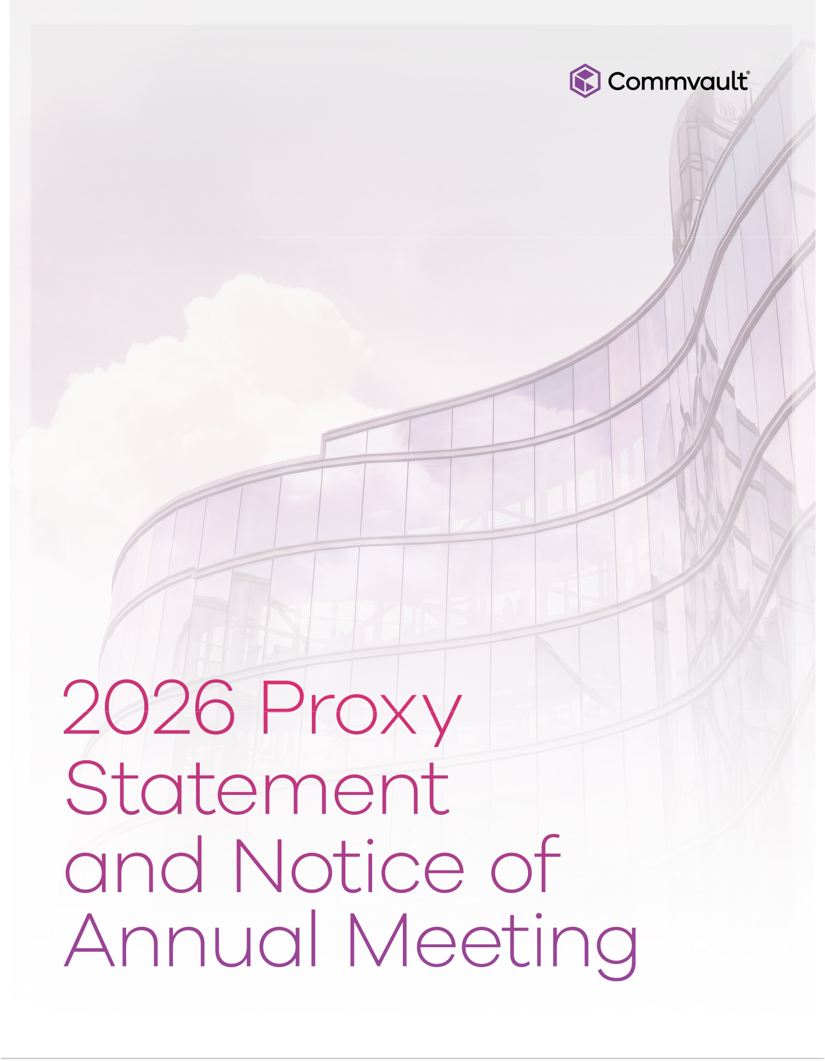



Commvault Systems, Inc.

1 Commvault Way

Tinton Falls, New Jersey 07724

- 870-4000 June 24, 2026
Dear Fellow Stockholders:

Last year was a defining chapter in Commvault’s history, marked by industry-leading innovation, disciplined execution, and clear strategic vision for resilience in a world being reshaped by AI. Total revenue grew 19% to a record $1.184 billion, and we surpassed our $1 billion total annual recurring revenue target two quarters early, closing the year at $1.122 billion.

I would like to extend my appreciation to our CEO, Sanjay Mirchandani, the entire leadership team, and our employees worldwide. Their sustained focus and determination drove strong profitability and free cash flow generation, while the Company returned $446 million to stockholders through share repurchases.

The agentic era is ushering in a new reality for our customers. While enterprises are increasing productivity and efficiencies, they also face exponential data growth, a surge in AI-driven attacks, and scores of new identities attempting to access enterprise data and systems. These risks pose a material threat to organizations, requiring enterprises to think about resilience in an entirely new way.

By unifying data security, identity resilience, and cyber recovery, Commvault helps organizations address today's challenges. We protect the data that powers AI while enabling customers to use AI to detect threats faster, recover at scale, and automate their resilience operations. This is further enhanced by our industry-leading partners, who extend our reach, deepen our interoperability, and allow customers to rely on Commvault as part of their secure ecosystems.

We remain focused on developing and deploying purpose-built innovations for our customers and partners, driving sustainable, profitable growth, and delivering long-term value for our shareholders.

On behalf of the Board of Directors, thank you for your continued support.

Sincerely,


Nicola Adamo
Chair of the Board



TIME AND DATE |  | LOCATION |  |  |  | RECORD DATE
Thursday, August 6, 2026 |  | Virtual only |  |  |  | June 12, 2026
10:00am ET |  | https://ir.commvault.com/news-and-events/annual-
 |  |  | meeting

It is my pleasure to notify our stockholders of our 2026 Annual Meeting. We look forward to your participation.

The purposes of the meeting are:

- To elect seven directors for one-year terms;

- To approve, on an advisory basis, Commvault’s executive compensation;

- To ratify the appointment of Ernst & Young LLP as Commvault’s independent public accountants for the fiscal year ending March 31, 2027; and
- To approve Commvault’s 2026 Equity Plan.

Only stockholders of record as of the Record Date are entitled to notice of, and to vote at, the Annual Meeting and any adjournment or postponement thereof. We will mail a Notice of Internet Availability of Proxy Materials to stockholders of record on or about June 24, 2026, so you can access our proxy materials online or request paper copies of these materials.

For information about how to access the virtual meeting, and what to do if you have technical difficulties, please see “Additional Information About the Annual Meeting.”

If you vote in advance using our telephone or Internet voting procedures or by sending in your proxy card, you may still attend and vote at the Annual Meeting.

A list of stockholders entitled to vote at the Annual Meeting will be available for examination by stockholders during the ten days preceding the meeting. Information regarding how to examine the stockholder list is available at the meeting website at https://ir.commvault.com/news-and-events/annual-meeting.

Important Notice of Internet Availability of Proxy Materials for the Meeting to be held on August 6, 2026: This proxy statement and our annual report to stockholders are available at www.edocumentview.com/CVLT.

By Order of the Board of Directors


Danielle Sheer

Chief Legal and Trust Officer

June 24, 2026

How to Vote:


Online During
the Meeting

Attend the Annual Meeting virtually at
https://ir.commvault.com/news-and-
events/annual-meeting and follow the instructions on the website


Online Before
the Meeting

Visit www.investorvote.com/CVLT and finish
voting by Wednesday, August 5, 2026 at 11:59pm ET.


Mail

Sign, date and return your proxy card in the enclosed envelope


Telephone

Call the telephone number on your proxy card

2 COMMVAULT SYSTEMS, INC. | 2026 PROXY STATEMENT

Proxy Summary |  |  |  |  |  |  |  |  |  |  |  |  |  |  |  |  |  |  |  | 4
 | What’s New |  |  |  |  |  |  |  |  |  |  |  |  |  |  |  |  |  |  | 4
 | Election of Directors |  |  |  |  |  |  |  |  |  |  |  |  |  |  |  |  |  |  | 5
 | Board Composition |  |  |  |  |  |  |  |  |  |  |  |  |  |  |  |  |  |  | 5
 | Fiscal 2026 Financial Highlights |  |  |  |  |  |  |  |  |  |  |  |  |  |  |  |  |  |  | 6
 | Governance Highlights |  |  |  |  |  |  |  |  |  |  |  |  |  |  |  |  |  |  | 7
 | Executive Compensation Highlights |  |  |  |  |  |  |  |  |  |  |  |  |  |  |  |  |  |  | 8
 | Sustainability Developments |  |  |  |  |  |  |  |  |  |  |  |  |  |  |  |  |  |  | 9
Proposal No. 1: Election of Directors |  |  |  |  |  |  |  |  |  |  |  |  |  |  |  |  |  |  |  | 10
 | Director Independence |  |  |  |  |  |  |  |  |  |  |  |  |  |  |  |  |  |  | 10
 | Nominees for Election |  |  |  |  |  |  |  |  |  |  |  |  |  |  |  |  |  |  | 11
 | Majority Vote Standard and Resignation Policy in Director |  |  |  |  |  |  |  |  |  |  |  |  |  |  |  |  |  |  | 14
 | Elections |  |  |  |  |  |  |  |  |  |  |  |  |  |  |  |  |  |  | 14
Corporate Governance |  |  |  |  |  |  |  |  |  |  |  |  |  |  |  |  |  |  |  | 15
 | Overview |  |  |  |  |  |  |  |  |  |  |  |  |  |  |  |  |  |  | 15
 | Cybersecurity |  |  |  |  |  |  |  |  |  |  |  |  |  |  |  |  |  |  | 16
 | Board Leadership Structure |  |  |  |  |  |  |  |  |  |  |  |  |  |  |  |  |  |  | 17
 | Board Oversight of Risk |  |  |  |  |  |  |  |  |  |  |  |  |  |  |  |  |  |  | 17
 | Stockholder Engagement |  |  |  |  |  |  |  |  |  |  |  |  |  |  |  |  |  |  | 18
 | How We Choose Directors |  |  |  |  |  |  |  |  |  |  |  |  |  |  |  |  |  |  | 18
 | Board Committees |  |  |  |  |  |  |  |  |  |  |  |  |  |  |  |  |  |  | 19
 | Meetings of the Board |  |  |  |  |  |  |  |  |  |  |  |  |  |  |  |  |  |  | 20
 | How to Contact Our Board |  |  |  |  |  |  |  |  |  |  |  |  |  |  |  |  |  |  | 20
 | Governance Documents |  |  |  |  |  |  |  |  |  |  |  |  |  |  |  |  |  |  | 21

3 COMMVAULT SYSTEMS, INC. | 2026 PROXY STATEMENT

Transactions With Related Persons


Director Compensation

Stock Ownership Guidelines for Independent Directors

Security Ownership of Management and Certain Beneficial Owners

Delinquent Section 16(a) Reports

Proposal No. 2: Advisory Vote on Commvault’s Executive Compensation

Executive Compensation

Compensation Committee Report

Audit Committee Report

Proposal No. 3: Ratification of the Appointment of Independent Auditors

Audit, Audit-Related, Tax, and All Other Fees

Policy on Audit Committee Pre-Approval of Audit and Non-Audit Services of Independent Auditors

Proposal No. 4: Approval of 2026 Equity Plan

Background

Key Data

Description of the 2026 Equity Plan

Fiscal 2026 Equity Compensation Plan Information

Additional Information About the Annual Meeting

Annex A: Reconciliation of GAAP to Non-GAAP Financial Measures

21

22

23

24

25

26

27

40

51

52

52

53

54

54

55

56

62

63

67

Table of Contents


This proxy summary highlights information contained elsewhere in this proxy statement. It does not contain all the information that you should consider. Please read the entire proxy statement carefully before voting. This proxy statement is first being made available to stockholders of Commvault Systems, Inc. (“Commvault,” “we,” “our,” “us,” or the “Company”) on or about June 24, 2026.

TIME AND DATE |  | LOCATION |  |  |  | RECORD DATE
Thursday, August 6, 2026 |  | Virtual only |  |  |  | June 12, 2026
10:00am ET |  | https://ir.commvault.com/news-and-events/annual-
 |  |  | meeting

MEETING AGENDA

Proposal | Board’s voting |  | For more
 | recommendation |  | information
Election of directors | ✓ | FOR each | Page 10
Election of directors | ✓ | nominee | Page 10
Advisory vote on Commvault’s executive compensation | ✓ | FOR | Page 26
Ratification of the independent auditors | ✓ | FOR | Page 52
Approval of the 2026 Equity Plan | ✓ | FOR | Page 54

What’s New

- We unveiled Commvault Cloud Unity, our cloud-native, AI-enabled resilience platform that unifies data and AI security, identity resilience, and cyber recovery across cloud, SaaS, hybrid, and on-prem environments – all from a single interface.

- We hired a Deputy Chief Information Security Officer (“Deputy CISO”) and a Senior Director of Product Security to deepen our security leadership across operations and product development.

- We launched sovereign cloud capabilities to deliver cyber resilience for customers operating in highly regulated environments.

- We established our AI Governance Council and launched our AI governance training for all employees.

- We published a refreshed Sustainability Report, including our commitment to setting net-zero targets through the Science-Based Targets initiative (“SBTi”).

4 COMMVAULT SYSTEMS, INC. | 2026 PROXY STATEMENT

Table of Contents

PROXY SUMMARY | ELECTION OF DIRECTORS

Election of Directors

The following table shows information about our director nominees. All of our directors and nominees are independent except Mr. Mirchandani, Commvault’s President and Chief Executive Officer (“CEO”).

 |  |  |  |  | Committees
 |  | Director
NOMINEES | Age | Director | Professional Background | Audit | Nominations and | Operating | Compensation
NOMINEES | Age | Since | Professional Background | Audit | Governance | Operating | Compensation
Nicola Adamo, | 62 | 2018 | Founder and President, Making a Mark
Chair of the Board
Martha Bejar | 64 | 2018 | Senior Partner, DaGrosa Capital Partners | n | n
Keith Geeslin | 73 | 1996 | Partner, Francisco Partners |  |  | n | n
Vivie "YY" Lee | 59 | 2018 | Former Senior Vice President and Chief |  | n |  | n
 |  |  | Strategy Officer, Anaplan
Sanjay Mirchandani | 62 | 2019 | President and CEO, Commvault Systems
Chuck Moran | 71 | 2018 | Founder and former President and CEO, |  |  | n | n
 |  |  | Skillsoft
Shane Sanders | 63 | 2022 | Former Senior Vice President of Business | n | n
 |  |  | Transformation, Verizon Communications
Number of Directors |  |  |  | 2 | 3 | 2 | 3
 |  |  |  | n Committee Chair |  | n Committee Member

Board Composition
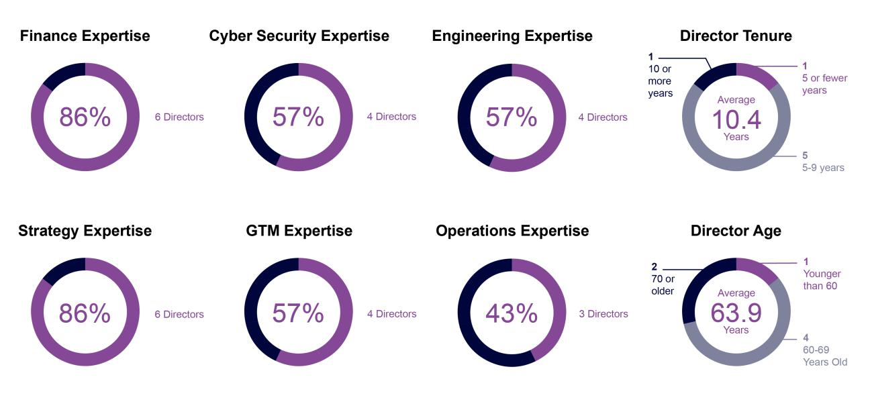

5 COMMVAULT SYSTEMS, INC. | 2026 PROXY STATEMENT

Table of Contents

PROXY SUMMARY | FISCAL 2026 FINANCIAL HIGHLIGHTS

Fiscal 2026 Financial Highlights

Fiscal 2026 reflected strong operational execution, highlighted by notable increases in revenues, total annualized recurring revenue (“ARR”)⁽¹⁾, subscription
ARR⁽¹⁾ and SaaS ARR⁽¹⁾. The following charts present selected financial metrics (amounts in millions):
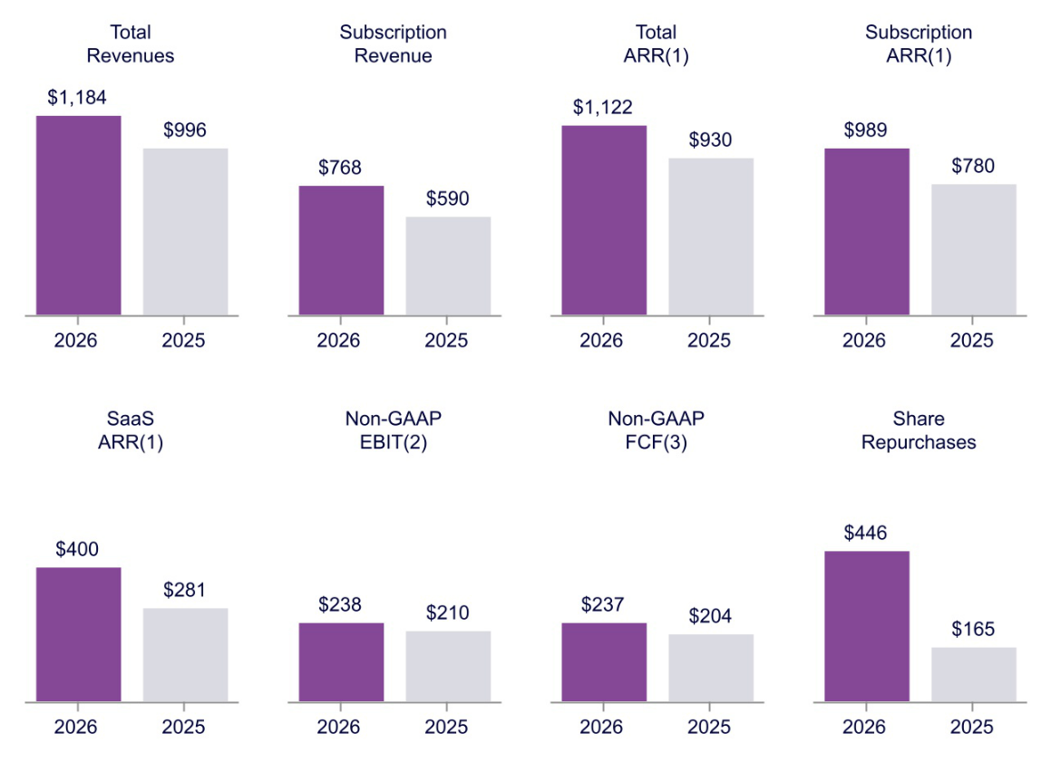

- Total ARR represents the annualized value of all active contracts as of the end of a reporting period. ARR includes recurring subscription offerings, customer support associated with perpetual and term licenses, premium support offerings for subscription-based customers, and managed service offerings. ARR excludes non-recurring elements, such as perpetual licenses and professional services, which are typically delivered at a point in time. For all term-based arrangements, ARR is calculated by dividing the total active contract value by the number of days in the contract term and multiplying the result by 365. For consumption-based arrangements on a pay as you go model without a fixed commitment, ARR is calculated by annualizing the revenue contractually expected to be received in a given month based on actual monthly usage from a prior month. Because ARR includes only contracts that are active at the end of the reporting period, it does not reflect assumptions or estimates regarding future contract renewals or non-renewals. Subscription ARR represents the portion of ARR attributable to term-based licenses, maintenance and support services associated with term license arrangements, SaaS subscriptions, and consumption‑based arrangements, calculated using the same ARR methodology. SaaS ARR represents the cloud‑hosted portion of Subscription ARR and excludes revenue attributable to term license arrangements and related maintenance and support services. SaaS ARR reflects the annualized value of active SaaS contracts.

These metrics are non-GAAP measures and do not have standardized definitions under U.S. generally accepted accounting principles ("GAAP"). As such, they may not be comparable to similarly titled measures used by other companies and should be considered as a supplement to, and not as a substitute for, financial information prepared in accordance with GAAP. Management uses these metrics to assess the health of our recurring revenue base and to inform strategic decision making. These metrics should be viewed independently of GAAP revenue, deferred revenue and unbilled revenue and are not intended to be combined with or to replace those items. ARR is not a forecast of future revenue.

- Non-GAAP EBIT is defined as GAAP income from operations (“EBIT”) adjusted to exclude certain noncash expenses, restructuring and acquisition-related costs, and other nonrecurring charges. These adjustments are detailed in the reconciliation of GAAP to non-GAAP financial measures included in Annex A. Commvault believes that the use of this non-GAAP financial measure, when used as a supplement to GAAP financial measures, provides an additional tool for investors to use in evaluating ongoing operating results and trends, and in comparing its financial results with other companies in Commvault’s industry, many of which present similar non-GAAP financial measures to the investment community. Our GAAP EBIT was $74.0 million and $73.7 million in fiscal years 2026 and 2025, respectively.

- Non-GAAP free cash flow (“FCF”) is defined as net cash provided by operating activities less purchases of property and equipment. Commvault considers non-GAAP FCF a useful metric for Commvault management and its investors in evaluating Commvault's ability to generate cash from its business operations. Our GAAP cash provided by operating activities was $245 million and $207 million in fiscal years 2026 and 2025, respectively. Please see “Reconciliation of GAAP to Non-GAAP Financial Measures” in Annex A for additional information about our non-GAAP financial measures.

6 COMMVAULT SYSTEMS, INC. | 2026 PROXY STATEMENT

Table of Contents

PROXY SUMMARY | GOVERNANCE HIGHLIGHTS

Governance Highlights

Commvault is committed to corporate governance excellence. We strengthened several of our policies and practices to demonstrate this commitment, including those summarized below.

AI Governance. We established an AI Governance Council to promote and enforce the responsible, principled, and compliant development of AI. This council is the enforcement arm of our AI Governance Framework. We also launched a company-wide AI governance training program aligned with the National Institute of Standards and Technology (“NIST”) AI Risk Management Framework 1.0, reinforcing the Principles for Responsible Artificial Intelligence adopted by our Board of Directors (the “Board”).

Cybersecurity Leadership. We added our Deputy CISO and a Senior Director of Product Security, deepening our leadership bench across enterprise security, product security governance, and incident preparedness.

Data Privacy and Regulatory Compliance. We continue to expand our global data governance program in response to evolving regulatory requirements, including publishing an EU Data Act Addendum to our customer terms, incorporating ransomware payment reporting procedures under Australia's Cyber Security Act 2024, and preparing for India's Digital Personal Data Protection Rules.

Disclosure Committee. We expanded the scope and leadership of the Disclosure Committee and broadened its oversight of the Company's public disclosures.

Enterprise Risk Management. We evolved our Enterprise Risk Management program to a top-down and bottom-up risk assessment framework and introduced automated risk monitoring and reporting, increasing the timeliness and depth of risk visibility across the organization.

Investment Policy. We adopted an Investment Policy, approved by the Audit Committee and Operating Committee, establishing parameters, responsibilities, and controls for investing the Company's available cash. Management provides quarterly updates on investment activity to the Audit Committee.

We believe these updates and practices represent strong corporate governance measures that are in the best interests of the Company and its stockholders.

7 COMMVAULT SYSTEMS, INC. | 2026 PROXY STATEMENT

Table of Contents

PROXY SUMMARY | EXECUTIVE COMPENSATION HIGHLIGHTS

Executive Compensation Highlights

Commvault’s executive compensation program is designed to support our long-term strategic vision and align with our pay-for-performance philosophy. As shown below, a significant amount of our executives’ direct compensation is long-term and varies based on Company performance. Please see “Compensation Discussion and Analysis” for additional information on executive compensation.
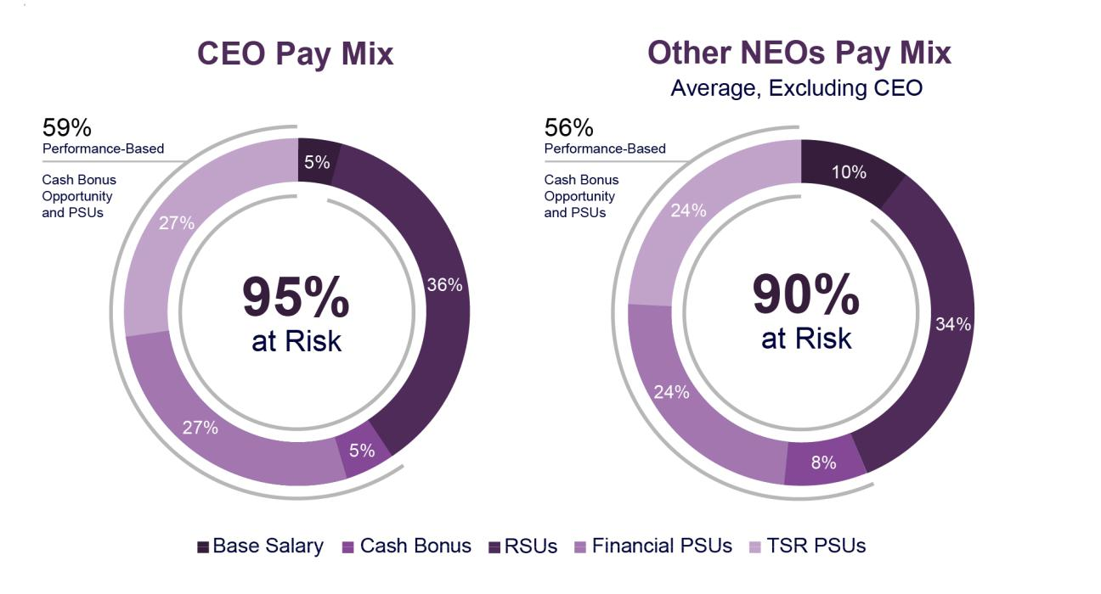

8 COMMVAULT SYSTEMS, INC. | 2026 PROXY STATEMENT

Table of Contents

PROXY SUMMARY | SUSTAINABILITY DEVELOPMENTS

Sustainability Developments


TALENT DEVELOPMENT & ENGAGEMENT

Our people drive our success. In fiscal 2026, we launched new cybersecurity and AI governance training programs for all employees, reflecting our investment in equipping our workforce with the skills to meet evolving technology and security challenges. Employees, partners, and customers participated in over 3,400 training programs totaling more than 219,000 hours.

INTEGRATION WITH RISK MANAGEMENT

Sustainability-related risks are reported to the Enterprise Risk Management Committee ("ERMC") and escalated to our Audit Committee as appropriate. In fiscal 2026, we expanded our Dynamic Materiality Assessment process to incorporate double materiality considerations, enabling the Company to evaluate both the impact of sustainability risks on the business and the Company's impact on the environment and stakeholders.

SUSTAINABLE STEWARDSHIP

In fiscal 2026, we completed a comprehensive assessment of our Scope 1, 2, and 3 greenhouse gas emissions, building on prior assessments to further refine our emissions profile and inform our reduction strategy. Further, we committed to setting net-zero science-based emissions reduction targets through the SBTi.


SUSTAINABILITY REPORT

We evaluated our fiscal 2026 performance in our seventh annual Sustainability Report published in June 2026.

GOVERNANCE

All directors of the Board are elected annually. All directors are independent with the exception of our President and CEO.

INNOVATION

In fiscal 2026, we earned 30+ awards and other recognitions for our technical and organizational innovations, giving us a critical edge in a competitive industry.

9 COMMVAULT SYSTEMS, INC. | 2026 PROXY STATEMENT

Table of Contents


WHAT AM I VOTING ON? |  |  | VOTE RECOMMENDATION
The Board has nominated seven people to serve as directors until the 2027 Annual Meeting. |  |  | FOR all seven nominees.

Election of Directors

If you sign, date and return your proxy card, the individuals named as proxy voters on the proxy card for our 2026 Annual Meeting, or their substitutes, will vote your proxy for all the nominees, unless you provide contrary instructions. Commvault has no reason to believe that any nominee will be unavailable to serve as a director. However, if any nominee for director withdraws or for any reason is not able to serve as a director, we will vote your proxy for any replacement nominee designated by the Board.

Director Independence

Our Corporate Governance Guidelines provide that the Board must have a majority of members who meet the independence standards set forth in the listing standards of the Nasdaq Stock Market (“Nasdaq”). The Board annually assesses the independence of each director and has determined that all the current directors except our President and CEO, Mr. Sanjay Mirchandani, are independent under these standards. In making this determination, the Nominations and Governance Committee (“NGC”), acting on behalf of our Board, considered all relevant facts and circumstances to ascertain whether there was any relationship between a director and Commvault that, in the opinion of the NGC, would interfere with the director’s exercise of independent judgment in carrying out the responsibilities of a director.

10 COMMVAULT SYSTEMS, INC. | 2026 PROXY STATEMENT

Table of Contents

PROPOSAL NO. 1: ELECTION OF DIRECTORS | NOMINEES FOR ELECTION

Nominees for Election


Independent

Age: 62

Director since 2018

Chair of the Board

since 2019

Committees: Attends All

Nicola Adamo

Professional Background

Nicola Adamo has served as the Chair of the Board since April 2019 and has served as a director of the Company since August 2018. Mr. Adamo is a former senior executive of Cisco Systems (“Cisco”), where he served in a variety of sales and leadership roles over a 22-year career prior to his retirement in 2016. While there, Mr. Adamo served as the Senior Vice President of the Americas, where he managed Cisco’s largest geographic region, with annual IT and communications sales of more than $26 billion, and was responsible for 6,500 employees working across 60 different countries. Mr. Adamo also served as the Senior Vice President of Cisco’s $12 billion Global Service Provider organization, leading sales, service delivery, and development for the company’s top service provider customers, among various other roles. Prior to his tenure at Cisco, Mr. Adamo spent more than a decade at IBM in various sales and management assignments. Since leaving Cisco in 2016, Mr. Adamo has consulted with a range of tech companies, and currently serves on the board of directors of Lookout, Inc. Mr. Adamo is also the Founder and President of Making A Mark, Inc., which is a charitable foundation located in Monmouth County, New Jersey, dedicated to empowering change through awareness, knowledge and inclusive opportunities targeting the environment and education.

Qualifications

Mr. Adamo holds a BS in Computer Engineering from Columbia University. Mr. Adamo is an experienced executive in the information technology industry, who brings a deep working knowledge of the industry and experience from both enterprise and service provider segments, that he can deploy to provide valuable insight and perspectives to our Board. He also has extensive experience and successes as a leader who is able to balance strategy and execution, foster long-standing strategic relationships, and guide business and technology discussions and decisions for shared success. This combination makes him an effective leader for our Board.

Independent


Age: 64

Director since 2018

Committees:

NGC (Chair), Audit

Martha Bejar

Professional Background

Martha Bejar has served as a director of the Company since July 2018. Ms. Bejar is a Senior Partner at DaGrosa Capital Partners. Previously, she was the Co-Founder/CEO of Red Bison Advisory Group, LLC. Ms. Bejar was also the CEO of several private telecommunications and technology companies, including Unium Inc., Flow Mobile Inc., and Wipro Infocrossing Inc. She has also held executive positions at Microsoft Corporation, Nortel Networks Corporation, and Bell Communications Research. Ms. Bejar currently serves on the board of directors of Lumen Technologies and Sportsman's Warehouse, and previously served on the board of directors of Quadient S.A. from 2019 to 2025.

Qualifications

Ms. Bejar earned an Advanced Management Program degree from Harvard Business School, graduated cum laude with a BS in Industrial Engineering from the University of Miami and earned an MBA from Nova Southeastern University. Ms. Bejar has a strong track record of leadership with some of the world's leading corporations where she evidenced a proven ability to drive and support innovation in the technology and software space. She also brings significant executive, governance, strategic, and financial expertise to the Board. Her experience leading complex global organizations and driving transformational growth initiatives enables her to provide valuable insight on strategy, operations, capital allocation, talent development, and long-term shareholder value creation.

11 COMMVAULT SYSTEMS, INC. | 2026 PROXY STATEMENT

Table of Contents

PROPOSAL NO. 1: ELECTION OF DIRECTORS | NOMINEES FOR ELECTION

Independent


Age: 73

Director since 1996

Committees:

Compensation, Operating


Independent

Age: 59

Director since 2018

Committees:

Compensation (Chair), NGC

Keith Geeslin

Professional Background

Keith Geeslin has served as a director of the Company since May 1996. Mr. Geeslin has been a partner at Francisco Partners, a global private equity firm, since January 2004, prior to which Mr. Geeslin spent 19 years with the Sprout Group, the venture capital arm of Credit Suisse’s asset management business. Prior to joining the Sprout Group, Mr. Geeslin was the general manager of a division of Tymshare, Inc., a provider of public computer and network services and held various positions at its Tymnet subsidiary from 1980 to 1984. He was also previously a staff member of the U.S. Senate Commerce Committee.

Qualifications

Mr. Geeslin obtained his BS in Electrical Engineering from Stanford University and MA from University of Oxford. Mr. Geeslin also serves on the board of directors of Synaptics, Inc. Mr. Geeslin’s private equity and venture capital experience, with a focus on technology sector companies, has given him an understanding of finance and of growth strategies, as well as experience in evaluating businesses in our industry, all of which is very helpful to the Board. Originally representing one of the Company’s initial investors, Mr. Geeslin has a long history with Commvault and its management, providing continuity to Board deliberations. Mr. Geeslin has held various public company directorships and brings that experience to the Board.

Vivie “YY” Lee

Professional Background

Vivie "YY" Lee has served as a director of the Company since February 2018. Ms. Lee served as Senior Vice President and Chief Strategy Officer of Anaplan, a SaaS software company, from 2018 to 2021. Prior to joining Anaplan, Ms. Lee served as CEO for FirstRain, a business analytics platform company, where she served as Chief Operating Officer before becoming CEO. Prior to joining FirstRain, Ms. Lee served as General Manager of Worldwide Services at Cadence Design Systems leading an advanced technology operation with P&L responsibility spanning research and development, go-to-market, sales, and support across global regions. She has held executive and operational responsibility in businesses with a broad range of technology, software, and systems products and services, requiring awareness and oversight of digital security risks and practices. Before Ms. Lee’s tenure at Cadence, she co-founded the software company, Aqueduct Software, an enterprise-class software engineering solution for automating application data collection, profiling and analysis enabling iterative development and deployment. Bootstrapping the company from the ground-up, she secured top-tier VC financing, and ultimately led the company through acquisition by NetManage in 2000. In addition to Commvault, Ms. Lee serves on the board of directors of Synaptics, Inc. and Belden, Inc. Ms. Lee began her career at Bell Labs, Inc. and was part of early technical and product teams at Synopsys, Inc. and 8x8, Inc. (formerly Integrated Information Technology, Inc.).

Qualifications

Ms. Lee earned a BA in Mathematics from Harvard University. Through her tenures at numerous start-up and mature Silicon Valley-based technology companies, she brings significant entrepreneurial and executive-level experience in the technology and software industry to the Board. Her expertise in the IT space is broad, and provides the Board with tech-focused insight and perspective in the critical areas of operations, marketing and strategic development.

12 COMMVAULT SYSTEMS, INC. | 2026 PROXY STATEMENT

Table of Contents

PROPOSAL NO. 1: ELECTION OF DIRECTORS | NOMINEES FOR ELECTION

Age: 62


Director since 2019

Committees:

None

Sanjay Mirchandani

Professional Background

Sanjay Mirchandani has served as Commvault’s President and Chief Executive Officer and as a member of the Board of Directors since joining the Company in February 2019. Prior to Commvault, he served as CEO of Puppet, Inc., an IT automation company, from 2016 to 2019. Prior to that, Mr. Mirchandani served as VMware’s Corporate Senior Vice President and General Manager of Asia Pacific and Japan from October 2013 to April 2016. From June 2006 to October 2013, Mr. Mirchandani held various senior leadership positions at EMC Corporation, including Chief Information Officer and leader of the Global Centers of Excellence, as well as various positions at Microsoft Corporation.

Qualifications

Mr. Mirchandani holds an MBA from the University of Pittsburgh and a Bachelor of Arts in Mathematics from Drew University. He brings extensive global leadership, operational, and entrepreneurial experience, gained through a distinguished career spanning established technology enterprises and high-growth organizations

As President and CEO, Mr. Mirchandani provides the Board with valuable insight into the Company’s strategic priorities, financial performance, operational execution, and long-term growth opportunities. His deep understanding of Commvault’s business, industry dynamics, and future direction contributes significantly to the Board’s oversight and decision-making responsibilities.

Since 2023, Mr. Mirchandani has also served as a director of Itron, Inc., a technology company that delivers innovative solutions and services for energy and water resource management.

Independent


Age: 71

Director since 2018

Committees:

Compensation, Operating

Chuck Moran

Professional Background

Chuck Moran has served as a director of the Company since July 2018. Mr. Moran founded Skillsoft Plc. (“Skillsoft”) in 1998, and served as its CEO and President from its beginning until his retirement in December 2015. He was also a director on the Skillsoft board. Since Skillsoft was one of the first ever SaaS/cloud companies and there were no commercial SaaS providers available, he had to help manage building Skillsoft’s own infrastructure to host its SaaS solution offering for its customers. This undertaking included, among others, a deep understanding of cybersecurity matters. Skillsoft provided solutions to many customers, some with the highest level of sensitive information such as the NSA, CIA, FBI, DHS, White House, IRS, VA, DOD, US Air Force, US Army, and many more. Prior to Skillsoft, Mr. Moran was the President and CEO of National Education Training Group (“NETg”), a computer-based information technology training company, from 1995 to 1997. Prior to NETg, Mr. Moran was the CFO and Chief Operations Officer of Softdesk, Inc, where he helped lead the company's successful initial public offering. Mr. Moran has previously held senior level sales and marketing positions at Insite Peripherals, Inc. and Archive Corporation. Mr. Moran currently serves as a member of the boards of directors of private companies Exostar, TCP, and OverseeAI, and public companies Manhattan Associates, Inc. and Intapp, Inc. Mr. Moran previously served on the board of directors of Duck Creek Technologies from 2016 to 2022.

Qualifications

Mr. Moran earned an MBA from Suffolk University and a BS from Boston College. With more than two decades of experience working with technology companies, Mr. Moran has extensive leadership experience in the industry and expertise in critical areas including operations, finance, sales, marketing SaaS, which are valuable to our Board.

13 COMMVAULT SYSTEMS, INC. | 2026 PROXY STATEMENT

Table of Contents

PROPOSAL NO. 1: ELECTION OF DIRECTORS | NOMINEES FOR ELECTION

Independent


Age: 63

Director since 2022

Committees:

Audit (Chair),

NGC

Shane Sanders

Professional Background

Shane Sanders has served as a director of the Company since December 2022. He spent more than 25 years at Verizon Communications Inc., a global telecommunications and technology company, holding a series of increasingly senior executive leadership positions across finance, accounting, audit, and enterprise transformation.

Most recently, Mr. Sanders served as Senior Vice President of Business Transformation from March 2020 to December 2022, leading enterprise-wide operational excellence initiatives to drive efficiency and cost transformation. From 2015 to 2020, he served as Senior Vice President of Corporate Finance, responsible for enterprise financial planning and analysis, long-range planning, capital allocation, and corporate financial strategy, while partnering with executive management and the Board on long-term financial plans, capital deployment, performance against shareholder expectations, and investor communications.

Earlier in his career, he served as Senior Vice President of Internal Audit and Chief Audit Executive, reporting directly to Verizon’s Audit Committee. In this role, he oversaw global internal audit, enterprise governance, compliance, and enterprise risk management, including developing Verizon’s enterprise risk management framework and overseeing financial, operational, regulatory, and technology risks. He also played a leading role in reestablishing company-wide focus on cybersecurity governance by partnering with Verizon’s Chief Security Officer to establish the Enterprise Security Council, which provided enterprise-wide oversight of cybersecurity and IT risk.

Mr. Sanders currently serves on the board of directors of Danaher Corporation.

Qualifications

Mr. Sanders’ leadership experience spans a broad range of financial and operational areas including financial planning and analysis, accounting, internal audit, public reporting, capital allocation, mergers and acquisitions, public company governance, regulatory compliance and enterprise risk management. His risk management experience, including cybersecurity, his insights into all aspects of the business, and his leadership in business transformation and long-term value creation make him well qualified to advise the Board and management.

Majority Vote Standard and Resignation Policy in Director Elections

In uncontested elections, if a quorum is present or represented, directors are elected by an affirmative vote of a majority of the votes cast. If an incumbent director fails to receive the affirmative vote of a majority of votes cast in an uncontested election, such director must promptly tender an irrevocable resignation to the Board, which is contingent upon the Board’s acceptance. Within 90 days after certification of the results of the stockholder vote, the Board of Directors will act on the resignation, taking into account, among other things, a recommendation from the NGC. We will publicly disclose the Board’s decision whether to accept or reject the resignation, together with an explanation of the process (and the reasons for rejecting the resignation, if applicable). Any director whose resignation is being so considered may not participate in the deliberations of the NGC or the Board.

14 COMMVAULT SYSTEMS, INC. | 2026 PROXY STATEMENT

Table of Contents


Overview

The Board has adopted comprehensive Corporate Governance Guidelines to define responsibilities, set high standards of professional and personal integrity, and support compliance with such responsibilities and standards. The Board annually monitors developments in the area of corporate governance and reviews the Corporate Governance Guidelines. Some of our significant corporate governance policies and practices are listed below.


INDEPENDENCE AND COMPOSITION OF OUR BOARD OF DIRECTORS

- Seven of our eight current directors are independent under the Nasdaq listing standards.

- Our Board is led by an independent Chair so our President and CEO can focus on his executive leadership role.

- All directors are elected for one-year terms.


MAJORITY VOTING FOR DIRECTORS

- We have adopted a majority vote standard for the election of directors in an uncontested election.

- Any incumbent director who does not receive a majority of the votes cast in an uncontested election must promptly tender an irrevocable resignation, which is contingent upon the Board’s acceptance.


STANDING COMMITTEES

- The members of all four of the Board’s standing committees are independent and, where relevant, meet the heightened independence standards prescribed by the Nasdaq listing standards and Securities and Exchange Commission (“SEC”) rules for service on particular committees.
- All Audit Committee members, including the Audit Committee Chair, qualify as “audit committee financial experts” pursuant to SEC guidelines.

- Each standing committee operates under a written charter that is available on our website.

- The Chairs of each committee serve for a term of five years, and such term may be extended, upon recommendation of the Committee, based on the needs of the business.
- The Chair of the Board rotates every ten years.

15 COMMVAULT SYSTEMS, INC. | 2026 PROXY STATEMENT

Table of Contents

CORPORATE GOVERNANCE | OVERVIEW


CORPORATE GOVERNANCE POLICIES

  - Our Code of Ethics highlights Commvault’s core operating principles and values and promotes lawful and ethical business conduct. The Code applies to all directors, officers, employees, and contractors, and is approved by the NGC and the Board of Directors annually.
  - Our Code of Ethics for Senior Financial Officers lays out specific requirements for individuals involved in maintaining financial records and preparing financial statements, and applies to our CEO, CFO, and Chief Accounting Officer.

  - Our Ethics and Integrity Reporting Policy outlines management’s handling of unethical behavior and reports, our zero-tolerance policy for retaliation of any kind, and ways to report misconduct confidentially or anonymously. Our reporting policy and process is covered at the end of each compliance training program provided to employees throughout the year.

  - Our Workplace Health and Safety Policy describes our commitment to appropriate health and safety objectives in our global business operations and supply chain.

- Our Insider Trading Policy provides guidelines with respect to trading our securities and securities of those companies with which we have a business relationship.
- Our Sanctions Guide helps our team understand what sanctions require and why compliance with such sanctions is critical for a global company.

- Our Human Rights Policy includes our commitment to community and belonging; personal privacy; safety, health, and wellness; fair work hours and wages; freedom of association; and opposition of forced labor, child labor, and human trafficking. We require our employees, contractors, representatives, and suppliers to uphold the principles of this Policy.

- Our Supplier Code of Conduct mirrors our Code of Ethics, outlining key principles for ethical business conduct. We require all suppliers, meaning any third-party providing goods or services to Commvault, to comply with the principles therein and encourage the same for their supply chains.
- All key governance documents are publicly available on our website at www.commvault.com, from the Investor Relations—Corporate Governance tab.

Cybersecurity

Commvault has established a cybersecurity program designed to protect the company, our customers, partners and other stakeholders. The cybersecurity program includes policies, processes and practices that are designed to assess, identify and manage material risks from cybersecurity threats and is integrated into our enterprise risk management program. Led by the Chief Security Officer (“CSO”), Commvault’s cybersecurity program leverages the NIST Cybersecurity Framework, with the primary objective of securing systems and data from cyber threats. Commvault’s Board provides oversight of Commvault’s enterprise risk management strategy, which includes risks from cybersecurity threats. The Audit Committee receives quarterly briefings from the CSO on the cybersecurity program, material cybersecurity threats and incidents, and related mitigation and response activities. The Audit Committee also receives updates from the Chief Legal and Trust Officer on the ERMC. The Board is kept apprised of cybersecurity matters through quarterly reporting from the Audit Committee Chair and annual, or as needed, reporting directly from the CSO. Commvault’s Management, including the Chief Financial Officer, Chief Legal and Trust Officer, CSO, Deputy CISO, CIO, and Chief Products Officer, is responsible for our cybersecurity risk management strategy, operational decision-making, and incident preparedness and response. The current CSO holds a Bachelor of Science and Master of Business Administration from the University of Maryland, holds industry certifications including CISSP, PMP, CIPP/E, CIPP/US and CISA, is affiliated with various industry working groups focused on threat intelligence and privacy, and has over twenty years of experience in cybersecurity leading technical, operational, and strategic programs to protect critical data and infrastructure. Management communicates cybersecurity risks through the ERMC and regular, or as needed, reporting to the Audit Committee and the Board. The ERMC is responsible for the implementation, maintenance, and execution of our enterprise risk management program. The ERMC meets quarterly, or as needed, to assess, consider, and manage material risks, including cybersecurity threats across the business. Management also uses the Security Incident Response Plan and related escalation procedures to evaluate and respond to cybersecurity incidents and to determine whether escalation to the Audit Committee, the Board, or external disclosure processes is appropriate. Our Executive Security Council is responsible for the significant operational decisions in the event of an active cybersecurity incident. The Executive Security Council meets monthly, or as needed, with the Audit Committee Chair as an optional attendee, to provide counsel and foster productive communication between Management and the Board.

16 COMMVAULT SYSTEMS, INC. | 2026 PROXY STATEMENT

Table of Contents

CORPORATE GOVERNANCE | BOARD LEADERSHIP STRUCTURE

Board Leadership Structure

Our policy is to adopt the leadership structure that best serves Commvault’s needs at any particular time. Currently, our Board has determined that the most effective leadership structure is to have an independent Chair so our President and CEO can focus on his executive leadership role. The Board believes this leadership structure is appropriate because separating these roles allows the Board to exercise independent judgment on executive compensation, succession planning, and strategic direction. Further, an independent Chair serves as a direct conduit between shareholders and management, so that investor concerns receive appropriate Board attention.

Mr. Adamo has served as Chair of the Board since 2019. In this capacity, Mr. Adamo is responsible for presiding at Board meetings and executive sessions, and facilitating communication between Board members and the CEO and other members of senior management. As a member of our Board, Mr. Mirchandani ensures that Board members have a high level of access and visibility regarding Commvault’s business, including Mr. Mirchandani’s insights and perspectives on our operations, strategy, and future performance. Each member of the Board serves a one-year term.

Annual elections enable more agile Board composition changes to address skill gaps or strategic shifts. Directors must earn shareholder confidence each year, reinforcing accountability and ensuring that the Board's composition keeps pace with the Company's evolving strategic priorities.

Board Oversight of Risk

The Board oversees Commvault’s policies and procedures relating to enterprise risk. This involves understanding the risks the Company faces and the steps management is taking to manage those risks, and also considering what level of risk is appropriate for our Company. The Board’s involvement in overseeing Commvault’s business strategy informs its assessment of management’s risk tolerance and its determination of an appropriate level of risk. The Board considers risk management to varying degrees regularly at its meetings. The Board adjusts its practices with respect to risk oversight as necessary and involves itself in particular areas or business circumstances where the proper exercise of oversight requires it. The Board and senior management may engage outside advisors for risk assessment where warranted.

While the Board has ultimate oversight responsibility for the risk management process, the Board’s committees also have responsibility for risk assessment and risk management with respect to matters in their purview.

The Audit Committee is required under its charter to discuss with management and the independent auditors our cybersecurity, IT, and financial risks or exposures and to assess the steps management has taken to minimize such risks. The Audit Committee receives quarterly cybersecurity briefings from the CSO and ERMC briefings from the Chief Legal and Trust Officer. The Audit Committee also oversees Commvault’s internal audit function and compliance matters, and reviews with the Chief Legal and Trust Officer any legal or compliance matters, including litigation, that may have a material impact on our financial statements, financial condition, or results of operations.

The Compensation Committee assesses compensation-related risk. The Nominations and Governance Committee addresses management
and governance risk, including through its oversight of the succession planning and nominating processes, our Corporate Governance Guidelines, and our corporate sustainability efforts. The NGC also assists the Board in its oversight of human capital, including corporate culture, talent management, and employee relations.

The Operating Committee provides oversight on various risk-related matters as determined by the Board and management, including risks associated with the Company's capital allocation and earnings guidance.

Each of these Board committees reports to the full Board with respect to its risk oversight functions.

At the management level, our CFO and Chief Legal and Trust Officer oversee risk-related matters. In addition, we have established disclosure controls to monitor our compliance with securities disclosure obligations and an executive review committee to monitor and approve certain transactions or other corporate matters that deviate from our standard practices. Senior management reports to the Board or an appropriate Board committee regarding risk issues.

The Enterprise Risk Management Committee is responsible for the implementation, maintenance, and execution of our enterprise risk management program. The ERMC meets quarterly, or as needed, to assess, consider, and manage material risks, including cybersecurity threats and climate-related financial risks, across the business.

Under our Corporate Governance Guidelines, the Board has complete and open access to any member of management and any employee, as well as any outside advisor or independent advisor retained by the Board, to inquire about risk-related (or other) topics. In addition, our CFO and Chief Legal and Trust Officer are available at Board and committee meetings to answer questions relating to risk oversight. Further, because the CEO is a director, he brings a unique perspective on our risk profile and risk assessment to Board deliberations based on his day-to-day management, responsibilities and knowledge about the Company.

17 COMMVAULT SYSTEMS, INC. | 2026 PROXY STATEMENT

Table of Contents

CORPORATE GOVERNANCE | STOCKHOLDER ENGAGEMENT

Stockholder Engagement
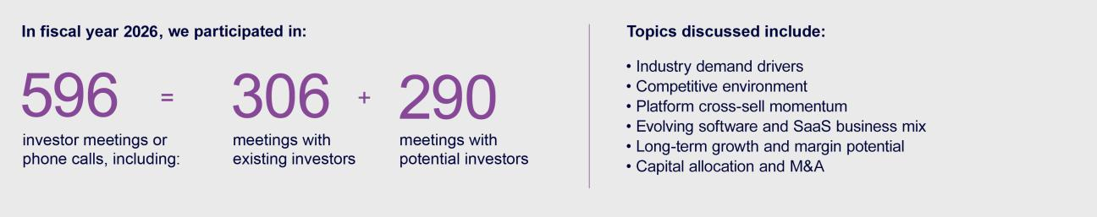

We maintain a quarterly stockholder outreach program, which includes proactive CEO and CFO post-earnings calls with our top stockholders, and subsequent engagement with all interested investors. Our CEO, CFO, Investor Relations Officer, and senior management participate in non-deal roadshows and conferences each quarter. In fiscal 2026, we participated in 596 investor meetings or phone calls, including 306 meetings with existing stockholders and 290 meetings with potential investors.

How We Choose Directors

The NGC is responsible for evaluating the composition of our Board of Directors and carrying out due diligence with respect to prospective Board members. In doing so, the NGC considers the Company's evolving business needs to promote an appropriate mix of skills, experience, and backgrounds. In general, we believe the Board should include individuals with skills and experience in the following areas:

• | Cybersecurity | • | Go-to-Market | • | Global Strategy
• | Artificial Intelligence | • | Customer Success | • | Executive Leadership
• | SaaS and Cloud | • | Finance | • | Human Capital Management
• Engineering and Product Development |  | • | M&A and Integrations | • | Risk Management

In evaluating nominees, the NGC considers, among other things, depth and breadth of professional experience, integrity, the ability to exercise independent judgment, understanding of the Company's business and competitive environment, willingness to devote adequate time to Board duties, and how the candidate's skills complement those of other Board members. The NGC also considers the current size and composition of the Board, the needs of the Board and its committees, and factors such as professional background, independence, and potential conflicts of interest. The NGC's evaluation generally involves a review of background materials, internal discussions, and interviews with selected candidates as appropriate, and the NGC may engage third-party search firms to assist in identifying and evaluating potential nominees.

Consistent with the criteria described above and the Board's skills matrix (see "Board Composition," page 5), the NGC is actively engaged in identifying and evaluating prospective director candidates.

Stockholders who wish to recommend director candidates may submit recommendations in writing to the Secretary of the Company at 1 Commvault Way, Tinton Falls, New Jersey 07724 or by email at CorporateSecretary@commvault.com. Recommendations must include the information that would be required under the advance notice provisions of our bylaws and the rules of the SEC. Director candidate recommendations will be evaluated against the same criteria applied to candidates identified through other means. Stockholders also have the right to directly nominate director candidates pursuant to the advance notice and proxy access provisions of our bylaws, as described under "Additional Information About the Annual Meeting."

18 COMMVAULT SYSTEMS, INC. | 2026 PROXY STATEMENT

Table of Contents

CORPORATE GOVERNANCE | BOARD COMMITTEES

Board Committees

The Board of Directors has four standing committees. Each committee operates under a written charter that is available on the “Investor Relations— Corporate Governance—Overview” section of our website. The members of all of the committees are independent directors under the Nasdaq listing standards.

Members:


Mr. Sanders

(Chair) and Ms. Bejar Meetings in fiscal 2026: 7

Audit Committee

The Audit Committee is responsible for:

- the appointment, compensation, and oversight of our independent auditors
- the integrity of our financial statements

- our independent auditor’s performance, qualifications, and independence
- our compliance with legal and regulatory requirements and our compliance program generally
- the performance of our internal audit function and independent auditors

- related person transactions

- our cybersecurity risk management strategies, security program oversight, and IT compliance programs
- whistleblower complaints (Integrity Counts) and related investigations

- our audit results

- our critical accounting policies and practices

- the adequacy of our disclosure controls and procedures
- management of significant financial risk

The Audit Committee is also responsible for Commvault’s Code of Ethics for Senior Financial Officers remaining current and for approving any non-auditing services performed by our independent auditors.

The Audit Committee relies on the knowledge and expertise of our management, the internal auditors, and the independent auditors in carrying out its oversight responsibilities.

The members of the Audit Committee meet all of the heightened independence standards for audit committee membership as set forth in the Nasdaq listing standards and SEC rules. The Board of Directors has determined that each of Mr. Sanders and Ms. Bejar qualify as an “audit committee financial expert” as that term is defined in SEC rules, and that each is able to read and understand fundamental financial statements.

Members:


Ms. Lee

(Chair) and Messrs. Geeslin and Moran

Meetings in fiscal 2026: met 7 times and acted by unanimous written consent 12 times

Compensation Committee

The Compensation Committee is responsible for overseeing Commvault’s compensation and benefit plans, including all compensation arrangements for executive officers and directors. In particular, the Compensation Committee sets the compensation of our CEO and reviews and approves our CEO’s recommendations regarding the compensation of our other executive officers. Additionally, the Compensation Committee oversees:

• executive employment agreements | • assessment of risk arising from compensation practices
• stock plans and incentive compensation awards, including the | and policies
Company’s equity delegation and clawback policies

All members of the Compensation Committee meet the heightened independence standards for compensation committee members set forth in the Nasdaq listing standards.

19 COMMVAULT SYSTEMS, INC. | 2026 PROXY STATEMENT

Table of Contents

CORPORATE GOVERNANCE | BOARD COMMITTEES

Members:


Mses. Bejar

(Chair) and Lee, and Mr.

Sanders

Meetings in fiscal 2026: 4


Nominations and Governance Committee

The NGC is responsible for identifying and recommending to our Board of Directors appropriate director nominee candidates and providing oversight with respect to corporate governance matters, including reviewing our corporate governance program and approving Corporate Governance Guidelines and other governance policies, including the Code of Ethics. The NGC also oversees:

- Commvault’s sustainability efforts

- succession planning

- annual review of all Board committee charters

- annual performance evaluations of the CEO, Board and its committees

- recommendations for directors to serve on Board committees

- human capital management

Operating Committee

The general purpose of the Operating Committee is to provide oversight of various corporate and operational matters as determined by the Board and management. The Operating Committee reviews Commvault’s annual budget and works with management to establish margin targets and a balanced capital allocation policy. The Operating Committee also oversees earnings announcements and guidance. The focus of the Operating Committee is on achieving profitable growth, return on investment, and stockholder value.

Members:

Messrs. Shenkman

(Chair), Geeslin, and Moran

Meetings in fiscal 2026: 9

Meetings of the Board

During the fiscal year ended March 31, 2026, our Board of Directors held five meetings, made up of both virtual and in person meetings. As required by law, each director attended at least 75% of the aggregate number of meetings of the Board and of the committees on which they served during fiscal 2026.

The Board of Directors meets in executive session, without management, at every Board meeting. During fiscal 2026, Mr. Adamo, as the independent Chair of the Board, led these executive sessions and acted as primary spokesperson in communicating matters arising out of these sessions to management.

Because we do not regularly schedule a Board of Directors meeting to coincide with our Annual Meeting, director attendance at our Annual Meeting is encouraged but not required.

How to Contact Our Board

Stockholders can contact our Board of Directors to provide comments, report concerns, or ask questions at the following address:

Corporate Secretary

Commvault Systems, Inc.

1 Commvault Way

Tinton Falls, New Jersey 07724

Email: CorporateSecretary@commvault.com

Communications are distributed to our Board of Directors, or to individual directors as appropriate, depending on the nature of the communication. You may also communicate online with our Board of Directors as a group through the Investor Relations section of our website at www.commvault.com. All relevant communications directed to the full Board will be forwarded to the Chair of the Audit Committee or the Chair of the NGC, who will determine when it is appropriate to distribute such communications to other members of the Board or to management.

20 COMMVAULT SYSTEMS, INC. | 2026 PROXY STATEMENT

Table of Contents

CORPORATE GOVERNANCE | GOVERNANCE DOCUMENTS

Governance Documents

Our Code of Ethics applies to all of our directors, employees (including executives and officers), contractors, and business partners. The Code establishes our legal and ethical standards of behavior, and supports our commitments to human rights, respectful treatment of others, and equal opportunity, among other core values. Employees and interested third parties can report concerns or suspected violations of the Code, other Company policies, or violations of the law to Commvault's Chief Legal and Trust Officer or Chief People Officer directly or through Integrity Counts, a confidential and anonymous reporting hotline at commvault@integritycounts.ca or by navigating to the website https://integritycounts.ca/org/commvault. The Code and the following additional governance documents are available in the Investor Relations section of our website under "Corporate Governance—Overview":

• Ethics and Integrity Reporting Policy |  | • Workplace Health and Safety Policy
• | Insider Trading Policy | • | Corporate Governance Guidelines
• Supplier Code of Conduct |  | • | Sanctions Guide
• | Human Rights Policy | • Amended and Restated Bylaws
• Code of Ethics for Senior Financial Officers |  | • Board Committee and Disclosure Committee Charters

If we were to amend or waive any provision of the Code of Ethics or Code of Ethics for Senior Financial Officers applicable to our directors and executive officers (including senior financial officers), we intend to satisfy our disclosure obligations, if any, with respect to any such waiver or amendment by posting such information on our website at the address and location specified above.

The Company has adopted and maintains an Insider Trading Policy that governs the purchase, sale, and other dispositions of its securities by its officers, directors, and employees that are reasonably designed to promote compliance with insider trading laws, rules and regulations and applicable listing standards. A copy of the Company’s Insider Trading Policy is filed as Exhibit 19.1 to the Company’s Annual Report on Form 10-K for the fiscal year ended March 31, 2026.

Transactions With Related Persons

The Board of Directors recognizes that transactions between the Company and certain related persons present a heightened risk of conflicts of interest. The Company has adopted a written related person transaction policy setting forth the policies and procedures for the identification, review, and approval of related person transactions. This policy covers any transaction, arrangement, or relationship (or any series thereof) in which the Company is a participant, the amount involved exceeds $120,000, and in which any director, executive officer, beneficial owner of more than 5% of the Company's stock, any of their immediate family members, or any entity in which such persons have a significant interest, has a direct or indirect material interest. The Audit Committee reviews any such transaction based upon the applicable SEC rules, Nasdaq listing standards, and our Corporate Governance Guidelines, and may approve only those related person transactions that it determines in good faith to be in the best interest of the Company and its stockholders.

We did not enter into any related person transactions during the fiscal year ended March 31, 2026.

Compensation Committee Interlocks and Insider Participation

During fiscal 2026, no member of the Compensation Committee was an officer or employee of Commvault, and no member of the Compensation Committee is a former officer of Commvault. No member of the Compensation Committee had any relationship with Commvault requiring disclosure under Item 404 of Regulation S-K. During fiscal 2026, none of our executive officers served as a member of the board of directors or compensation committee of any other entity that had one or more of its executive officers serving on our Board or Compensation Committee.

21 COMMVAULT SYSTEMS, INC. | 2026 PROXY STATEMENT

Table of Contents

CORPORATE GOVERNANCE | DIRECTOR COMPENSATION

Director Compensation

ANNUAL CASH AND EQUITY RETAINERS

Our Compensation Committee determines the amount and form of any fees and expense reimbursements that non-employee directors receive for or in connection with their service on Commvault’s Board of Directors. In July 2025, the Compensation Committee engaged an external third-party compensation consultant, Compensia, to provide an assessment of our non-employee director compensation practices, including a peer analysis of practices related to cash compensation, equity compensation, and equity vesting. Based on the results of this analysis, the Compensation Committee approved the following changes to director compensation intended to better align our compensation with the median of our peer group:

- Director equity compensation was increased to $220,000 from $215,000.

- The annual cash retainer for the NGC chair was increased to $15,000 from $12,000, and for NGC members to $6,000 from $5,000.

- The annual cash retainer for the Operating Committee chair was increased to $20,000 from $12,000, and for Operating Committee members to $10,000 from $5,000.

For more information about our peer group, see “Proposal No. 2: Advisory Vote on Executive Compensation—How Compensation Decisions Are Made— Role of the Peer Group.”

Compensation earned by our non-employee directors for their service as members of the Board of Directors or any committee of the Board was as follows:

Who receives | Amount | Form
Every non-employee director | $42,000 | Cash annual retainer
Independent Board Chair | $110,000 | Additional cash annual retainer
Audit Committee Chair | $30,000 | Additional cash annual retainer
Compensation Committee Chair | $20,000 | Additional cash annual retainer
Operating Committee Chair | $20,000 | Additional cash annual retainer
NGC Chair | $15,000 | Additional cash annual retainer
Audit Committee members | $15,000 | Additional cash annual retainer
Compensation Committee members | $10,000 | Additional cash annual retainer
Operating Committee members | $10,000 | Additional cash annual retainer
NGC members | $6,000 | Additional cash annual retainer

In addition, every non-employee director received an equity retainer at a target value of $220,000 granted on August 7, 2025 in the form of 1,189 restricted stock units (“RSUs”), except for Mr. Haydon, who received a prorated grant of 1,027 RSUs in connection with his appointment to the Board on October 17, 2025. The RSUs will vest on the later of the one year anniversary of the grant date or the next Annual Meeting following the grant date.

RSUs granted to the non-employee directors were issued under our 2016 Omnibus Incentive Plan (“2016 Plan”). See “Long-Term Equity Incentive Awards” in the “Fiscal 2026 Compensation Decisions” section for more information about RSUs granted under this plan. We also reimburse our non-employee directors for their reasonable expenses incurred in attending meetings of our Board or Board committees.

22 COMMVAULT SYSTEMS, INC. | 2026 PROXY STATEMENT

Table of Contents

CORPORATE GOVERNANCE | DIRECTOR COMPENSATION

The following table shows the specific compensation received for services rendered to us by our non-employee directors in fiscal 2026. Mr. Mirchandani does not receive any additional compensation for his service on the Board.

 | Fees Earned or
Name | Paid in Cash | Stock Awards(1) | Total
Nicola Adamo | $152,000 | $220,643 | $372,643
Martha Bejar | $71,250 | $220,643 | $291,893
Keith Geeslin | $60,750 | $220,643 | $281,393
William Geoffrey Haydon⁽²⁾ | $11,875 | $174,508 | $186,383
Vivie “YY” Lee | $67,750 | $220,643 | $288,393
Chuck Moran | $60,750 | $220,643 | $281,393
Allison Pickens⁽³⁾ | $15,500 | $220,643 | $236,143
Shane Sanders | $77,750 | $220,643 | $298,393
Arlen Shenkman⁽⁴⁾ | $70,000 | $220,643 | $290,643

- The amounts in this column represent the grant date fair value of 1,189 RSUs granted during the fiscal year indicated, except for Mr. Haydon, who received a prorated grant of 1,027 RSUs in connection with his appointment to the Board on October 17, 2025, as computed in accordance with FASB ASC Topic 718, all of which are outstanding as of March 31, 2026. See "Note 11. Stock Plans" in Item 8 of our Annual Report filed on Form 10-K for the fiscal year ended March 31, 2026, for a discussion of all assumptions made by us in determining the grant date fair value of such awards.

- Mr. Haydon was appointed to the Board effective October 17, 2025 and received pro rata compensation. Mr. Haydon resigned from the Board effective April 13, 2026 in connection with his appointment as President of Customer and Field Operations. Mr. Haydon’s outstanding RSU award remained eligible to vest in accordance with its terms.

- Ms. Pickens resigned from the Board effective October 15, 2025. Ms. Pickens’ cash compensation was pro-rated through her resignation date. Ms. Pickens’ outstanding RSU award remained eligible to vest in accordance with its terms.

- Mr. Shenkman is not standing for reelection at the 2026 Annual Meeting.

Stock Ownership Guidelines for Independent Directors

The NGC has adopted Share Ownership Guidelines for our independent directors to align the interests of our directors with the interests of our stockholders and the long-term performance of the Company. Each independent director is required to hold shares of Commvault Common Stock with a value equal to five times the base annual cash retainer within five years of the date the director first joined the Board. Each independent director who is required to be in compliance with these guidelines owns the requisite amount of stock.

23 COMMVAULT SYSTEMS, INC. | 2026 PROXY STATEMENT

Table of Contents

CORPORATE GOVERNANCE | SECURITY OWNERSHIP OF MANAGEMENT AND CERTAIN BENEFICIAL OWNERS

Security Ownership of Management and Certain Beneficial Owners

MANAGEMENT

The following table shows, as of May 31, 2026, the number of shares of our Common Stock (the only class of voting securities outstanding) beneficially owned by: (i) each current director and nominee for director; (ii) each named executive officer (defined below); and (iii) all directors and current executive officers as a group. The number of shares of our Common Stock beneficially owned by a person includes shares of Common Stock issuable with respect to options, RSUs (including performance-based stock units), and convertible securities held by the person that are exercisable, convertible, or will vest within

60 days. The percentage of our Common Stock beneficially owned by a person is based on 41,421,689 shares of common stock outstanding as of May 31, 2026, and assumes the person has exercised all options, vested in all RSUs, and converted all convertible securities, that are exercisable, convertible, or will vest within 60 days, and that no other person exercised any of their options, vested in any of their RSUs, or converted any of their convertible securities. Except as otherwise noted, each individual exercises sole voting power and investment power over the shares of voting securities shown.
 | Shares of Common | Percent of Common
 | Stock Owned | Stock Outstanding
Directors
Nicola Adamo | 16,178 | *
Martha Bejar | 5,847 | *
Keith Geeslin | 32,991 | *
Vivie "YY" Lee | 12,785 | *
Sanjay Mirchandani | 239,567 | *
Chuck Moran | 12,497 | *
Shane Sanders | 6,222 | *
Arlen Shenkman⁽¹⁾ | 15,620 | *
Named Executive Officers that are not Directors
Gary Merrill | 13,848 | *
Danielle Abrahamsen | 694 | *
William Geoffrey Haydon⁽²⁾ | — | —
Jen DiRico⁽³⁾ | 833 | *
All directors and executive officers as a group (13 individuals) | 357,082 | *

- Less than 1%

- Mr. Shenkman is not standing for reelection at the 2026 Annual Meeting.

- Mr. Haydon served as a member of the Board from October 17, 2025 to April 13, 2026, when he resigned in connection with his appointment as President of Customer and Field Operations. Mr. Haydon is included in this table as a current executive officer of the Company.

- Beneficial ownership information for Ms. DiRico is based solely on the Company’s records during the period of her employment and any reports on Form 4 filed by or on behalf of Ms. DiRico following her resignation from the Company effective December 31, 2025.

CERTAIN OTHER STOCKHOLDERS

The following table sets forth, as of May 31, 2026, except to the extent otherwise indicated, certain information regarding the persons known by us to be the beneficial owner of more than 5% of our outstanding Common Stock. Except as otherwise noted, each entity exercises sole voting power and investment power over the shares of voting securities shown.

Name of Beneficial Owner | Shares of Common | Percent of Common
Name of Beneficial Owner | Stock Owned | Stock Outstanding
BlackRock, Inc.⁽¹⁾ | 5,737,508 | 13.9%
Vanguard Portfolio Management, LLC⁽²⁾ | 3,648,095 | 8.8%
Vanguard Capital Management, LLC⁽³⁾ | 2,320,857 | 5.6%

- Based solely on a Schedule 13G/A filed on April 29, 2025, by BlackRock, Inc., except for Percent of Common Stock Outstanding. BlackRock, Inc. reported it held 5,677,503 shares with sole voting power, 0 shares with shared voting power, 5,737,508 shares with sole dispositive power, and 0 shares with shared dispositive power. The address for BlackRock, Inc. is 50 Hudson Yards New York, NY 10001.

- Based solely on a Schedule 13G filed on April 29, 2026, by Vanguard Portfolio Management, LLC, except for Percent of Common Stock Outstanding. Vanguard Portfolio Management, LLC reported it held 38,458 shares with sole voting power, 0 shares with shared voting power, 3,648,095 shares with sole dispositive power and 0 shares with shared dispositive power. The address for Vanguard Portfolio Management, LLC is 100 Vanguard Blvd., Malvern, PA 19355.

- Based solely on a Schedule 13G filed on April 29, 2026, by Vanguard Capital Management, LLC, except for Percent of Common Stock Outstanding. Vanguard Capital Management, LLC reported it held 336,922 shares with sole voting power, 0 shares with shared voting power, 2,320,857 shares with sole dispositive power and 0 shares with shared dispositive power. The address for Vanguard Capital Management, LLC is 100 Vanguard Blvd., Malvern, PA 19355.

24 COMMVAULT SYSTEMS, INC. | 2026 PROXY STATEMENT

Table of Contents

CORPORATE GOVERNANCE | DELINQUENT SECTION 16(a) REPORTS

Delinquent Section 16(a) Reports

Section 16(a) of the Securities Exchange Act of 1934, as amended, requires the Company’s directors, executive officers, and beneficial owners of more than 10% of any class of its equity securities to file with the SEC initial reports of ownership (Form 3) and reports of changes in ownership (Forms 4 and 5).

Based solely on a review of the copies of such reports and written representations from reporting persons, the Company believes that all Section 16(a) filing requirements applicable to its officers, directors, and greater-than-10% beneficial owners were complied with during the fiscal year ended March 31, 2026, except that, due to administrative delays by the Company in obtaining EDGAR filing

codes following executive appointments, one Form 3 for Mr. William Geoffrey Haydon, Director, and one Form 3 for Ms. Danielle Abrahamsen, Chief Accounting Officer, were each filed late.

25 COMMVAULT SYSTEMS, INC. | 2026 PROXY STATEMENT

Table of Contents


WHAT AM I VOTING ON?

We are asking stockholders to approve, on a non-binding advisory basis, the compensation of our named executive officers.

VOTE RECOMMENDATION

FOR the resolution approving our executive compensation program.

Every year we give stockholders the opportunity to approve, on a non-binding, advisory basis, the compensation of our named executive officers (“NEOs”) as set forth in the following “Compensation Discussion and Analysis.”

Our executive compensation program is designed to attract, motivate, and reward talented executives who possess the skills required to formulate and drive our Company’s strategic direction and operational execution to create stockholder value. Our compensation practices, which balance long-term and short-term awards, are structured to competitively pay for performance, to encourage decision-making aligned with the Company’s long-term interests, and to promote and support our business. We encourage you to read the Compensation Discussion and Analysis for complete details about our executive compensation program, including information about the fiscal 2026 compensation of our NEOs.

We are asking stockholders to indicate their support for our NEO compensation as described in this proxy statement. This proposal, commonly known as “say-on-pay,” is not intended to address any specific item of compensation, but rather the overall executive compensation program and the related philosophy, policies, and practices. We encourage you to vote FOR the following resolution:

“RESOLVED, that the compensation paid to Commvault’s NEOs, as disclosed pursuant to the compensation disclosure rules of the SEC, including the Compensation Discussion and Analysis, compensation tables, and any related material disclosed in Commvault’s proxy statement, is hereby APPROVED.”

The say-on-pay vote is advisory, and therefore not binding on our Company, the Compensation Committee, or the Board of Directors. However, the Board of Directors and the Compensation Committee value the opinions of our stockholders. If the voting results indicate there is any significant concern about our executive officer compensation program, we will consider those concerns and evaluate whether any actions are necessary to address them.

Because this is a non-binding, advisory vote, there is no specific approval requirement. However, the Board of Directors will consider that the stockholders have approved executive compensation on an advisory basis if this proposal receives the affirmative vote of a majority of the votes cast (in person or by proxy).

The Board of Directors recommends that you vote FOR the approval of Commvault’s executive compensation.

26 COMMVAULT SYSTEMS, INC. | 2026 PROXY STATEMENT

Table of Contents


Compensation Discussion and Analysis

This section discusses the compensation of the following NEOs, who served as executive officers during the fiscal year ended March 31, 2026.


Ms. Jen DiRico, who served as our Chief Financial Officer (“CFO”) and was a named executive officer (“NEO”) for the fiscal year ended March 31, 2026, resigned effective December 31, 2025. Effective January 1, 2026, Ms. Danielle Abrahamsen, then Chief Accounting Officer (“CAO”), assumed the roles of principal financial officer and principal accounting officer. On April 13, 2026, Mr. Gary Merrill, who served as the Company’s Chief Commercial Officer throughout fiscal 2026, was appointed CFO, succeeding Ms. Abrahamsen as principal financial officer. Also on April 13, 2026, Mr. Geoff Haydon assumed the role of President of Customer and Field Operations. As Mr. Haydon's appointment occurred after the end of fiscal 2026, his executive compensation will first be reflected in the Company's fiscal 2027 proxy statement.

Table of Contents

Executive Summary |  |  |  |  |  |  |  |  |  |  |  |  |  |  |  | 28
 | Compensation Philosophy |  |  |  |  |  |  |  |  |  |  |  |  |  |  | 28
 | Mix of Compensation Elements |  |  |  |  |  |  |  |  |  |  |  |  |  |  | 30
 | How Compensation Decisions Are Made |  |  |  |  |  |  |  |  |  |  |  |  |  |  | 31
Fiscal 2026 Compensation Decisions |  |  |  |  |  |  |  |  |  |  |  |  |  |  |  | 33
Compensation Committee Report |  |  |  |  |  |  |  |  |  |  |  |  |  |  |  | 40
Compensation Tables |  |  |  |  |  |  |  |  |  |  |  |  |  |  |  | 41
 | Summary Compensation Table |  |  |  |  |  |  |  |  |  |  |  |  |  |  | 41
 | Fiscal 2026 Grants of Plan-Based Awards Table |  |  |  |  |  |  |  |  |  |  |  |  |  |  | 42
 | Fiscal 2026 Outstanding Equity Awards at Fiscal Year End Table |  |  |  |  |  |  |  |  |  |  |  |  |  |  | 43
 | Fiscal 2026 Stock Vested Table |  |  |  |  |  |  |  |  |  |  |  |  |  |  | 44
Pension Benefits and Deferred Compensation |  |  |  |  |  |  |  |  |  |  |  |  |  |  |  | 44
Individual Agreements |  |  |  |  |  |  |  |  |  |  |  |  |  |  |  | 44
Estimated Payments and Benefits Upon Termination or Change In Control |  |  |  |  |  |  |  |  |  |  |  |  |  |  |  | 45
CEO Pay Ratio |  |  |  |  |  |  |  |  |  |  |  |  |  |  |  | 46
Pay Versus Performance |  |  |  |  |  |  |  |  |  |  |  |  |  |  |  | 47

27 COMMVAULT SYSTEMS, INC. | 2026 PROXY STATEMENT

Table of Contents

CD&A | EXECUTIVE SUMMARY

Executive Summary

We believe the skill, talent, judgment, and dedication of our executive officers are critical to Commvault’s long-term value. Therefore, our objective in setting compensation policies for our NEOs is to align pay with performance, while at the same time providing fair, reasonable, and competitive compensation that will allow us to attract, retain, and reward superior executive talent. The Compensation Committee strongly believes that executive compensation should align our executive officers’ interests with those of our stockholders by rewarding achievement of specific annual, long-term, and strategic company goals, with the ultimate objective of enhancing long-term stockholder value.

FISCAL 2026 COMPENSATION HIGHLIGHTS

Our fiscal 2026 compensation plans and payouts for our NEOs reflect our overarching philosophy of pay-for-performance. Highlights of our executive compensation program include:

- Competitive Base Salary: Base salaries are set to be competitive within our industry and are important in attracting and retaining talented executives.

- Challenging Annual Incentive: In fiscal 2026, the Compensation Committee approved target annual incentives for our NEOs that were eligible to be earned based on achievement of total revenue and non-GAAP EBIT goals and, for Mr. Merrill, Software-as-a-Service Annual Recurring Revenue, Software-as-a-Service Gross Revenue Retention, and Software Gross Revenue Retention. The Company's performance against these targets resulted in a company performance factor of 127% of target for Mr. Mirchandani and Ms. Abrahamsen and 135.5% for Mr. Merrill. The Compensation Committee also considered individual performance factors, including leadership contributions and assumption of the principal financial officer role, in determining the final annual incentive outcomes for Ms. Abrahamsen.

- Long-term Incentive Awards: We believe that stock awards with multi-year vesting are an effective tool for motivating our NEOs to drive long-term stockholder value. During fiscal 2026, 60% of the target value of the annual long-term equity incentive granted to Messrs. Mirchandani and Merrill and 50% of the target value of the annual long-term equity incentive granted to Ms. Abrahamsen was awarded in the form of performance-based equity. These grants included a mix of performance stock units (“PSUs”) tied to one, two and three-year goals as well as relative and absolute performance measurement.

Compensation Philosophy and Objectives

As a technology company, we operate in an extremely competitive and rapidly changing industry. When setting compensation policies for our executive officers, the Compensation Committee strives to align pay with performance; to provide fair, reasonable, and competitive compensation that will allow us to attract, retain, and reward superior executive talent; and to align our executive officers’ interests with those of our stockholders by rewarding achievement of specific annual, long-term, and strategic goals. To that end, the compensation opportunities provided to our executive officers include a mix of both cash and equity elements that reward performance as measured against pre-established goals and objectives. The specific goals that our current executive compensation program rewards are focused primarily on key financial and stockholder return measures that the Compensation Committee believes are the most direct drivers of long-term stockholder value creation.

Decisions with respect to the total compensation for our executive officers are based primarily upon an assessment of each individual’s performance and potential to enhance long-term stockholder value. Often, the Compensation Committee relies on judgment rather than rigid guidelines or formulas in determining the amount and mix of compensation for each executive officer. Factors affecting such judgment include performance compared to strategic goals established at the beginning of the fiscal year, the nature and scope of each executive’s responsibilities, and whether the executive conducts all activities in a manner consistent with our core Company values.

In addition, the Compensation Committee seeks to ensure that we maintain sound governance and compensation policies and practices. In designing and overseeing our executive compensation program, we strive to employ best practices and regularly assess our policies and practices.

What we do

- Align executive pay with short- and long-term performance.

- Require our CEO and directors to satisfy meaningful stock ownership requirements.

- Maintain a robust clawback policy that allows the Company to recover incentive-based compensation from current and former executives in the event of a financial restatement or other misconduct, consistent with applicable law and stock exchange requirements.

- Perform an annual review of our peer group to benchmark executive compensation.

- Conduct annual risk assessment of companywide compensation plans to identify any issues that could have a material adverse impact on the Company.

- Hold an annual advisory vote on executive compensation.

- Our Compensation Committee directly engages an independent compensation consultant, Compensia, to provide analysis for the annual executive compensation review and guidance on other executive compensation matters independent of management.

28 COMMVAULT SYSTEMS, INC. | 2026 PROXY STATEMENT

Table of Contents

CD&A | EXECUTIVE SUMMARY

What we do not do

- Provide guaranteed bonuses to our executive officers.

- Provide any excise tax reimbursement payments (including “gross-ups”) with respect to payments or benefits contingent upon a change in control of our Company.

- Offer pension arrangements, or non-qualified deferred compensation plans or arrangements to our executive officers, other than our 401(k) plan, which is open to all U.S.-based, salaried employees.

- Allow our employees, including our NEOs and the members of our Board of Directors, to engage in hedging transactions or pledging of our shares.

- Grant discounted stock options nor reprice underwater stock options.

29 COMMVAULT SYSTEMS, INC. | 2026 PROXY STATEMENT

Table of Contents

CD&A | EXECUTIVE SUMMARY

Mix of Compensation Elements

Our fiscal 2026 executive compensation program consists of three principal elements: base salary, annual cash incentive bonuses, and long-term equity incentive awards. Consistent with our pay for performance philosophy, the majority of target total direct compensation for the NEOs in fiscal 2026 consisted of incentive awards, particularly long-term equity incentive awards. The Compensation Committee believes that emphasizing equity-based compensation creates a strong incentive for our executives to build sustainable long-term stockholder value. The following table represents the different components of the CEO’s total compensation package. For more details on each individual compensation component, please see “Annual Incentive Plan” and “Long-Term Equity Incentive Awards” under “Fiscal 2026 Compensation Decisions” below.
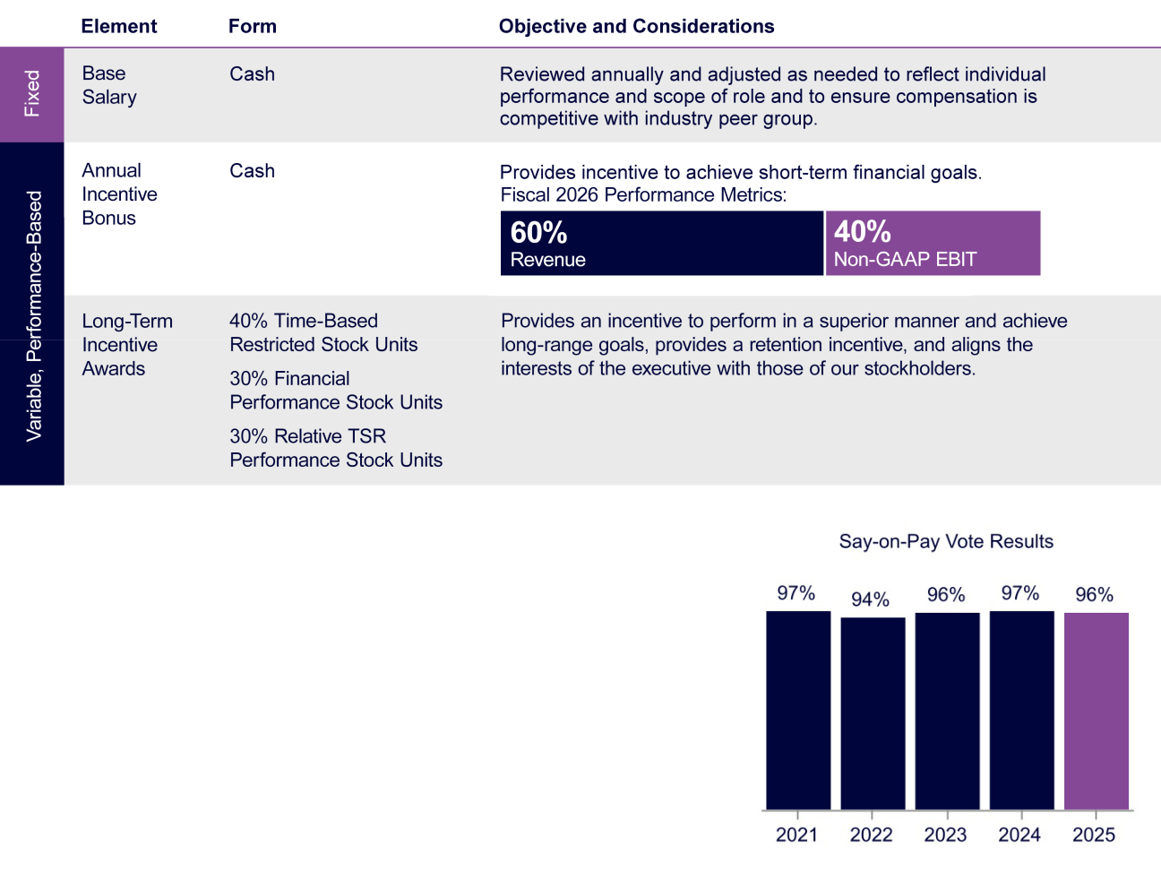

PRIOR STOCKHOLDER ADVISORY VOTE ON NAMED EXECUTIVE OFFICER COMPENSATION

In light of the 2025 say-on-pay vote, in which 96% of the votes cast were in favor of our executive compensation program, the Compensation Committee maintained a consistent approach for fiscal 2026. In particular, the Compensation Committee continued to emphasize pay-for-performance through the use of performance share awards that reward our executive officers only if they deliver value for our stockholders. The Compensation Committee will continue to consider input from our stockholders when making compensation decisions for our executive officers.

30 COMMVAULT SYSTEMS, INC. | 2026 PROXY STATEMENT

Table of Contents

CD&A | HOW COMPENSATION DECISIONS ARE MADE

How Compensation Decisions Are Made

The Compensation Committee’s goal is generally to target elements of compensation within a competitive range, using a balanced approach that does not use rigid percentiles to determine target pay levels for each compensation element. For fiscal 2026, the Compensation Committee reviewed each element of compensation described below and set the target total direct compensation opportunities of our executive officers after taking into consideration the following factors:

- market data, including practices among companies in our compensation peer group;

- each executive officer’s scope of responsibilities;

- each executive officer’s tenure, skills, and experience;

- internal pay equity across the executive management team;

- our overall performance, taking into consideration performance versus internal plans and industry peers;

- the recommendations of our CEO; and

- general market conditions.

The Compensation Committee does not assign relative weights or rankings to any of these factors and does not solely use any quantitative formula, target percentile or multiple for establishing compensation among the executive officers or in relation to the competitive market data.

ROLE OF COMPENSATION COMMITTEE

The Compensation Committee is responsible for setting the compensation of our CEO and for reviewing and approving our CEO’s recommendations regarding the compensation of our other executive officers. The Compensation Committee retains discretion to modify any bonus or incentive payout that would otherwise be payable, notwithstanding the achievement of any related performance goals.

ROLE OF EXECUTIVE OFFICERS

Each year, the CEO reviews the performance and compensation of each of the executive officers and makes recommendations to the Compensation Committee with respect to their compensation for the coming year. In addition, our CEO, CFO, and Chief People Officer support the Compensation Committee in its work by providing information relating to our financial plans and personnel-related data.

ROLE OF THE COMPENSATION CONSULTANT

The Compensation Committee has authority under its charter to engage outside advisors and experts for advice as appropriate. In preparation for fiscal 2026, the Compensation Committee engaged the services of Compensia, Inc., a national compensation consulting firm, as the Compensation Committee’s consultant to provide advice on matters relating to the compensation of our executive officers and non-employee directors. Compensia provided the Compensation Committee with an analysis of industry sector competitive market data regarding executive compensation, information on compensation trends, and peer group and general market data, as well as assistance with the parameters used to determine the peer group, base salaries, incentive plan design, and the overall structure of our executive compensation program.

The Compensation Committee regularly reviews the objectivity and independence of the advice provided by its compensation consultant. The Compensation Committee has evaluated Compensia’s engagement and, based on the six factors for assessing independence and identifying potential conflicts of interest that are set forth in SEC rules and Nasdaq standards (and such other factors as were deemed relevant under the circumstances), the Compensation Committee has determined that its relationship with Compensia and the work of Compensia on behalf of the Compensation Committee did not raise any conflict of interest.

31 COMMVAULT SYSTEMS, INC. | 2026 PROXY STATEMENT

Table of Contents

CD&A | HOW COMPENSATION DECISIONS ARE MADE

ROLE OF THE PEER GROUP

In preparation for fiscal 2026, the Compensation Committee engaged Compensia to conduct a competitive market analysis for purposes of evaluating our base salaries, annual cash bonus opportunities, and long-term equity incentive plan. The data from this analysis was used to ensure that our executive compensation program was optimally structured to attract, motivate, retain, and reward our highly experienced management team, to keep management focused during our expected period of growth, and to align our compensation practices with comparable technology industry companies.

In developing the peer group, the Compensation Committee targeted U.S.-headquartered companies within similar industries and of a similar size as the Company. In particular, the Compensation Committee targeted direct competitors and other business application software companies. The peer companies were also evaluated based on two financial criteria:

- Revenue: Target approximately 0.5x to 2.0x the Company’s trailing 12-month revenue; and

- Market Capitalization: Target approximately 0.3x to 3.0x the Company’s market capitalization

Criteria are not necessarily “gating” items; companies that do not satisfy one or more criteria may be included if deemed a reasonable fit across other selection criteria.

The companies included in the peer group for fiscal 2026 were:


ACI Worldwide | Gitlab | Rapid7
Blackbaud | Informatica | Rubrik
Box | Nutanix | SentinelOne
Confluent | Progress Software | SolarWinds
DigitalOcean Holdings | Pure Storage | Tenable Holdings
Dynatrace | Qualys | Varonis Systems

32 COMMVAULT SYSTEMS, INC. | 2026 PROXY STATEMENT

Table of Contents

CD&A | FISCAL 2026 COMPENSATION DECISIONS

Fiscal 2026 Compensation Decisions

We are committed to competitive and equitable pay practices that align with market standards. This approach promotes fairness and reinforces our ability to attract and retain top talent while supporting our long-term growth and future performance trajectory.

BASE SALARY

The Compensation Committee generally compares our executive officer base salaries to the 25th–75th percentile of the competitive market data in the analysis prepared by its compensation consultant.

Typically, base salary levels are reviewed annually as part of our performance review process, as well as upon a promotion or other change in job responsibility. In addition to considering the competitive market analysis when setting base salaries for fiscal 2026, the Compensation Committee also evaluated the scope of, and accountability associated with, each executive officer’s position and the overall experience of each executive officer. The table below shows the fiscal 2026 and 2025 base salary rates for each NEO.

Name and Principal Position Held | Fiscal 2026 Salary | Fiscal 2025 Salary | Percentage Increase
Sanjay Mirchandani | $700,000 | $645,000 | 9%
President and CEO | $700,000 | $645,000 | 9%
Gary Merrill | $475,000 | $460,000 | 3%
CCO | $475,000 | $460,000 | 3%
Danielle Abrahamsen | $340,000 | $300,000 | 13%
CAO | $340,000 | $300,000 | 13%
Jen DiRico⁽¹⁾ | $485,000 | $450,000 | 8%
Former CFO | $485,000 | $450,000 | 8%

- Ms. DiRico resigned from the Company effective December 31, 2025, and received a prorated salary for the portion of fiscal 2026 during which she served as CFO.

ANNUAL INCENTIVE PLAN

During fiscal 2026, Messrs. Mirchandani and Merrill and Mses. Abrahamsen and DiRico each participated in the Commvault Annual Incentive Plan (the “Fiscal 2026 AIP”), which made them eligible to earn a cash bonus based on achievement of pre-established corporate financial goals.

Target Annual Cash Incentive Opportunities

The Compensation Committee approved fiscal 2026 target cash incentive opportunities for the NEOs in April 2025 after considering a competitive market analysis, the scope of, and accountability associated with, each executive officer’s position, the performance of each executive officer since the last annual performance review and the overall experience of each executive officer.

Executive | Fiscal 2026 Salary | Target Annual Cash Incentive (%) | Target Annual Cash Incentive ($)(1)
Sanjay Mirchandani | $700,000 | 125% | $875,000
Gary Merrill | $475,000 | 100% | $475,000
Danielle Abrahamsen | $340,000 | 45% | $153,000
Jen DiRico | $485,000 | 70% | $339,500

- Cash bonus payments under the Fiscal 2026 AIP could range from zero to 200% of target.

33 COMMVAULT SYSTEMS, INC. | 2026 PROXY STATEMENT

Table of Contents

CD&A | FISCAL 2026 COMPENSATION DECISIONS

Performance Measures

In April 2025, the Compensation Committee selected total revenue (weighted 60%) and non-GAAP EBIT (weighted 40%) as the performance metrics for the Fiscal 2026 AIP for our NEOs. These metrics were selected because the Compensation Committee believes that, at this stage of our development, revenue growth and profitability are important measures of Commvault’s financial performance and are correlated to increasing stockholder value. Revenue and non-GAAP EBIT are key measures the Company uses to evaluate its performance. Accordingly, these metrics are closely aligned with how management evaluates and operates the business.

For purposes of the Fiscal 2026 AIP, the Compensation Committee set the various performance levels for these performance metrics and the payout amounts for each performance level as shown below.

For Mr. Mirchandani

Metric | Weight | Threshold Attainment | Target Attainment | Maximum Attainment
Metric | Weight | (50% payout) | (100% payout) | (200% payout)
Revenue | 60% | 88% | 100% | 108%
Non-GAAP EBIT | 40% | 85% | 100% | 106%

If actual performance falls between the specified goals, the payout percentage is calculated on a linear basis.

For Mr. Merrill

Because Mr. Merrill served as Chief Commercial Officer, the Compensation Committee designed his incentive structure to emphasize revenue performance. His incentive opportunity was based on Total Revenue (40%), Software-as-a-Service Annual Recurring Revenue (20%), Software-as-a-Service Gross Revenue Retention (10%), and Software Gross Revenue Retention (10%). Given his ability to earn incentive compensation incrementally based on quarterly performance, the Compensation Committee expected that payout levels for the revenue-related metrics could differ from those of the other NEOs. The remaining 20% of his annual incentive opportunity was based on non-GAAP EBIT, the same as the annual goal established for the other NEOs.

For Ms. Abrahamsen

The actual bonus paid to Ms. Abrahamsen is determined based on the same performance metrics applicable to the CEO, except that, 50% of her bonus is based on financial metrics and 50% is based on an individual performance modifier.

FISCAL 2026 ANNUAL CASH INCENTIVE PLAN ACHIEVEMENT

In May 2026, the Compensation Committee determined that our achievement for the revenue and non-GAAP EBIT portions of the Fiscal 2026 AIP were as follows:

 | Achievement | Target | Achievement | Payout | Weighting | Weighted
 | (in millions) | (in millions) | vs. Target | Factor | Weighting | Payout
Revenue | $1,184 | $1,137 | 104.1% | 151.3% | 60.0% | 90.8%
Non-GAAP EBIT | $238 | $244 | 97.5% | 91.7% | 40.0% | 36.2%
Total |  |  |  |  | 100.0% | 127.0%

34 COMMVAULT SYSTEMS, INC. | 2026 PROXY STATEMENT

Table of Contents

CD&A | FISCAL 2026 COMPENSATION DECISIONS

An individual performance multiplier was applied to Ms. Abrahamsen’s bonus due to her expanded role in fiscal 2026. As a result, the NEOs received the annual incentive bonuses shown below.

 | Target Annual Cash | Percentage of Target | Actual Annual
 | Incentive Opportunity | Annual Incentive Earned | Incentive Earned
Sanjay Mirchandani | $875,000 | 127.0% | $1,111,250
Gary Merrill | $475,000 | 135.5% | $643,626
Danielle Abrahamsen⁽¹⁾ | $153,000 | 200.0% | $306,000
Jen DiRico⁽²⁾ | $339,500 | N/A | $0

- Ms. Abrahamsen’s annual bonus was based on a weighting of 50% Company performance and 50% individual performance. In recognition of her expanded responsibilities as principal financial officer, her bonus payout was further increased.

- Ms. DiRico departed the Company on December 31, 2025. Her target annual cash incentive opportunity was established in early fiscal 2026 in connection with her service as CFO. Ms. DiRico received a draw under our executive compensation program in October 2025, similar to other executive officers. The Company was not required to claw back her draw in connection with her resignation.

LONG-TERM EQUITY INCENTIVE AWARDS

We provide long-term equity incentive awards pursuant to our 2016 Plan, which is designed to provide plan participants with appropriate incentives to achieve long-range goals and to align participants’ interests with those of our stockholders. The 2016 Plan permits the grant of stock options (“Options”), stock appreciation rights (“SARs”), restricted stock awards, performance stock awards, and other forms of equity based on, or related to, shares of our Common Stock, and cash incentive awards that are contingent on performance.

Generally, new executive officers receive a significant equity award when they commence employment. The size of each equity award is set at a level that we believe is appropriate to create a meaningful opportunity for stock ownership based upon our equity award grant guidelines, the individual’s position with Commvault, and the individual’s potential for future responsibility and promotion. The relative weight given to each of these factors varies from individual to individual. All equity awards granted to our executive officers are approved by the Compensation Committee.

When annual equity awards are granted, typically in May of each year, the Compensation Committee bases grants on an evaluation of each executive officer’s performance during the prior fiscal year, as well as our overall corporate financial performance. The terms of annual awards and the number and form of awards granted are designed to ensure the recipient has a meaningful incentive to remain a Commvault employee.

In preparation for granting annual equity awards in May 2025, the Compensation Committee reviewed a competitive market analysis prepared by Compensia to obtain data primarily related to the grant date fair value of the equity awards granted to similarly situated executives at companies in our compensation peer group. The annual equity awards granted to our NEOs in May 2025 were provided in three forms, and subject to the terms and conditions shown below.

Time-Based RSU awards | These awards vest 33% on the first anniversary of the grant date and 8.375% at the end of each
 | successive three-month period thereafter, generally subject to continued service on the vesting date.
Relative TSR PSU awards | Recipients may earn up to 300% of their target award based on Commvault’s TSR performance relative to
 | the Russell 3000 Index over equally weighted one-year, two-year, and three-year performance periods.
 | Earned shares, if any, vest at the end of each applicable performance period, generally subject to
 | continued service on the vesting date.
Financial PSU awards | Recipients may earn up to 300% of their target award based 100% on Commvault’s total ARR for fiscal
 | 2026. Earned shares, if any, vest 33% on the first anniversary of the grant date and 8.375% at the end of
 | each successive three-month period thereafter, generally subject to continued service on the vesting date.

Equity awards for Messrs. Mirchandani and Merrill and Ms. DiRico were granted in May 2025 and allocated 40% to Time-Based RSUs, 30% to Relative TSR PSUs, and 30% to Financial PSUs. Ms. Abrahamsen's May 2025 annual award was allocated 50% to Time-Based RSUs, 25% to Relative TSR PSUs, and 25% to Financial PSUs. Ms. Abrahamsen received an additional RSU award in February 2026 in connection with her assumption of the principal financial officer role in January 2026.

Based on the competitive market analysis prepared by Compensia, Commvault’s long-term equity grants are more heavily weighted toward performance-based awards than is the norm within our compensation peer group.

35 COMMVAULT SYSTEMS, INC. | 2026 PROXY STATEMENT

Table of Contents

CD&A | FISCAL 2026 COMPENSATION DECISIONS

Taking into consideration market data and the performance of individual executive officers, the Compensation Committee approved the following equity award grants for our NEOs during fiscal 2026:
 | Aggregate | Time-Based Restricted | Relative TSR | Financial PSU
Executive | Aggregate | Stock | Relative TSR | Financial PSU
Executive | Target Value | Unit Awards (#) | PSU Awards (#) | Awards (#)
Sanjay Mirchandani | $15,000,000 | 33,997 | 25,497 | 25,497
Gary Merrill | $4,500,000 | 10,199 | 7,649 | 7,649
Danielle Abrahamsen | $1,200,000 | 6,830 | 1,133 | 1,133
Jen DiRico | $4,850,000 | 10,992 | 8,244 | 8,244

Annual long-term incentive awards granted to Messrs. Mirchandani and Merrill and Mses. Abrahamsen and DiRico were approved in May 2025. Ms.

Abrahamsen received an additional RSU award in February 2026 in connection with her assumption of the principal financial officer role in January 2026.

In determining the number of shares granted to each NEO, the Compensation Committee converted the target value of each award to a number of units based on the 5-trading day average closing price of our Common Stock prior to the grant date.

Relative TSR PSU Awards

The Relative TSR PSU awards granted to our NEOs in fiscal 2026 will be earned based on our TSR measured relative to the Russell 3000 Index over three equally weighted overlapping one-year, two-year, and three-year performance periods. The payout opportunities for the Relative TSR PSU awards are as follows:

Relative TSR Percentile Rank | % of Target PSU Earned
< 25th | 0%
25th | 50%
50th | 100%
₇₅th | 150%
85th | 200%
₉₀th | 250%
₉₅th | 300%

The performance/payout scale is linear between shown points. Regardless of Commvault’s relative TSR performance, earned shares cannot exceed 100% of target if the Company’s stock price is lower at the end of the performance period than it was at the beginning.

The Compensation Committee regularly considers the appropriate time horizon for the performance measures used in the compensation plan for our NEOs. The Compensation Committee believes that using multiple-year vesting for the Relative TSR PSUs appropriately balances the one-year performance period for the annual bonus and the three-year vesting period for the time-based RSUs and Financial PSUs.

We consider relative TSR to be an objective, external benchmark for evaluating shareholder value creation. It serves as a valuable complement to our financial performance metrics, designed for a balanced and comprehensive assessment of our financial success.

Relative TSR PSU Awards - Performance Vesting

Grant | May | May | May | May | May
Grant | 2021 | 2022 | 2023 | 2024 | 2025
Actual Vest %
First annual tranche | 98% | 100% | 200% | 290% | 0%
Second annual tranche | 100% | 200% | 200% | 72% | TBD
Third annual tranche | 194% | 200% | 132% | TBD | TBD

36 COMMVAULT SYSTEMS, INC. | 2026 PROXY STATEMENT

Table of Contents

CD&A | FISCAL 2026 COMPENSATION DECISIONS

Earned units for each performance period, if any, vest following certification of results by the Compensation Committee.

For the one-year performance period for the May 2025 award, which ended May 15, 2026, the Company’s TSR ranked below the 25th percentile of the benchmark; accordingly, the Compensation Committee certified a payout of 0% of target for the first annual tranche of the Relative TSR PSU awards, reflecting the Company’s TSR ranking relative to the Russell 3000 for the one-year period ending May 2026.

For the two-year performance period for the May 2024 award, which ended May 15, 2026, the Company’s TSR ranked above the 25th percentile and below the 50th percentile of the benchmark; accordingly, the Compensation Committee certified a payout of 72% of target for the second annual tranche of the Relative TSR PSU awards, reflecting the Company’s TSR ranking relative to the Russell 3000 for the two-year period ending May 2026.

For the three-year performance period for the May 2023 award, which ended May 15, 2026, the Company’s TSR ranked above the 50th percentile and below the 75th percentile of the benchmark; accordingly, the Compensation Committee certified a payout of 132% of target for the third annual tranche of the Relative TSR PSU awards, reflecting the Company’s TSR ranking relative to the Russell 3000 for the three-year period ending May 2026.

Financial PSU awards

The Financial PSUs granted to our NEOs in fiscal 2026 were eligible to be earned based on our level of achievement against total ARR goals established at the beginning of fiscal 2026 and measured over a one-year performance period.
Achievement | ARR Achievement | ARR Achievement | % of Target PSU Earned
Achievement | (in millions) | (% of Target) | % of Target PSU Earned
Below Threshold | <$930 | <85% | —%
Threshold | $930 | 85% | 50%
Target | $1,100 | 100% | 100%
Maximum | $1,485 | 135% | 300%

Our actual ARR achievement for fiscal 2026 was equal to 102% of target. As a result, the Compensation Committee certified a payout equal to 111% of the target number of shares. Any shares earned based on our actual one-year financial performance were to vest 33% on the first anniversary of the grant date and 8.375% at the end of each successive three-month period thereafter.

OTHER BENEFITS

Our executive officers participate in retirement, health and welfare benefit programs that are substantially the same as the benefits for all other eligible Commvault employees. These benefits include a 50% matching contribution on the first 4% of eligible pay contributed to our 401(k) plan.

Our executive officers also are eligible to participate in our Employee Stock Purchase Plan (the “ESPP”). The ESPP is a stockholder approved plan under which substantially all employees may purchase the Company’s Common Stock through payroll deductions at a price equal to 85% of the lower of the fair market value of the Common Stock as of the beginning or the end of six-month offering periods. An employee’s payroll deductions under the ESPP are limited to 10% of salary, and employees may not purchase more than $25,000 of Common Stock during any calendar year. Mr. Mirchandani and Ms. Abrahamsen participated in the ESPP in fiscal 2026 and received nominal benefits related to the 15% discount on the purchase price of the Company’s Common Stock. Mr. Merrill and Ms. DiRico did not participate in the ESPP during fiscal 2026.

Our executive officers are generally not provided any perquisite or other benefits not available to our other employees. As disclosed in the Summary Compensation Table below, we do provide our CEO with access to a car and driver service. In addition, Messrs. Mirchandani and Merrill are provided access to executive medical and financial and estate planning support.

COMPENSATION RISK ASSESSMENT

We have reviewed our compensation policies and practices for all employees and concluded that any risks arising from our policies and practices are not reasonably likely to have a material adverse effect on the Company or its financials.

37 COMMVAULT SYSTEMS, INC. | 2026 PROXY STATEMENT

Table of Contents

CD&A | FISCAL 2026 COMPENSATION DECISIONS

INDIVIDUAL AGREEMENTS

As more fully described in the section entitled "Potential Payments Upon Termination or Change in Control—Individual Agreements," we have entered into individual agreements with each of our NEOs. We entered into these arrangements to acknowledge each executive's importance to Commvault and our stockholders and to attempt to avoid the distraction and loss of key management personnel that may occur in connection with rumored or actual fundamental corporate organizational changes. These agreements provide for payments and benefits upon specified qualifying termination events, in certain cases both inside and outside the change-in-control context.

STOCK OWNERSHIP GUIDELINES FOR THE CEO

The NGC has adopted Share Ownership Guidelines for our CEO to align the interests of our CEO with the interests of our stockholders and the long-term performance of the Company. The CEO is required to hold shares of Commvault Common Stock with a value equal to five times his current annual base salary within five years of the date he first became CEO. As of March 31, 2026, Mr. Mirchandani’s equity ownership exceeded this required level of ownership.

HEDGING PROHIBITION

Our Insider Trading Policy prohibits our employees (including officers) and directors from engaging in any hedging transactions with regard to Commvault Common Stock, including: short sales; purchases or sales of puts, calls, or other derivative securities; and purchases of financial instruments (such as prepaid variable forward contracts, equity swaps, collars, and exchange funds) or other transactions that hedge or offset, or are designed to hedge or offset, any decrease in the market value of Commvault securities. These hedging transactions enable the holder to continue to own shares of our Common Stock, but without the full risks and rewards of ownership. The Board believes these transactions are inadvisable because a holder who no longer has the full risks and rewards of ownership may not have the same objectives as the Company and our other stockholders.

PLEDGING PROHIBITION

Our Insider Trading Policy also prohibits our employees (including officers) and directors from pledging Commvault securities as collateral to secure a loan. The Board believes these transactions are inadvisable because the practice may put the stock price at risk due to an employee’s personal decision and create misalignment of interests with those of our stockholders.

EQUITY AWARD GRANT PRACTICES

We do not currently grant Options, SARs or similar option-like instruments as part of our equity compensation program. We grant equity awards on an annual basis at approximately the same time every year and may grant equity awards on a discretionary basis in connection with certain events such as the commencement of employment or promotion. We do not grant equity awards in anticipation of the release of material nonpublic information, and we do not time the release of material nonpublic information for the purpose of affecting the value of executive compensation.

CLAWBACK POLICY

We have a “clawback” policy that permits the Compensation Committee to seek to recover cash or equity incentive awards from certain senior leaders, in the event Commvault is required to prepare a financial restatement, without regard to whether the restatement is caused by wrongdoing, negligence, or misconduct. In October 2023, we adopted an additional Clawback Policy for executive officers that complies with the SEC rules promulgated under the Dodd-Frank Act and the Nasdaq listing standards. This policy applies to all incentive-based compensation (including cash bonus payments) received by our current and former executive officers on or after October 2, 2023, the effective date specified in the Nasdaq listing standards. Under this policy, “incentive-based compensation” means any compensation that is granted, earned, or vested based wholly or in part upon the attainment of a financial reporting measure. In the event of an accounting restatement that impacts the financial reporting measures on which incentive-based compensation is calculated, this policy will require the clawback on a pre-tax basis of the amount by which the compensation actually received exceeds the amount that otherwise would have been received based on the restated financial results. Our complete Clawback Policy is filed as Exhibit 97.1 to our Annual Report on Form 10-K for the fiscal year ended March 31, 2026.

38 COMMVAULT SYSTEMS, INC. | 2026 PROXY STATEMENT

Table of Contents

CD&A | FISCAL 2026 COMPENSATION DECISIONS

TAX AND ACCOUNTING CONSIDERATIONS

Section 162(m) of the Internal Revenue Code places a limit of $1 million on the amount of compensation that we may deduct as a business expense in any year with respect to certain of our most highly paid executive officers. While the Compensation Committee considers the deductibility of compensation as one factor in determining executive compensation, the Compensation Committee believes it is in the best interests of our stockholders to maintain flexibility in our approach to executive compensation and to structure a program that we consider to be the most effective in attracting, motivating, and retaining key executives.

We account for the equity awards granted to all of our employees under ASC 718, Compensation—Stock Compensation, which requires us to estimate and record compensation expense over the service period of the award. All equity awards to our employees, including our executive officers, and to the non-employee members of our Board of Directors, are reflected in our consolidated financial statements, based upon the applicable accounting guidance, at fair value on the grant date.

39 COMMVAULT SYSTEMS, INC. | 2026 PROXY STATEMENT

Table of Contents


The Compensation Committee has reviewed and discussed with management the disclosures contained in the foregoing “Compensation Discussion and Analysis.” Based on this review and discussion, the Compensation Committee recommended to the Board that the section entitled “Compensation Discussion and Analysis” be included in this Proxy Statement for the Annual Meeting.

Members of the Compensation Committee

Vivie "YY" Lee—Chair

Keith Geeslin

Chuck Moran

Arlen Shenkman⁽¹⁾

- Mr. Shenkman is not standing for reelection at the 2026 Annual Meeting.

40 COMMVAULT SYSTEMS, INC. | 2026 PROXY STATEMENT

Table of Contents


Summary Compensation Table

The following table summarizes the compensation earned by the NEOs during the fiscal years ended March 31, 2026, 2025, and 2024.

 |  |  |  | Stock | Non-Equity | All Other
 |  |  |  | Stock | Incentive Plan | All Other
 |  |  |  | Awards | Compensation | Compensation
Name and Principal Position | Year | Salary ($) | Bonus ($) | ($)⁽¹⁾ | ($)⁽²⁾ | ($)⁽³⁾ | Total ($)
Sanjay Mirchandani | 2026 | 693,654 | — | 18,046,786 | 1,111,250 | 57,810 | 19,909,500
President and CEO | 2025 | 645,000 | — | 16,522,465 | 1,612,500 | 31,638 | 18,811,603
 | 2024 | 645,000 | — | 10,694,658 | 703,050 | 65,052 | 12,107,760
Gary Merrill | 2026 | 473,269 | — | 5,413,971 | 643,626 | 27,534 | 6,558,400
CCO | 2025 | 460,000 | — | 5,947,829 | 851,000 | 22,924 | 7,281,753
 | 2024 | 451,000 | — | 3,528,001 | 344,113 | 20,455 | 4,343,569
Danielle Abrahamsen⁽⁴⁾ | 2026 | 335,385 | — | 1,337,614 | 306,000 | 7,908 | 1,986,907
CAO
Jen DiRico | 2026 | 374,635 | — | 5,835,048 | 135,800 | 4,135 | 6,349,618
Former CFO | 2025 | 286,027 | — | 6,148,630 | 398,790 | 692 | 6,834,139

- The amounts reported in this column represent the grant date fair value of the RSU awards and PSU awards granted during the fiscal year indicated, as calculated in accordance with FASB ASC Topic 718. For PSU awards with a market condition (TSR PSUs), the grant date fair value is determined using a Monte Carlo simulation model. The amounts shown disregard forfeitures related to service-based vesting conditions and assume PSUs at target (100%). If the PSU awards are achieved at the maximum (300%), this would result in stock award values of $41,921,157 for
Mr. Mirchandani, $12,576,189 for Mr. Merrill, $2,398,510 for Ms. Abrahamsen, and $13,554,400 for Ms. DiRico in fiscal 2026. See our consolidated financial statements contained in our Annual Report on Form 10-K for the year ended March 31, 2026, for a discussion of the assumptions we made in determining the grant date fair value of such awards.

- The amounts reported in this column consist of annual cash incentive bonuses earned during the fiscal year indicated and are more fully described in “Fiscal 2026 Compensation Decisions” under the heading “Annual Incentive Plan” in the Compensation Discussion and Analysis. Ms. DiRico received a draw under our executive compensation program in October 2025, similar to other executive officers.

- Mr. Mirchandani’s All Other Compensation in fiscal 2026 included $6,615 related to his 401(k) plan company matching contributions, $12,730 for financial and estate planning, $4,590 for executive physicals and medical services, and $33,875 related to the use of a corporate car and driver. Mr. Merrill’s All Other Compensation in fiscal 2026 included $5,274 related to his 401(k) plan company matching contributions, $15,910 for financial and estate planning, $2,600 for executive physicals and $3,750 in taxable income from participating in a prior year’s ESPP offering period. All Other Compensation amounts for Mses. Abrahamsen and DiRico reflect company matching contributions under the 401(k) plan of $7,908 and $4,135, respectively.

- Ms. Abrahamsen became a NEO effective January 1, 2026 and compensation information for fiscal 2025 and fiscal 2024 has not been provided in accordance with SEC rules.

41 COMMVAULT SYSTEMS, INC. | 2026 PROXY STATEMENT

Table of Contents

COMPENSATION TABLES | FISCAL 2026 GRANTS OF PLAN-BASED AWARDS TABLE

Fiscal 2026 Grants of Plan-Based Awards Table

The following table sets forth information as to grants of plan-based awards to our NEOs in fiscal 2026:

 |  | Estimated future payouts under non-equity |  |  | Estimated future payouts under
 | Grant & | incentive plan awards ($) |  |  | equity incentive plan awards (#)
 | Approval
Name | Date | Threshold⁽¹⁾ | Target⁽²⁾ | Maximum⁽³⁾ | Threshold⁽⁴⁾ | Target⁽⁵⁾ | Maximum⁽⁶⁾

All Other
Stock
Awards: | Grant Date
Number of | Fair Value
Shares of | of Stock
Stock or | and Option
Units | Awards
(#)⁽⁷⁾ | _{($)}(8)

Sanjay Mirchandani | — | 437,500 | 875,000 | 1,750,000 | — | — | — | — | —
 | 05/15/25 | — | — | — | — | — | — | 33,997 | 6,109,600
 | 05/15/25 | — | — | — | 12,748 | 25,497 | 76,491 | — | 7,355,120
 | 05/15/25 | — | — | — | 12,748 | 25,497 | 76,491 | — | 4,582,066
Gary Merrill | — | 237,500 | 475,000 | 950,000 | — | — | — | — | —
 | 05/15/25 | — | — | — | — | — | — | 10,199 | 1,832,862
 | 05/15/25 | — | — | — | 3,824 | 7,649 | 22,947 | — | 2,206,507
 | 05/15/25 | — | — | — | 3,824 | 7,649 | 22,947 | — | 1,374,602
Danielle Abrahamsen | — | 76,500 | 153,000 | 306,000 | — | — | — | — | —
 | 02/17/26 | — | — | — | — | — | — | 4,564 | 399,943
 | 05/15/25 | — | — | — | — | — | — | 2,266 | 407,223
 | 05/15/25 | — | — | — | 566 | 1,133 | 3,399 | — | 326,837
 | 05/15/25 | — | — | — | 566 | 1,133 | 3,399 | — | 203,611
Jen DiRico | — | 169,750 | 339,500 | 679,000 | — | — | — | — | —
 | 05/15/25 | — | — | — | — | — | — | 10,992 | 1,975,372
 | 05/15/25 | — | — | — | 4,122 | 8,244 | 24,732 | — | 2,378,147
 | 05/15/25 | — | — | — | 4,122 | 8,244 | 24,732 | — | 1,481,529

- Represents the threshold amount with respect to each applicable metric under the Fiscal 2026 AIP for each NEO. Actual total payouts may be less than the threshold amounts shown if threshold performance goals are not attained. See “Annual Incentive Plan” in “Fiscal 2026 Compensation Decisions” for more information on the Fiscal 2026 AIP and performance objectives for each of our NEOs.

- Represents the total target amount with respect to each applicable metric under the Fiscal 2026 AIP for each NEO. See “Annual Incentive Plan” in “Fiscal 2026 Compensation Decisions” for more information.

- Represents the maximum amount with respect to each applicable metric under the Fiscal 2026 AIP for each NEO. See “Annual Incentive Plan” in “Fiscal 2026 Compensation Decisions” for more information.

- Represents the threshold amount for PSUs granted, or 50% of the target amount, for each NEO under our 2016 Plan. If the threshold conditions for these awards are not met, the award value will be zero. See “Long-Term Equity Incentive Awards” in “Fiscal 2026 Compensation Decisions” for more information on the plan and the related performance objectives.

- Represents the target amount for PSUs granted for each NEO under our 2016 Plan. See “Long-Term Equity Incentive Awards” in “Fiscal 2026 Compensation Decisions” for more information.

- Represents the maximum amount for PSUs granted. The maximum payout opportunity for PSUs is 300% for each of our NEOs. See “Long-Term Equity Incentive Awards” in “Fiscal 2026 Compensation Decisions” for more information.

- Amounts in this column reflect time-based RSU awards granted during fiscal 2026 to our NEOs under our 2016 Plan.

- The amounts reported in this column represent the grant date fair value of the RSU awards and PSU awards (shown at target) granted during the fiscal year indicated, as calculated in accordance with FASB ASC Topic 718. The amounts shown disregard forfeitures related to service-based vesting conditions. See "Note 11. Stock Plans" in Item 8 of our Annual Report filed on Form 10-K for the year ended March 31, 2026, for a discussion of the assumptions we made in determining the grant date fair value of such awards.

42 COMMVAULT SYSTEMS, INC. | 2026 PROXY STATEMENT

Table of Contents

COMPENSATION TABLES | FISCAL 2026 OUTSTANDING EQUITY AWARDS AT FISCAL YEAR END TABLE

Fiscal 2026 Outstanding Equity Awards at Fiscal Year End Table

The following table reflects all outstanding equity awards held by our NEOs as of March 31, 2026:

 |  | Option Awards |  |  |  | Stock Awards
 |  |  |  |  |  |  | Equity Incentive | Equity Incentive
 |  |  |  |  |  |  | Equity Incentive | Plan Awards:
 |  |  |  |  |  |  | Plan Awards: | Market or
 |  | Number of |  |  | Number of | Market Value | Number of | Payout Value of
 |  | Securities |  |  | Number of | of Shares or | Unearned | Unearned
 |  | Underlying |  |  | Shares or | Units of | Shares, Units or | Shares, Units or
 |  | Unexercised | Option | Option | Units of Stock | Stock That | Other Rights | Other Rights
 |  | Options | Exercise | Expiration | That Have Not | Have Not | That Have Not | That Have Not
Name | Grant Date⁽¹⁾ | (Exercisable)(#) | Price($) | Date | Vested(#)⁽²⁾ | Vested($)⁽²⁾ | Vested(#)⁽³⁾ | Vested($)⁽³⁾
Sanjay Mirchandani | 05/15/25 | — | — | — | — | — | 12,748 | 992,942
 | 05/15/25 | — | — | — | 28,302 | 2,204,443 | — | —
 | 05/15/25 | — | — | — | 33,997 | 2,648,026 | — | —
 | 05/15/24 | — | — | — | — | — | 22,778 | 1,774,178
 | 05/15/24 | — | — | — | 15,021 | 1,169,986 | — | —
 | 05/15/24 | — | — | — | 18,983 | 1,478,586 | — | —
 | 05/15/23 | — | — | — | — | — | 25,936 | 2,020,155
 | 05/15/23 | — | — | — | 3,518 | 274,017 | — | —
 | 05/15/23 | — | — | — | 6,485 | 505,117 | — | —
Gary Merrill | 05/15/25 | — | — | — | — | — | 3,824 | 297,851
 | 05/15/25 | — | — | — | 8,490 | 661,286 | — | —
 | 05/15/25 | — | — | — | 10,199 | 794,400 | — | —
 | 05/15/24 | — | — | — | — | — | 8,200 | 638,698
 | 05/15/24 | — | — | — | 5,405 | 420,995 | — | —
 | 05/15/24 | — | — | — | 6,833 | 532,222 | — | —
 | 05/15/23 | — | — | — | — | — | 8,556 | 666,427
 | 05/15/23 | — | — | — | 1,159 | 90,275 | — | —
 | 05/15/23 | — | — | — | 2,139 | 166,607 | — | —
Danielle Abrahamsen | 02/17/26 | — | — | — | 4,564 | 355,490 | — | —
 | 05/15/25 | — | — | — | — | — | 566 | 44,086
 | 05/15/25 | — | — | — | 1,258 | 97,986 | — | —
 | 05/15/25 | — | — | — | 2,266 | 176,499 | — | —
 | 05/15/24 | — | — | — |  |  | 910 | 70,880
 | 05/15/24 | — | — | — | 595 | 46,345
 | 05/15/24 | — | — | — | 1,139 | 88,717 | — | —
 | 08/15/23 | — | — | — | 642 | 50,005 | — | —
Jen DiRico⁽⁴⁾ | — | — | — | — | — | — | — | —

- Unless otherwise indicated, all RSU awards granted to our NEOs vest over three years, with 33% vesting on the first anniversary of the grant date and 8.375% vesting at the end of each successive three-month period thereafter, subject, in each case, to continued employment or service through the applicable vesting date. Financial PSUs follow the same vesting schedule, but at their respective achievement rates. Relative TSR PSUs vest equally on an annual basis over three years, subject to continued employment or service through the applicable vesting date. The vesting commencement date for all RSU awards and PSU awards is the grant date.

- Time-based awards include time-vesting RSU awards and financial PSU awards at the rate achieved for the respective fiscal year. The May 2023 and May 2024 financial PSU awards achieved at 108% and 105%, respectively. For the May 2025 grants with a performance period ending March 31, 2026, achievement was 111%, which has been reflected accordingly. The value is computed based on the number of achieved unvested shares multiplied by the closing market price of our Common Stock at the end of fiscal 2026. The actual value, if any, to be realized by the NEO depends on the future performance of our Common Stock. On March 31, 2026, the closing price of our Common Stock was $77.89 per share. See “Long-Term Equity Incentive Awards” in “Fiscal 2026 Compensation Decisions” for more information on the plan and the related performance objectives.

- Performance-based awards include all outstanding Relative TSR PSUs as of March 31, 2026. Relative TSR PSUs granted in May 2023, May 2024, and May 2025 are presented at 200% (maximum), 100% (target), and 50% (threshold) performance, respectively, based on Company performance relative to the applicable peer group as of March 31, 2026. The reported value is calculated based on the number of unvested shares multiplied by the closing market price of our Common Stock on March 31, 2026. The actual value realized, if any, will depend on the extent to which the applicable performance conditions are achieved and the future price of our Common Stock. The closing price of our Common Stock on March 31, 2026 was $77.89 per share. See “Long-Term Equity Incentive Awards” in “Fiscal 2026 Compensation Decisions” for additional information regarding these awards and the related performance measures.

- In connection with Ms. DiRico’s resignation effective December 31, 2025, all unvested shares as of that date were forfeited.

43 COMMVAULT SYSTEMS, INC. | 2026 PROXY STATEMENT

Table of Contents

COMPENSATION TABLES | FISCAL 2026 STOCK VESTED TABLE

Fiscal 2026 Stock Vested Table

The following table sets forth information on the number and value of RSUs vested during fiscal 2026 for our NEOs.

 | Stock Awards
Name | Number of Shares | Value Realized
Name | Acquired on Vesting(#) | on Vesting($)(1)
Sanjay Mirchandani | 182,959 | 30,393,927
Gary Merrill | 57,822 | 9,549,174
Danielle Abrahamsen | 5,820 | 939,285
Jen DiRico⁽²⁾ | 27,723 | 4,903,154

- The value realized on the vesting of the RSU awards and PSU awards is based on the market price of our Common Stock on the vesting date. See “Long-Term Equity Incentive Awards” in “Fiscal 2026 Compensation Decisions” for more information on the plan and the related performance objectives.

- In connection with Ms. DiRico’s resignation effective December 31, 2025, all unvested shares as of that date were forfeited.

Pension Benefits and Deferred Compensation

None of our NEOs during fiscal 2026 participated in or had account balances in qualified or non-qualified defined benefit plans sponsored by Commvault or in non-qualified defined contribution plans maintained by Commvault.

Individual Agreements

The Company maintains individual agreements with its NEOs that provide for severance payments and benefits upon specified termination events, as described below. All severance payments, other than accrued obligations and, in the case of Mr. Mirchandani, COBRA continuation payments, are conditioned upon the executive's timely execution and non-revocation of a release of claims in favor of the Company. The amounts payable under each termination scenario are set forth in the tables below.

Each executive’s agreement provides that upon a qualifying termination or death or disability on or within two years of a Change in Control, all outstanding unvested equity awards immediately vest and become exercisable, with any performance-based awards for which performance conditions are not yet determinable deemed earned at 100% of target (or, if a performance measurement period is applicable, the actual level of performance achieved).

- Mr. Mirchandani. Mr. Mirchandani is party to an employment agreement with the Company. Upon a termination by the Company without Cause or by Mr. Mirchandani for Good Reason, Mr. Mirchandani is entitled to: (i) a lump-sum payment equal to 12 months of base salary plus his target annual bonus; (ii) one additional year of accelerated equity vesting, with performance-based awards deemed earned at target; and (iii) 18 months of continued health coverage pursuant to COBRA for him and his eligible dependents. Upon a qualifying termination following a Change in Control, Mr. Mirchandani is entitled to the same benefits, except that the cash severance increases to 18 months of base salary plus his target annual bonus.

- Mr. Merrill. Mr. Merrill maintains an Executive Retention Agreement providing severance upon both Change in Control and non-Change in Control qualifying terminations. Upon a termination by the Company without Cause, a non-uniform material reduction in base salary or target bonus, or a Company-required relocation from his home office without his consent, Mr. Merrill is entitled to: (i) 12 months of base salary paid in substantially equal installments; (ii) 12 months of continued equity vesting, with performance-based awards vesting at actual performance; and (iii) a lump-sum payment equal to 12 months of continued health, medical, dental, and vision coverage for him and his eligible dependents. Upon a qualifying termination following a Change in Control, in addition to full equity acceleration, Mr. Merrill is entitled to the same cash severance and health coverage benefits, except that the cash payment also includes a prorated target bonus and all amounts are paid in a lump sum.

- Ms. Abrahamsen. Ms. Abrahamsen is party to a Change in Control Agreement that provides benefits upon a qualifying termination following a Change in Control. In addition to the equity acceleration described above, Ms. Abrahamsen is entitled to: (i) a lump-sum payment equal to nine months of base salary plus a prorated target bonus; and (ii) a lump-sum payment equal to nine months of continued health, medical, dental, vision, and life insurance coverage for her and her eligible dependents.

- Ms. DiRico. Ms. DiRico maintained an Executive Retention Agreement with the Company, providing for non-Change in Control and Change in Control severance benefits substantially similar to Mr. Merrill's agreement. Due to Ms. DiRico’s resignation from the Company effective December 31, 2025, Ms. DiRico did not receive any payments in connection with a termination or Change in Control.

44 COMMVAULT SYSTEMS, INC. | 2026 PROXY STATEMENT

Table of Contents

COMPENSATION TABLES | ESTIMATED PAYMENTS AND BENEFITS UPON TERMINATION OR CHANGE IN CONTROL

Estimated Payments and Benefits Upon Termination or Change In Control

The amount of compensation and benefits payable to each NEO has been estimated in the table below as if any termination was effective as of March 31, 2026, the last day of our fiscal year. The actual amounts to be paid out can only be determined at the time of an executive’s separation.

 |  | Compensation ($)
 |  |  |  | Accelerated
 |  |  |  | Vesting of
 |  |  |  | Restricted | Continuation
 |  | Annual |  | Stock & | of Medical | Total
 |  | Cash |  | Performance | Benefits | Compensation
 |  | Incentive |  | Stock | (Present | and
 | Base Salary⁽¹⁾ | Bonus |  | _{Units}(2)(3)(4) | Value)($) | Benefits ($)
Sanjay Mirchandani
Death | — | — |  | 13,050,392 | — | 13,050,392
Disability | — | — |  | 13,050,392 | — | 13,050,392
Involuntary termination without cause or with good reason | 700,000 | 875,000 |  | 8,283,368 | 30,686 | 9,889,054
Involuntary termination without cause, on account of disability, or with | 1,050,000 | 875,000 |  | 13,050,392 | 30,686 | 15,006,078
good reason in connection with a change in control | 1,050,000 | 875,000 |  | 13,050,392 | 30,686 | 15,006,078
Gary Merrill
Death | — | — |  | 4,233,477 | — | 4,233,477
Disability | — | — |  | 4,233,477 | — | 4,233,477
Involuntary termination without cause or with good reason | 475,000 | — |  | 2,718,750 | 40,323 | 3,234,073
Involuntary termination without cause or with good reason in connection | 475,000 | 475,000 |  | 4,233,477 | 40,323 | 5,223,800
with a change in control | 475,000 | 475,000 |  | 4,233,477 | 40,323 | 5,223,800
Danielle Abrahamsen
Death | — | — |  | 974,170 | — | 974,170
Disability | — | — |  | 974,170 | — | 974,170
Involuntary termination without cause or with good reason | — | — |  | — | — | —
Involuntary termination without cause or with good reason in connection | 255,000 | 153,000 |  | 974,170 | 23,695 | 1,405,865
with a change in control | 255,000 | 153,000 |  | 974,170 | 23,695 | 1,405,865
Jen DiRico⁽⁵⁾ | — | — |  | — | — | —

- Amounts shown reflect the NEOs’ fiscal year‑end monthly base salary multiplied by the number of months specified in their respective employment agreements.

- Amounts in this column describe the value of RSU awards and PSU awards that would vest upon the triggering event described in the leftmost column, based on a closing price of $77.89 per share of our Common Stock on March 31, 2026.

As described in the NEOs’ respective employment agreements, executive retention agreements, or change in control agreements, as applicable, upon death or disability, all outstanding RSU awards and PSU awards would become immediately vested. Any stock awards with performance conditions that are not yet determinable (such as if the performance measurement period has not been completed) will be deemed to have been earned at 100% of target and will be payable in accordance with their terms.

- As described in Mr. Mirchandani's employment agreement and Mr. Merrill's Executive Retention Agreement, involuntary termination by the Company without cause or by the NEO for good reason other than within two years following a change in control would result in the vesting of RSUs and PSU awards that would have vested had the NEO remained with the Company an additional year. Any PSU awards with conditions that are not yet determined (such as if the performance measurement period has not been completed) will be deemed to have been earned at 100% of target and will be payable in accordance with their terms.

- As described in the NEOs’ respective employment agreements, executive retention agreements, or change in control agreements, as applicable, upon death, disability, or involuntary termination by the Company without cause or by the NEO for good reason, in each case, on or within the two years following a change in control, all outstanding RSU awards and PSU awards would become immediately vested. Any stock awards with performance conditions that are not yet determinable (such as if the performance measurement period has not been completed) will be deemed to have been earned at 100% of target and will be payable in accordance with their terms.

- Ms. DiRico resigned as CFO effective December 31, 2025.

45 COMMVAULT SYSTEMS, INC. | 2026 PROXY STATEMENT

Table of Contents

COMPENSATION TABLES | CEO PAY RATIO

CEO Pay Ratio

As required by Item 402(u) of Regulation S-K, we are providing the following information regarding the relationship of the annual total compensation for our CEO compared to the median of the annual total compensation of all of our employees (except for our CEO).

For fiscal 2026:

- The median of the annual total compensation of all of our employees, excluding our CEO, was $113,527.

- The annual total compensation of our CEO was $19,909,500.

- Therefore, the ratio of CEO compensation relative to the median employee is approximately 175 to 1.

We have approximately 3,300 employees globally. Several factors influence the Company’s pay ratio, including our strategic expansion into global centers of excellence. Approximately 64% of our employees are located outside the United States, including approximately 40% based in India, in markets where compensation benchmarks are generally lower than in the United States. In addition, compensation levels vary across countries to reflect differences in local cost of living. Approximately 36% of our employees are based in the United States, where our CEO resides and works. Our globally distributed workforce structure supports broader spans of control and enhances management effectiveness and operational efficiency.

The methodology we used to identify our median employee for fiscal 2026 was as follows:

- We selected March 31, 2026 as the date upon which we identified our employee population. We included all employees as of that date, with no exclusions.

- We used total cash compensation as our consistently applied compensation measure to identify our median employee. For this purpose, we defined total cash compensation as base wages plus any incentive compensation (bonuses or commissions). We did not annualize the compensation of any employees who were employed less than a full year and we did not make any adjustments, assumptions or estimates. For employees outside the United States, we converted cash compensation to U.S. dollars using the applicable March 31, 2026 exchange rate.

- Using this methodology, we determined that our median employee was a full-time, salaried employee based in India.

We calculated the annual total compensation of our median employee in the same manner that we calculated the total compensation of our CEO for purposes of the Summary Compensation Table. This annual total compensation amount for our median employee was then compared to the annual total compensation of our CEO as reported in the “Total” column of our fiscal 2026 Summary Compensation Table included in this Proxy Statement to determine the pay ratio.

It should be noted that the SEC rules provide a fair amount of flexibility in developing a methodology to identify the median employee, and the global composition of our workforce may contribute to a lack of comparability between our pay ratio and that of our peer companies. We believe that this pay ratio is a reasonable estimate calculated in a manner consistent with Item 402(u) of

Regulation S-K.

46 COMMVAULT SYSTEMS, INC. | 2026 PROXY STATEMENT

Table of Contents

COMPENSATION TABLES | PAY VERSUS PERFORMANCE

Pay Versus Performance

As required by Item 402(v) of Regulation S-K, we are providing the following information about the relationship between the compensation actually paid to our principal executive officer (“PEO”) and non-PEO NEOs and certain aspects of our financial performance. For further information concerning our pay for performance philosophy and how executive compensation aligns with our performance, please refer to the Compensation Discussion and Analysis.

 |  |  |  |  | Value on Initial Fixed $100
 |  |  |  |  | Investment⁽³⁾
 | Summary |  | Average Summary | Average
 | Summary | Compensation Compensation Table |  | Compensation |  | Peer Group
Year(1) | Compensation Table | Actually Paid for | Total for Non-PEO | Actually Paid for | TSR | Peer Group | Net Income /(Loss) | Revenue(5)
Year(1) | Total for PEO | PEO⁽²⁾ | NEOs | Non-PEO NEOs⁽²⁾ | TSR | _{TSR}(4) | Net Income /(Loss) | Revenue(5)
2026 | $19,909,500 | $(3,617,162) | $4,964,975 | $(827,299) | $121 | $226 | $70,657,000 | $1,183,690,000
2025 | $18,811,603 | $42,127,082 | $7,057,946 | $11,393,342 | $245 | $169 | $76,106,000 | $995,619,000
2024 | $12,107,760 | $30,293,753 | $3,901,453 | $3,890,783 | $157 | $161 | $168,906,000 | $839,247,000
2023 | $10,852,803 | $8,128,462 | $3,237,743 | $1,706,699 | $88 | $108 | $(35,774,000) | $784,590,000
2022 | $10,760,212 | $11,275,932 | $3,342,790 | $3,534,151 | $103 | $120 | $33,624,000 | $769,591,000

- During fiscal years 2026, 2025, 2024, 2023, and 2022 our PEO and non-PEO NEOs were as follows:

Year | PEO (CEO) | Non-PEO (NEOs)
2026 | Sanjay Mirchandani | Gary Merrill, Danielle Abrahamsen, Jen DiRico
2025 | Sanjay Mirchandani | Jen DiRico, Gary Merrill
2024 | Sanjay Mirchandani | Gary Merrill, Riccardo Di Blasio
2023 | Sanjay Mirchandani | Gary Merrill, Riccardo Di Blasio, Brian Carolan
2022 | Sanjay Mirchandani | Riccardo Di Blasio, Brian Carolan

Table of Contents

COMPENSATION TABLES | PAY VERSUS PERFORMANCE

- The dollar amounts reported in these columns represent the amount of “compensation actually paid” to our PEO and Non-PEO NEOs in each respective year. The dollar amounts do not reflect the actual amount of compensation earned or received during the applicable fiscal year. There are no material differences between the assumptions used to compute the valuation of the equity awards for calculating the compensation actually paid from the assumptions used to compute the valuation of such equity awards as of the grant date. In accordance with the requirements of Item 402(v) of Regulation S-K, the following adjustments were made to the total compensation of our PEO and non-PEO NEOs for each year to determine the “compensation actually paid”:

PEO |  | 2022 | 2023 | 2024 | 2025 | 2026
 | Summary Compensation Table - Total Compensation | $10,760,212 | $10,852,803 | $12,107,760 | $18,811,603 | $19,909,500
- | Grant Date Fair Value of Stock Awards and Option Awards | $9,413,382 | $9,722,388 | $10,694,658 | $16,522,465 | $18,046,786
- | Granted in Fiscal Year
+ | Fair Value at Fiscal Year End of Outstanding and Unvested | $10,030,014 | $9,814,556 | $19,279,768 | $25,421,345 | $5,437,745
+ | Stock Awards and Option Awards Granted in Fiscal Year
+ | Change in Fair Value of Outstanding and Unvested Stock | $(616,535) | $(1,773,893) | $7,094,774 | $8,621,030 | $(13,227,555)
+ | Awards and Option Awards Granted in Prior Fiscal Years
+ | Fair Value at Vesting of Stock Awards and Option Awards | $— | $— | $— | $— | $—
+ | Granted in Fiscal Year That Vested During Fiscal Year
+ | Change in Fair Value as of Vesting Date of Stock Awards and | $515,623 | $(1,042,616) | $2,506,109 | $5,795,569 | $2,309,934
+ | Option Awards Granted in Prior Fiscal Years For Which
 | Applicable Vesting Conditions Were Satisfied During Fiscal Year
- | Fair Value as of Prior Fiscal Year End of Stock Awards and | $— | $— | $— | $— | $—
- | Option Awards Granted in Fiscal Years That Failed to Meet
 | Applicable Vesting Conditions During Fiscal Year
= | Compensation Actually Paid | $11,275,932 | $8,128,462 | $30,293,753 | $42,127,082 | $(3,617,162)
NEO Average |  | 2022 | 2023 | 2024 | 2025 | 2026
 | Summary Compensation Table - Total Compensation | $3,342,790 | $3,237,743 | $3,901,453 | $7,057,946 | $4,964,975
- | Grant Date Fair Value of Stock Awards and Option Awards | $2,491,707 | $2,559,448 | $3,142,162 | $6,048,230 | $4,195,544
- | Granted in Fiscal Year
+ | Fair Value at Fiscal Year End of Outstanding and Unvested | $2,655,470 | $2,185,843 | $3,179,994 | $8,385,381 | $762,404
+ | Stock Awards and Option Awards Granted in Fiscal Year
+ | Change in Fair Value of Outstanding and Unvested Stock | $(165,930) | $(924,865) | $625,474 | $1,264,427 | $(1,705,358)
+ | Awards and Option Awards Granted in Prior Fiscal Years
+ | Fair Value at Vesting of Stock Awards and Option Awards | $— | $287,324 | $— | $— | $—
+ | Granted in Fiscal Year That Vested During Fiscal Year
+ | Change in Fair Value as of Vesting Date of Stock Awards and | $193,528 | $(209,402) | $432,318 | $733,818 | $463,362
+ | Option Awards Granted in Prior Fiscal Years For Which
 | Applicable Vesting Conditions Were Satisfied During Fiscal Year
- | Fair Value as of Prior Fiscal Year End of Stock Awards and | $— | $310,496 | $1,106,294 | $— | $1,117,138
- | Option Awards Granted in Fiscal Years That Failed to Meet
 | Applicable Vesting Conditions During Fiscal Year
= | Compensation Actually Paid | $3,534,151 | $1,706,699 | $3,890,783 | $11,393,342 | $(827,299)

- Pursuant to SEC rules, the comparison assumes $100 was invested on March 31, 2021. Historical stock price performance is not necessarily indicative of future stock price performance.

- The TSR Peer Group consists of the companies included in the Nasdaq Computer Index, as used in the company’s performance graph in our Annual Report on Form 10-K.

- The measure has been designated as the “Company-Selected Measure” for fiscal 2026, in accordance with SEC rules, and represents the most important financial performance measure (that is not otherwise required to be disclosed in the table) used by the Company to link compensation actually paid to our NEOs in fiscal 2026.

48 COMMVAULT SYSTEMS, INC. | 2026 PROXY STATEMENT

Table of Contents

COMPENSATION TABLES | PAY VERSUS PERFORMANCE

Financial Performance Measures

In no particular order, the following table sets forth the Company's key financial performance measures used to link NEO compensation actually paid during fiscal 2026 to Company performance.

Company Performance Measures

Revenue

Non-GAAP EBIT

Relative TSR

ARR

Additional information about each of these performance measures and the role of our performance in each of these measures in determining our executive compensation are discussed in greater detail in the Compensation Discussion and Analysis.

Analysis of Information Presented in Pay-Versus-Performance Table

The following graph illustrates the relationship between compensation actually paid to our PEO and our non-PEO NEOs and our TSR for the period presented in the Pay-Versus-Performance table.
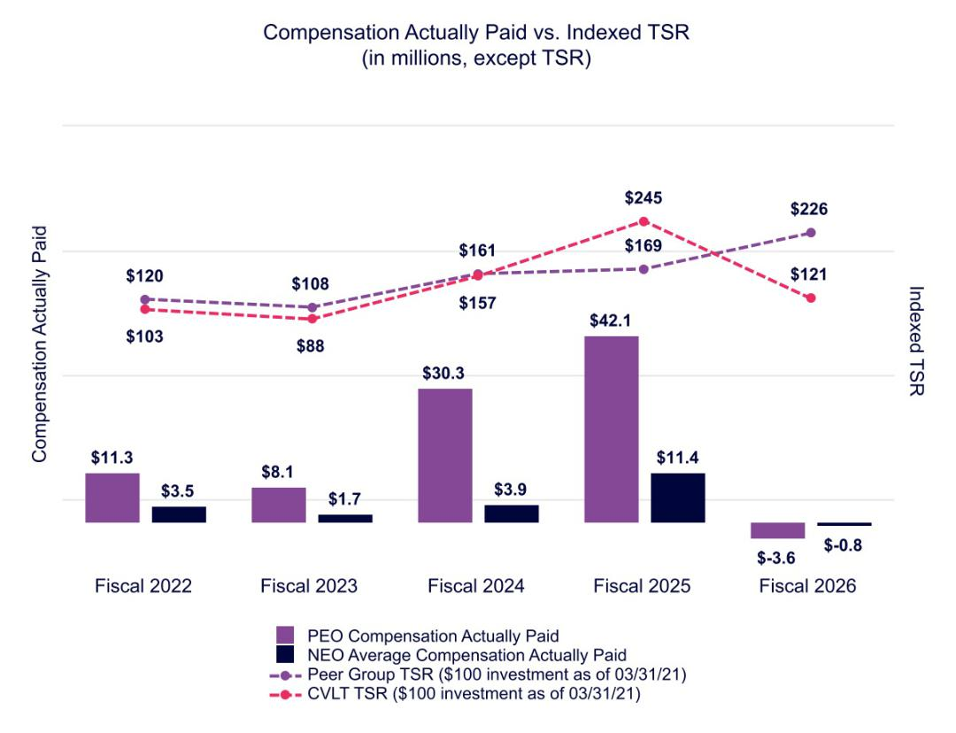

49 COMMVAULT SYSTEMS, INC. | 2026 PROXY STATEMENT

Table of Contents

COMPENSATION TABLES | PAY VERSUS PERFORMANCE

The following graph illustrates the relationship between compensation actually paid to our PEO and our non-PEO NEOs and our net income for the period presented in the Pay-Versus-Performance table.
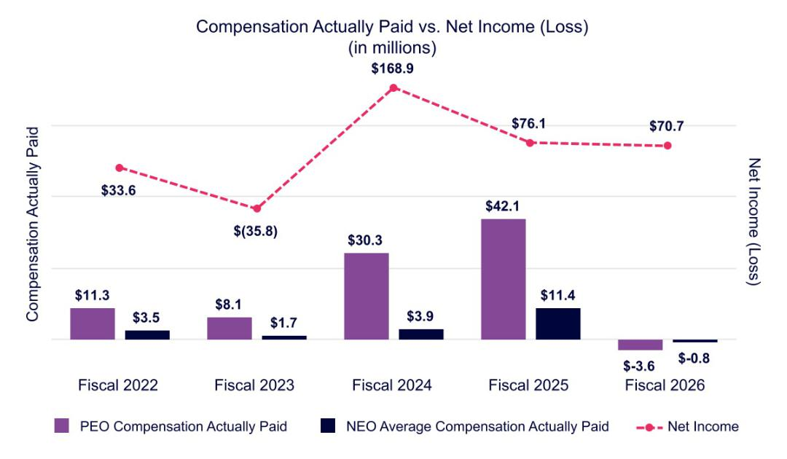

The following graph illustrates the relationship between compensation actually paid to our PEO and our non-PEO NEOs and our revenue for the period presented in the Pay-Versus-Performance table.
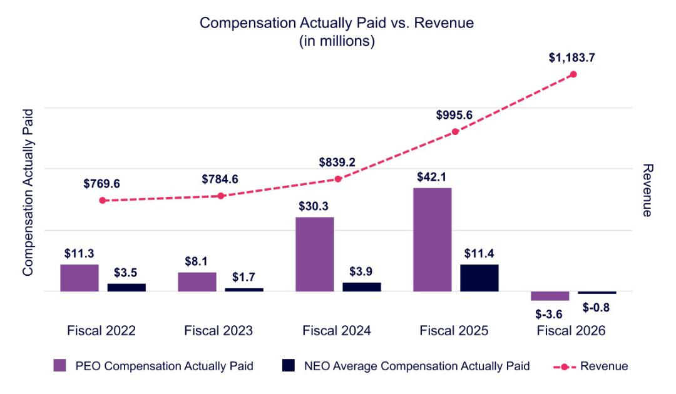

50 COMMVAULT SYSTEMS, INC. | 2026 PROXY STATEMENT

Table of Contents


The Audit Committee has reviewed and discussed Commvault’s audited financial statements for the fiscal year ended March 31, 2026 with our management. In addition, the Audit Committee has discussed with Ernst & Young LLP, our independent auditors, the matters required to be discussed by the applicable requirements of the Public Company Accounting Oversight Board (“PCAOB”) and the SEC.

The Audit Committee has received from the independent auditors written disclosures and the letter regarding the independent auditors’ communications with the Audit Committee concerning independence required by the applicable requirements of the PCAOB and has discussed with the independent auditors the firm’s independence.

The Audit Committee has considered whether the services rendered by our independent public accountants with respect to audit, audit-related, tax, and other non-audit fees are compatible with maintaining the firm’s independence.

Based on the review and discussions referred to above, the Audit Committee recommended to the Board of Directors that Commvault’s audited financial statements for the fiscal year ended March 31, 2026, be included in our Annual Report on Form 10-K for the fiscal year ended March 31, 2026, for filing with the SEC.

Audit Committee

Shane Sanders—Chair

Martha Bejar

51 COMMVAULT SYSTEMS, INC. | 2026 PROXY STATEMENT

Table of Contents



WHAT AM I VOTING ON? |  | VOTE RECOMMENDATION

As a matter of good corporate governance, we are asking stockholders to ratify the appointment of Ernst & Young LLP as Commvault’s independent auditors for fiscal 2027.

FOR ratification of the selection of the auditors.

Financial statements of the Company and our consolidated subsidiaries will be included in our Annual Report furnished to all stockholders. The Audit Committee of the Board of Directors has appointed Ernst & Young LLP as independent public accountants for us to examine our consolidated financial statements for the fiscal year ending March 31, 2027 and has determined as a matter of good governance to seek stockholders’ ratification of the appointment. If the stockholders do not ratify the appointment, the Audit Committee will reconsider the appointment for the 2028 fiscal year, rather than the 2027 fiscal year, because of the difficulty and expense involved in changing independent auditors on short notice.

Ernst & Young LLP has been engaged as our principal independent public accountants continuously since fiscal year 1998. Representatives of Ernst & Young LLP are expected to attend the Annual Meeting. They will have the opportunity to make a statement if they wish and are also expected to be available to respond to appropriate questions.

Audit, Audit-Related, Tax, and All Other Fees

The following table summarizes the aggregate fees and expenses billed to us for the fiscal years ended March 31, 2026 and 2025, by our principal accounting firm, Ernst & Young LLP.

 | 2026 | 2025
 | (In thousands)
Audit fees | $3,388 | $2,833
Audit-related fees | 125 | 13
Tax fees | 1,806 | 1,183
All other fees | 263 | —
Total fees | $5,582 | $4,029

Audit Fees—all services necessary to perform an audit of the consolidated financial statements of the Company presented in our annual report on Form 10-K; the reviews of the Company’s quarterly reports on Form 10-Q; services in connection with statutory and regulatory filings or engagements; statutory audits; and consents and review of documents filed with the SEC.

Audit-Related Fees—other assurance and related services that are reasonably related to the performance of an audit that are not included in Audit Fees, including fees related to the performance of audit and attest services not required by statute or regulation and subscription to Ernst & Young LLP’s online research tool.

Tax Fees—tax compliance; tax planning; and other tax advice.

All Other Fees—any other work that is not Audit, Audit-Related, or a Tax Service.

In considering the nature of the services provided by Ernst & Young LLP, the Audit Committee determined that such services are compatible with the provision of independent audit services. The Audit Committee discussed these services with Ernst & Young LLP and our management to determine that they are permitted under the rules and regulations concerning auditor independence promulgated by the SEC to implement the Sarbanes-Oxley Act of 2002.

52 COMMVAULT SYSTEMS, INC. | 2026 PROXY STATEMENT

Table of Contents

PROPOSAL NO. 3: RATIFICATION OF THE APPOINTMENT OF INDEPENDENT AUDITORS | | POLICY ON AUDIT COMMITTEE PRE-APPROVAL OF AUDIT AND NON-AUDIT SERVICES OF INDEPENDENT
 | AUDITORS

Policy on Audit Committee Pre-Approval of Audit and Non-Audit Services of Independent Auditor

The Audit Committee is responsible for appointing, setting compensation for, and overseeing the work of the independent auditors. The Audit Committee has established a policy regarding pre-approval of permissible non-audit services provided by the independent auditors. Generally, pre-approvals may be made by the chair of the Audit Committee and ratified by the full Audit Committee at its next meeting thereafter. All of the services performed by Ernst & Young LLP in the year ended March 31, 2026 were pre-approved in accordance with the pre-approval policy adopted by the Audit Committee.

The Board of Directors recommends that you vote FOR this proposal.

53 COMMVAULT SYSTEMS, INC. | 2026 PROXY STATEMENT

Table of Contents



WHAT AM I VOTING ON? |  | VOTE RECOMMENDATION

We are asking stockholders to approve the Commvault Systems, Inc. 2026 Equity Plan, a new equity incentive plan that will replace the 2016 Omnibus Incentive Plan, which expires in August 2026, and to authorize 3,374,000 shares of common stock for issuance thereunder.

FOR approval of 2026 Equity Plan.

The following summary of the 2026 Equity Plan is qualified in its entirety by the complete text of the 2026 Equity Plan contained in Exhibit 1 to this proxy statement.

Background

We are asking our stockholders to approve the Commvault Systems, Inc. 2026 Equity Plan (the "2026 Equity Plan"). Our Board adopted the 2026 Equity Plan on June 22, 2026, subject to stockholder approval at the Annual Meeting. A copy of the 2026 Equity Plan is attached as Exhibit 1 to this proxy statement.

The 2026 Equity Plan is intended to replace our 2016 Plan, which was approved by our stockholders in August 2016 and expires by its terms in August 2026. Upon stockholder approval of the 2026 Equity Plan, no further awards will be granted under the 2016 Plan. Any awards previously granted under the 2016 Plan will remain outstanding in accordance with their terms.

The 2026 Equity Plan provides for the issuance of up to 3,374,000 shares of our common stock, which includes shares remaining available for issuance under the 2016 Plan and shares subject to outstanding 2016 Plan awards that thereafter expire, are forfeited, cancelled, or terminated without issuance. As of June 12, 2026, a total of 2,029,546 shares currently remain available for future grant under the 2016 Plan and 2,100,268 shares were subject to outstanding awards under the 2016 Plan.

In determining the share reserve for the 2026 Equity Plan, the Board and the Compensation Committee considered a number of factors, including the Company's anticipated equity compensation needs, historical grant practices, burn rate, the dilutive impact of outstanding and available awards, the plan's expected duration, and external market practices. The 2026 Equity Plan is designed to attract, retain, and incentivize employees, consultants, and non-employee directors of the Company, and incorporates certain governance enhancements, including a prohibition on the recycling of shares used for tax withholding or exercise price payments and a prohibition on the payment of dividends or dividend equivalents on unvested awards.

The Compensation Committee is committed to effectively managing the number of shares reserved for issuance under the 2026 Equity Plan while minimizing stockholder dilution.

On June 12, 2026, the last reported sale price of our Common Stock on the Nasdaq stock market was $127.76 per share.

54 COMMVAULT SYSTEMS, INC. | 2026 PROXY STATEMENT

Table of Contents

PROPOSAL NO. 4: APPROVAL OF THE 2026 EQUITY PLAN | KEY DATA

Key Data

The following table includes information regarding outstanding equity awards and shares available for future awards as of May 31, 2026.

Outstanding Time-Vesting RSUs⁽¹⁾ | 1,583,989
Outstanding Performance Shares⁽¹⁾ | 517,656
Shares Available for Grant⁽²⁾ | 2,028,169
Common Shares Outstanding | 41,421,689

- There are no outstanding appreciation awards as of May 31, 2026.

- Note that the 2026 Equity Plan, if approved, will replace the 2016 Plan, and no future awards will be made under the 2016 Plan.

The following table summarizes our equity usage during the three most recent fiscal years.

 |  |  |  | Weighted Average
 | Time-Vesting | Performance | Performance | Common Shares
Time Period | Time-Vesting | Performance | Performance | Outstanding
Time Period | RSUs Granted | Shares Granted | Shares Earned⁽²⁾ | (Basic)
Fiscal 2026 | 979,753 | 191,278 | 86,755 | 43,976,000
Fiscal 2025 | 711,841 | 181,860 | 205,199 | 43,850,000
Fiscal 2024 | 1,219,774 | 239,832 | 342,160 | 43,885,000

- No stock options, stock appreciation rights, or other appreciation‑based awards were granted by the Company during the preceding three fiscal years.

- Earned amounts include actual payout levels as of May 31, 2026, and exclude the effect of forfeitures. The number of shares may vary until all actual results are confirmed. Earned amounts for Fiscal 2025 and Fiscal 2024 reflect updated actual payout levels as of May 31, 2026 and may differ from amounts previously reported.

55 COMMVAULT SYSTEMS, INC. | 2026 PROXY STATEMENT

Table of Contents

PROPOSAL NO. 4: APPROVAL OF THE 2026 EQUITY PLAN | DESCRIPTION OF THE 2026 EQUITY PLAN

Description of the 2026 Equity Plan

Purpose

The purpose of the 2026 Equity Plan is to:

- attract and retain talented executives and employees,

- advance the interests of Commvault and our stockholders by providing eligible employees and executives with appropriate incentives to perform in a superior manner and achieve long-range goals,

- enhance the link between performance and compensation for plan participants, and

- provide incentive compensation opportunities that are competitive with those offered by other similar companies.

Administration

For awards to Commvault officers and employees, the 2026 Equity Plan is administered by the Compensation Committee which selects award recipients under the 2026 Equity Plan, the types of awards to be granted, and the applicable terms, conditions, performance criteria, restrictions, and other provisions of such awards. The Compensation Committee also has the authority to conclusively interpret the 2026 Equity Plan and to adopt rules and procedures relating to the Plan and awards made thereunder. Subject to stock exchange listing standards and applicable law, the Compensation Committee may delegate all or any portion of its responsibilities or powers under the 2026 Equity Plan.

Eligibility

All officers, directors, or other employees of Commvault or a related company; all consultants, independent contractors, or agents of Commvault or a related company; and individuals who are expected to become officers, employees, directors, consultants, independent contractors, or agents of Commvault or a related company, are eligible to receive awards under the 2026 Equity Plan, with two limitations. Specifically, awards to a person who is expected to become a service provider to Commvault or a related company cannot be effective before such person’s service begins, and incentive stock options (“ISOs”) may only be granted to employees of Commvault or a related company that satisfies certain requirements in the Internal Revenue Code. For purposes of eligibility, a company is a “related company” for any period during which we own (directly or indirectly) at least 50% of voting power or ownership interests in such entity or such entity owns (directly or indirectly) at least 50% of the voting power of our stock.

In fiscal 2026, we granted equity awards of the type authorized under the 2026 Equity Plan to 2,165 individuals. As of March 31, 2026, approximately 3,246 persons were eligible to receive awards under the 2016 Plan, comprising 3,232 employees, eight non-employee directors and six consultants.

Shares of Common Stock Available for Awards

Awards may be made under the 2026 Equity Plan with respect to Common Stock that is authorized but unissued or, as permitted by applicable law, held or acquired by Commvault as treasury shares, including shares of Common Stock purchased in the open market or in private transactions. At the discretion of the Committee, an award under the 2026 Equity Plan may be settled in cash rather than Common Stock.

The maximum number of shares of Common Stock that may be delivered under the 2026 Equity Plan is 3,374,000. The share reserve includes (i) any shares remaining available for issuance under the 2016 Plan as of the effective date of the 2026 Equity Plan that are not then subject to outstanding awards, and (ii) any shares subject to outstanding awards under the 2016 Plan as of such effective date that thereafter expire, are forfeited, are cancelled, or are terminated without issuance of shares of Common Stock. Any shares of Common Stock subject to an award under the 2026 Equity Plan that is forfeited, expires or is terminated without issuance of shares of Common Stock (including shares of Common Stock that are attributable to awards that are settled in cash) will thereafter be available for further grants under the 2026 Equity Plan. Shares of Common Stock that are tendered or withheld in payment of the exercise price of an Option, shares of Common Stock that are withheld in payment of taxes payable with respect to the exercise of an Option or SAR, and shares of Common Stock that are tendered or withheld to satisfy taxes payable with respect to the vesting, settlement, or delivery under a Full Value Award, will in each case not again become available for issuance under the 2026 Equity Plan. Shares subject to a SAR that are not issued in connection with the stock settlement of that SAR upon its exercise will not again become available for further grants under the 2026 Equity Plan.

56 COMMVAULT SYSTEMS, INC. | 2026 PROXY STATEMENT

Table of Contents

PROPOSAL NO. 4: APPROVAL OF THE 2026 EQUITY PLAN | SHARES OF COMMON STOCK AVAILABLE FOR AWARDS

The following additional limits apply to awards under the 2026 Equity Plan:

- no more than 3,374,000 shares of Common Stock may be subject to ISOs.

- Awards granted to independent directors for any calendar year may not exceed $500,000 ($1,000,000 for the initial year of directorship), determined as of the date of grant.

In the event of a corporate transaction (including a stock dividend, stock split, reverse stock split, extraordinary cash dividend, recapitalization, reorganization, merger, consolidation, split-up, spin-off, exchange of shares, sale of assets or subsidiaries, or combination) that affects the Common Stock such that the Compensation Committee determines an adjustment is warranted in order to preserve the benefits or prevent the enlargement of benefits of awards under the 2026 Equity Plan, the Compensation Committee will adjust awards in a manner it determines to be equitable in its discretion.

Specifically, the Compensation Committee may:

- adjust the number and kind of shares that may be delivered under the 2026 Equity Plan (including adjusting the individual limitations described above);

- adjust the number and kind of shares subject to outstanding awards;

- adjust the exercise price of outstanding Options and SARs;

- replace awards with other awards that the Compensation Committee determines have comparable value and that are based on stock of a company resulting from the transaction; and

- cancel any award in return for cash payment of the award’s current value, determined as though the award is fully vested at the time of payment, provided that in the case of an Option or SAR, the amount of such payment may be the excess of the value of the shares of Common Stock subject to the Option or SAR at the time of the transaction over the exercise price.

Types of Awards

Options

The Compensation Committee may grant Options to purchase shares of Common Stock in the form of ISOs or non-qualified stock options (“NQOs”). The exercise price of an Option cannot be less than the fair market value of a share of Common Stock on the date the Option is granted. ISOs may only be granted to employees of Commvault or our permitted corporate subsidiaries and must satisfy other requirements of Section 422 of the Internal Revenue Code. An Option that does not satisfy the requirements for an ISO will be treated as a NQO.

Except for reductions approved by our stockholders or adjustment for corporate transactions, the exercise price of an Option may not be decreased after the date of grant, nor may an Option be surrendered to us as consideration for the grant of a replacement Option or SAR with a lower exercise price or for a Full Value Award. In addition, except as approved by our stockholders, no Option granted under the 2026 Equity Plan may be surrendered to us in consideration of a cash payment if, at the time of such surrender, the exercise price of the Option is greater than the fair market value of a share of Common Stock.

Options will be exercisable in accordance with the terms established by the Compensation Committee. The full exercise price of each share of Common Stock purchased upon the exercise of any Option must be paid at the time of exercise (except if the exercise price is payable through the use of cash equivalents, it may be paid as soon as practicable after exercise). Subject to applicable law, the exercise price of an Option may be payable in cash or cash equivalents, shares of Common Stock (valued at fair market value as of the day of exercise), or a combination thereof. The Committee may, in its discretion, impose such conditions, restrictions, and contingencies on the shares of Common Stock acquired pursuant to the exercise of an Option as the Committee determines to be desirable, including restrictions relating to disposition of the shares, forfeiture restrictions based on service or performance, stock ownership requirements, and conformity with our recoupment or clawback policies as in effect from time to time.

Except as provided by the Compensation Committee, an Option will expire on the earlier of:

- the 30th day after the participant’s employment or service terminates for any reason other than for cause (as defined in the 2026 Equity Plan), and

- the day on which the participant’s employment or service terminates for cause.

In any event, an Option will expire no later than the 10th anniversary of the date on which it is granted (or such shorter period required by the standards of any stock exchange on which the Common Stock is listed).

57 COMMVAULT SYSTEMS, INC. | 2026 PROXY STATEMENT

Table of Contents

PROPOSAL NO. 4: APPROVAL OF THE 2026 EQUITY PLAN | TYPES OF AWARDS

SARs

A SAR entitles the holder to receive the amount (in cash or shares of Common Stock) by which the fair market value of a specified number of shares of Common Stock on the exercise date exceeds an exercise price established by the Committee. The exercise price of a SAR cannot be less than the fair market value of a share of Common Stock on the date the SAR is granted. SARs are generally subject to the same terms and restrictions as apply to Options to the extent relevant, including the prohibition on lowering the exercise price, exchanges for cash or other awards, the expiration date provisions, and the minimum vesting period.

Full Value Awards

A Full Value Award is a grant of one or more shares of Common Stock or a right to receive one or more shares of Common Stock in the future (including restricted stock, RSUs, deferred stock units, performance stock, and PSUs). Grants may be subject to such conditions, restrictions, and contingencies as determined by the Committee, including provisions relating to dividend or dividend equivalent rights and deferred payment or settlement, but no dividends or dividend equivalent rights will be paid or settled on any award that has not vested or, in the case of performance-based awards, has not been earned.

Cash Incentive Awards

A Cash Incentive Award is the grant of a right to receive a payment of cash (or, in the discretion of the Committee, shares of Common Stock with an equivalent value) that is contingent on achievement of performance objectives over a specified period of time. The grant of Cash Incentive Awards may also be subject to such other conditions, restrictions, and contingencies as the Committee determines, including provisions relating to deferred payment.

No award may vest, in whole or in part, before the first anniversary of the date of grant or, in the case of vesting based upon the attainment of performance-based objectives, the first anniversary of the commencement of the period over which performance is evaluated, except for a limited number of awards (covering up to 5% of the shares available for issuance under the 2026 Equity Plan) or upon death, disability or a corporate transaction.

Change in Control

If (i) a Change in Control (as defined in the 2026 Equity Plan) occurs before an award vests and before the holder’s separation from service, and (ii) such award remains outstanding following the Change in Control (whether by substitution with another award or otherwise), and (iii) the participant’s service is involuntarily terminated by the Company or a related company (or any successor thereto), other than for cause, on or within two years following the Change in Control, then:

- the participant’s outstanding Options and SARs, if any, will become fully exercisable; and

- the participant’s Full Value awards will become fully vested and the Committee will determine the extent to which the associated performance conditions are met, taking into account actual performance and/or the passage of time, in

accordance with the terms of the 2026 Equity Plan and the applicable award agreement.

To the extent any provision of the 2026 Equity Plan or an award agreement would cause a payment of deferred compensation that is subject to section 409A of the Code to be made upon the occurrence of a Change in Control, then such payment will not be deferred unless such Change in Control also constitutes a “change in ownership,” “change in effective control,” or “change in ownership of a substantial portion of the Company’s assets” within the meaning of section 409A of the Code.

If an award does not remain outstanding following a Change in Control, the Compensation Committee will determine the vesting and other terms and conditions of the award in connection with the Change in Control in accordance with the terms of the 2026 Equity Plan.

Non-U.S. Employees

The Committee may grant awards to eligible individuals who are foreign nationals on terms and conditions different from those specified in the 2026 Equity Plan as may, in the Committee’s judgment, be necessary or desirable to foster and promote achievement of the purposes of the 2026 Equity Plan. Similarly, the Compensation Committee may make such modifications, amendments, procedures, and subplans as may be necessary or advisable to comply with provisions of laws in other countries or jurisdictions in which Commvault or a related company operates or has employees, but may not increase the share limitations under the 2026 Equity Plan or otherwise change any provision of the Plan that would require stockholder approval.

58 COMMVAULT SYSTEMS, INC. | 2026 PROXY STATEMENT

Table of Contents

PROPOSAL NO. 4: APPROVAL OF THE 2026 EQUITY PLAN | OTHER 2026 EQUITY PLAN INFORMATION

Other 2026 Equity Plan Information

Awards under the 2026 Equity Plan are not transferable except as designated by the holder by will or by laws of descent and distribution or, unless otherwise provided by the Compensation Committee, pursuant to a qualified domestic relations order. Unless otherwise provided by the Committee, awards (other than ISOs) may be transferred to or for the benefit of the holder’s family (including, without limitation, to a trust or partnership for the benefit of family) in accordance with rules established by the Compensation Committee.

All awards and other payments under the 2026 Equity Plan are subject to withholding of all applicable taxes. With the consent of the Committee, withholding obligations may be satisfied with previously owned shares of Common Stock or shares of Common Stock to which the participant is otherwise entitled under the 2026 Equity Plan. Previously-owned shares of Common Stock or shares to which a participant is otherwise entitled under the 2026 Equity Plan may only be used to satisfy tax withholding obligations in an amount not to exceed the applicable maximum statutory tax rates in the participant's applicable jurisdictions (or such lesser rates as would avoid a negative accounting impact).

The Board may, at any time, amend or terminate the 2026 Equity Plan, and the Board or the Compensation Committee may amend any award agreement, provided that no amendment or termination may, in the absence of written consent to the change by the affected participant (or, if the participant is not then living, the affected beneficiary), adversely affect the rights of any participant or beneficiary under any award granted before the date such amendment is adopted. The provisions of the 2026 Equity Plan that prohibit repricing of Options and SARs cannot be amended unless the amendment is approved by our stockholders, and no other amendment will be made to the 2026 Equity Plan without the approval of our stockholders if such approval is required by law or the rules of any stock exchange on which the Common Stock is listed. Adjustments to awards made in connection with corporate transactions are not subject to the foregoing restrictions. All awards under the 2026 Equity Plan are subject to our Clawback Policy as described above.

U.S. Federal Income Tax Considerations

The discussion that follows is a summary, based on current law, of some significant U.S. federal income tax considerations relating to awards under the 2026 Equity Plan. This does not purport to be a complete description of the federal income tax aspects of the 2026 Equity Plan. In addition, participants may be subject to foreign, state, and local taxes and employment taxes in connection with stock purchased under the 2026 Equity Plan. Participants should consult with a tax adviser to determine how the tax laws apply in their personal circumstances.

NQOs

The grant of an NQO will not result in taxable income to the participant. Except as described below, the participant will realize ordinary income at the time of exercise in an amount equal to the excess of the fair market value of the shares of Common Stock acquired over the exercise price for those shares, and Commvault will be entitled to a corresponding deduction. Gains or losses realized by the participant upon disposition of such shares of Common Stock will be treated as capital gains and losses, with a basis equal to the fair market value of the shares of Common Stock at the time of exercise.

The exercise of an NQO through the delivery of previously acquired Common Stock will generally be treated as a non-taxable, like-kind exchange as to the number of shares of Common Stock surrendered and the identical number of shares of Common Stock received under the Option. That number of shares will take the same basis and, for capital gains purposes, the same holding period as the shares of Common Stock that are given up. The value of the shares of Common Stock received upon such an exchange that exceed the number of shares given up will be includible as ordinary income to the participant at the time of exercise. The excess shares of Common Stock will have a new holding period for capital gain purposes and a basis equal to the value of such shares determined at

the time of exercise.

ISO

The grant of an ISO will not result in taxable income to the participant. The exercise of an ISO will not result in taxable income to the participant if the participant was, without a break in service, an employee of Commvault or a corporate subsidiary during the period beginning on the date the Option was granted and ending three months prior to the date of exercise (one year prior to the date of exercise if the participant is disabled, as that term is defined in the Internal Revenue Code).

The excess of the fair market value of the shares of Common Stock at the time of the exercise of an ISO over the exercise price is an adjustment that is included in the calculation of the participant’s alternative minimum taxable income for the tax year in which the ISO is exercised. For purposes of determining alternative minimum tax liability for the year of disposition of the shares of Common Stock acquired pursuant to the ISO exercise, the participant will have a basis in those shares equal to the fair market value of the shares of Common Stock at the time of exercise.

59 COMMVAULT SYSTEMS, INC. | 2026 PROXY STATEMENT

Table of Contents

PROPOSAL NO. 4: APPROVAL OF THE 2026 EQUITY PLAN | OTHER 2026 EQUITY PLAN INFORMATION

If a participant does not sell or otherwise dispose of the shares of Common Stock within two years from the date of the grant of the ISO or within one year after receiving the transfer of such shares, then, upon disposition of such shares of Common Stock, any amount realized in excess of the exercise price will be taxed to the participant as capital gain, and Commvault will not be entitled to any deduction for federal income tax purposes. A capital loss will be recognized to the extent the amount realized is less than the exercise price. If a participant sells or otherwise disposes of the shares of Common Stock sooner than two years from the date of grant of the ISO or one year after receiving the transfer of such shares, then the participant will generally realize ordinary income, and Commvault will be allowed a corresponding deduction, at the time of the disposition of the shares, in an amount equal to the lesser of

- the excess of the fair market value of the shares of Common Stock on the date of exercise over the exercise price, or (b) the excess, if any, of the amount realized upon disposition of the shares of Common Stock over the exercise price. If the amount realized exceeds the value of the shares of Common Stock on the date of exercise, any additional amount will be capital gain. If the amount realized is less than the exercise price, the participant will recognize no income, and a capital loss will be recognized equal to the excess of the exercise price over the amount realized upon the disposition of the shares.

The exercise of an ISO through the exchange of previously acquired stock will generally be treated in the same manner as such an exchange in connection with the exercise of an NQO—that is, as a non-taxable, like-kind exchange as to the number of shares of Common Stock given up and the identical number of shares received under the Option. That number of shares of Common Stock will take the same basis and, for capital gain purposes, the same holding period as the shares that are given up. However, such holding period will not satisfy the one-year holding period required for the new shares of Common Stock to receive ISO treatment. Shares received in excess of the number of shares of Common Stock given up will have a new holding period and will have a basis of zero or the amount of cash, if any, paid as part of the exercise price. A disqualifying disposition (a disposition before the end of the applicable holding period) with respect to any of the shares of Common Stock received from the exchange will be treated as a disqualifying disposition of the shares with the lowest basis.

If the exercise price of an ISO is paid with shares of Common Stock acquired through a prior exercise of an ISO, gain will be realized on the shares given up (taxed as ordinary income) if those shares of Common Stock have not been held for the minimum ISO holding period (two years from the date of grant and one year from the date of transfer), but the exchange will not affect the tax treatment of the shares of Common Stock received.

SARs

A participant generally will not realize any taxable income upon the grant of SARs. Upon the exercise of SARs, the participant will recognize ordinary income in an amount equal to the amount of cash and/or the fair market value, at the date of exercise, of the shares of Common Stock received as a result of such exercise. Commvault will generally be entitled to a deduction in the same amount.

Full Value Awards

The federal income tax consequences of a Full Value Award will depend on the type of award, and in particular, whether the shares are subject to a substantial risk of forfeiture (determined under Internal Revenue Code rules) at the time of the grant. If the shares are subject to a substantial risk of forfeiture, the participant will not recognize taxable income at the time of the grant. Instead, when the restrictions on the shares lapse (meaning the shares are no longer subject to a substantial risk of forfeiture), the participant will recognize ordinary taxable income in an amount equal to the fair market value of the shares at that time. If the shares are not subject to a substantial risk of forfeiture or if the participant elects to be taxed at the time of the grant of such shares under section 83(b) of the Internal Revenue Code, the participant will recognize taxable income when the shares are granted in an amount equal to the fair market value of such shares at the time, determined without regard to any of the restrictions. If the shares are forfeited before the restrictions lapse, the participant will not be entitled to a corresponding deduction. The participant’s tax basis in the shares will be the amount recognized as income attributable to such shares. Gain or loss recognized by the participant on a subsequent disposition of any such shares is capital gain or loss if the shares are otherwise capital assets.

In the case of other Full Value Awards, such as RSUs or PSUs, the participant generally will not have taxable income upon the grant of the award so long as there are restrictions on such awards that constitute a substantial risk of forfeiture. Participants will generally recognize ordinary income when the restrictions on awards lapse, on the date of grant if there are no such restrictions, or, in certain cases, when the award is settled. At that time, the participant will recognize taxable income equal to the cash or the fair market value of the shares issuable in payment of such award, and such amount will be the tax basis for any shares received. In the case of an award that does not constitute property at the time of grant (such as an award of units), participants will generally recognize ordinary income when the award is paid or settled.

Commvault generally will be entitled to a tax deduction in the same amount, and at the same time, as the income recognized by a participant.

60 COMMVAULT SYSTEMS, INC. | 2026 PROXY STATEMENT

Table of Contents

PROPOSAL NO. 4: APPROVAL OF THE 2026 EQUITY PLAN | OTHER 2026 EQUITY PLAN INFORMATION

Parachute Payments

Any acceleration of the vesting or payment of awards under the 2026 Equity Plan in the event of a change in control in the Company may cause part or all of the consideration involved to be treated as an “excess parachute payment” under the Internal Revenue Code, which may subject the participant to a 20% excise tax and preclude a deduction by the Company.

New Plan Benefits

Future benefits under the 2026 Equity Plan cannot be determined at this time because the grants are at the discretion of the Compensation Committee and because their value may depend upon the satisfaction of vesting conditions and the future price of the Company’s stock.

61 COMMVAULT SYSTEMS, INC. | 2026 PROXY STATEMENT

Table of Contents

PROPOSAL NO. 4: APPROVAL OF THE 2026 EQUITY PLAN | FISCAL 2026 EQUITY COMPENSATION PLAN INFORMATION

Fiscal 2026 Equity Compensation Plan Information

The following table provides certain information with respect to all of our equity compensation plans in effect as of March 31, 2026:

 |  | Weighted-Average | Number of Securities
 | Number of Securities to be | Weighted-Average | that Remained Available for
 | Number of Securities to be | Exercise Price of | Future Issuance Under Equity
 | Issued Upon Exercise of | Outstanding | Plans (Excluding
Plan Category | Outstanding Options, | Options, Warrants | Securities Reflected in
Plan Category | Warrants and Rights (a)(1) | and Rights (b)⁽²⁾ | Column (a)) (c)⁽³⁾

Equity compensation plans approved by security holders
Equity compensation plans not approved by security holders

Totals

1,742,110 — 3,610,261

— — —

1,742,110 — 3,610,261

- Consists of shares of Common Stock to be issued upon vesting of RSUs, including PSUs, under our 2016 Plan. PSUs for which achievement had not yet been determined as of March 31, 2026 are reflected at the maximum level of performance applicable to these awards. These amounts do not include potentially issuable shares under the ESPP, which depend on a number of factors described in the ESPP and will not be determined until the end of the applicable purchase period. See "Note 11. Stock Plans" in Item 8 of our Annual Report on Form 10-K for the fiscal year ended March 31, 2026 for additional information.

- The weighted-average exercise price does not consider the shares issuable upon vesting of outstanding RSUs and PSUs, which have no exercise price.

- Includes 3,162,626 shares under the 2016 Plan and 447,635 shares under the ESPP.

The Board of Directors recommends that you vote FOR approval of the 2026 Equity Plan.

62 COMMVAULT SYSTEMS, INC. | 2026 PROXY STATEMENT

Table of Contents


This proxy statement is furnished in connection with the solicitation on behalf of the Board of Directors of Commvault Systems, Inc. of proxies to be voted at the Annual Meeting of Stockholders, including any adjournment or postponement thereof. This proxy statement is first being made available at www.edocumentview.com/CVLT, and we intend to begin distribution of the Notice of Internet Availability of Proxy Materials to stockholders on or about June 24, 2026. A copy of our Annual Report on Form 10-K for the fiscal year ended March 31, 2026, which includes audited financial statements, is also being made available concurrently with the proxy statement at www.edocumentview.com/CVLT.

TIME AND DATE |  | LOCATION |  |  |  | RECORD DATE
Thursday, August 6, 2026 |  | Virtual only |  |  |  | June 12, 2026
10:00am ET |  | https://ir.commvault.com/news-and-events/annual-
 |  |  | meeting

How can I participate in the virtual Annual Meeting?

Our virtual Annual Meeting format will enable all stockholders to participate, regardless of their location. To participate in the Annual Meeting, please access the meeting website at https://ir.commvault.com/news-and-events/annual-meeting and follow the instructions found there. You will be required to establish your identity as a stockholder in order to vote during the meeting. Please have the control number found on your Notice of Internet Availability of Proxy Materials available.

Stockholders can submit questions for the Annual Meeting’s question and answer session prior to or during the meeting through https://ir.commvault.com/news-and-events/annual-meeting. Once the meeting has concluded, the webcast will be available for replay on the Investor Relations section of our website for 12 months.

Who is entitled to vote at the Annual Meeting?

The record date for determining stockholders entitled to vote at the Annual Meeting was June 12, 2026. On that date, 41,421,689 shares of Commvault Common Stock were outstanding and entitled to vote. Each stockholder is entitled to one vote for each registered share of Common Stock held of record for each matter to be considered. A list of stockholders entitled to vote at the Annual Meeting will be available for examination by stockholders by arrangement made with Commvault during the 10 days preceding the meeting. Information regarding how to examine the stockholder list is available at the meeting

website at https://ir.commvault.com/news-and-events/annual-meeting.

The presence at the Annual Meeting, in person (including virtually) or by proxy, of holders of a majority of the issued and outstanding shares of Common Stock entitled to vote as of the record date is considered a quorum for the transaction of business. If you submit a properly completed proxy or if you appear at the Annual Meeting to vote in person (including virtually), your shares of Common Stock will be considered part of the quorum. Abstentions and broker non-votes will be counted for the purpose of establishing a quorum.

If you choose to vote your shares at the Annual Meeting, you will be required to provide your control number, which is included in the Notice of Internet Availability of Proxy Materials that you received. If you hold your Commvault shares through a broker, bank, or other nominee, you may vote during the Annual Meeting only if you obtain a signed proxy from your bank, broker, or other nominee giving you the right to vote the shares. You will be asked to submit that proxy to Commvault via the email address provided on the meeting website at or prior to the Annual Meeting, along with an account statement or letter from the broker, bank, or other nominee indicating that you are the beneficial owner of the shares and that you were the beneficial owner of the shares on June 12, 2026.

63 COMMVAULT SYSTEMS, INC. | 2026 PROXY STATEMENT

Table of Contents

ADDITIONAL INFORMATION ABOUT THE ANNUAL MEETING

What proposals will be considered at the Annual Meeting, and how does the Board recommend that I vote?

The following table summarizes the matters we expect to present to stockholders during the Annual Meeting.

 |  |  |  | Effect of
 |  |  |  | abstentions,
Proposal | Voting options | Board | Vote required to pass | and broker
Proposal | Voting options | recommendation | Vote required to pass | non-votes(1)
Election of directors | FOR, AGAINST, or | FOR each | Each nominee must receive the affirmative vote of a | No effect
 | ABSTAIN for | nominee | majority of the votes cast on the proposal.
 | each nominee
Advisory vote on Commvault’s | FOR, AGAINST, or | FOR | As a non-binding, advisory vote, there is no specific | No effect
executive compensation | ABSTAIN |  | approval requirement. However, Commvault’s Board of
 |  |  | Directors will review and consider the outcome of this
 |  |  | advisory vote and will take it into account when making
 |  |  | future compensation decisions.
Ratification of the independent | FOR, AGAINST, or | FOR | The affirmative vote of a majority of the votes cast on | No effect
auditors | ABSTAIN |  | the proposal.
Approval of the 2026 Equity | FOR, AGAINST, or | FOR | The affirmative vote of a majority of the votes | No effect
Plan | ABSTAIN |  | cast on the proposal.

- For an explanation of broker non-votes, please see “How can I vote if I hold my Commvault stock through a broker?”

How can I vote if I do not plan to attend the Annual Meeting?

Registered stockholders of record may provide voting instructions before the Annual Meeting in one of three ways:

Mail

Sign, date and return your proxy card in the enclosed envelope

Online Before the Meeting Telephone

Visit www.investorvote.com/CVLT and finish voting Call the telephone number on your proxy card by Wednesday, August 5, 2026 at 11:59pm ET

All properly completed, unrevoked proxies received prior to the close of voting at the Annual Meeting will be voted in accordance with the instructions provided.

How can I vote if I hold my Commvault stock through a broker?

If you hold your shares through a bank, broker, or other nominee (meaning you are the “beneficial owner” of shares owned by someone else) your broker will ask how you want your shares to be voted. If you give voting instructions, your broker will vote your shares as you direct. If you do not provide voting instructions, your broker is only permitted to vote your shares on Proposal No. 3 regarding ratification of the auditors. Brokers holding shares beneficially owned by their clients do not have the authority to cast votes with respect to the election of directors or executive compensation unless they have received instructions from the beneficial owner of the shares. If you do not provide instructions to your broker, your vote will not be counted with respect to Proposal No. 1 (the election of seven directors for a one-year term), Proposal No. 2 (the advisory vote on executive compensation), or Proposal No. 4 (the approval of the 2026 Equity Plan). This is called a “broker non-vote.” Please submit voting instructions to your broker by Wednesday, August 5, 2026 at 11:59pm ET.

64 COMMVAULT SYSTEMS, INC. | 2026 PROXY STATEMENT

Table of Contents

ADDITIONAL INFORMATION ABOUT THE ANNUAL MEETING

What if I return a proxy card but don’t mark all of my choices?

If we have a properly executed, unrevoked proxy card that does not specifically direct the voting of shares, the shares represented by such proxy will be voted (i) FOR the election of all nominees for election as director described in this proxy statement, (ii) FOR approval, on an advisory basis, of our executive compensation, (iii) FOR the ratification of the appointment of Ernst & Young LLP as our independent public accountants for the fiscal year ending March 31, 2027, (iv) FOR the approval of the 2026 Equity Plan, and (v) in accordance with the judgment of the individuals named on the proxy card as to such other matters as may properly come before the Annual Meeting.

What if I change my mind after I vote?

You can revoke your proxy at any time prior to the voting at the Annual Meeting by submitting a later-dated proxy (including a later-dated proxy via the internet or telephone), by giving timely written notice of such revocation to our Corporate Secretary, or by attending the Annual Meeting and voting in person (virtually). If you attend the Annual Meeting and do not vote, it will not affect any previously submitted proxy or voting instructions.

Who is paying for this solicitation?

Commvault will pay all expenses related to the solicitation of proxies. Solicitation will be made by mail, and may be made by directors, officers, and employees, personally or by telephone, email, or other electronic means. Proxy cards and material also will be distributed to beneficial owners of our stock through brokers, custodians, nominees, and other like parties, and we expect to reimburse such parties for their charges and expenses.

I share an address with another stockholder. Why did we receive only one copy of the proxy materials?
As permitted by the SEC, we have adopted "householding," under which we deliver a single copy of the Notice of Internet Availability of Proxy Materials and, if applicable, our proxy materials to multiple stockholders who share the same address, unless we have received contrary instructions. Householding reduces our printing costs, mailing costs, and fees. Stockholders who participate in householding will still be able to access and receive individual proxy cards. Upon written or oral request, we will promptly deliver a separate copy of the Notice and, if applicable, our proxy materials to any stockholder at a shared address to which we delivered a single copy of any of these materials.

To receive a separate copy, or if you are receiving multiple copies and wish to participate in householding, please contact our Corporate Secretary at Commvault Systems, Inc., 1 Commvault Way, Tinton Falls, New Jersey 07724, by telephone at (732) 870-4000, or by email at CorporateSecretary@commvault.com. Street name stockholders may contact their broker, bank, or other nominee to request information about householding.

How can I submit a proposal or a nomination for the 2027 Annual Meeting?

Stockholder proposals to be included in Commvault’s proxy statement

We must receive any stockholder proposal to be considered for inclusion in our proxy statement and form of proxy relating to the 2027 Annual Meeting of stockholders by February 24, 2027. Such submissions must comply with applicable SEC rules, including without limitation Rule 14a-8 under the Securities Exchange Act of 1934, as amended.

Stockholder nominations under proxy access

Our Bylaws permit qualifying stockholders to include a certain number of director nominees in our proxy statement. For any such nomination for our 2027 Annual Meeting to be timely, we must receive notice and certain required information at our principal executive offices between January 27, 2027 and February 26, 2027. Stockholders who make nominations pursuant to our proxy access provision should be mindful of the requirements set forth in our Bylaws, which are available on the Investor Relations section of our website.

65 COMMVAULT SYSTEMS, INC. | 2026 PROXY STATEMENT

Table of Contents

ADDITIONAL INFORMATION ABOUT THE ANNUAL MEETING

Other stockholder proposals

If you wish to submit a proposal for consideration at the 2027 Annual Meeting or to nominate a candidate for election as a director at that meeting without utilizing our proxy access provision, you must deliver timely written notice and certain required information to our Secretary at our principal executive offices no earlier than April 8, 2027 and no later than the close of business on May 8, 2027. Any such notice must comply with the requirements set forth in Section

2.5 of our Bylaws, which are available on the Investor Relations section of our website. Among other things, the notice must set forth:

- the name and address, as they appears on our books, of the stockholder who intends to make the proposal or nomination, the beneficial owner, if any, on whose behalf the nomination or proposal is made, and any Stockholder Related Person (as defined in our Bylaws) of any such person;
- a representation that the stockholder is a holder of record of our stock entitled to vote at the meeting and intends to appear in person or by proxy at the meeting to present such proposal or nomination;
- whether the stockholder or any Stockholder Related Person intends to solicit proxies in support of the proposal or nomination; and

- the stockholder's ownership interests in our securities, including shares of stock and debt securities beneficially owned and owned of record, as well as any derivative positions, short interests, and voting arrangements.
If you are nominating a candidate to be elected as a director, your notice must include the following additional information:

- the name, age, and business and residence address of any person to be nominated,

- a description of all arrangements or understandings between you and each nominee and any other person or persons (naming such person or persons) pursuant to which the nomination or nominations are to be made, including a description of all direct and indirect compensation and other monetary arrangements during the past three years between the nominee and the stockholder, the beneficial owner, or any Stockholder Related Person, and all information that would be required to be disclosed under Item 404 of Regulation S-K,

- such other information regarding each nominee as would be required to be included in a proxy statement or other filing pursuant to Regulation 14A under the Securities and Exchange Act of 1934, as amended, in connection with solicitations of proxies for the election of directors in an election contest,

- the consent of each nominee to be named in a proxy statement and to serve as a director if elected, and

- such other information as is set forth in our Bylaws, which are available on the Investor Relations section of our website.

In addition to satisfying the requirements of our Bylaws, including the notice deadlines set out above and therein, to comply with universal proxy rules, stockholders who intend to solicit proxies in support of director nominees other than our nominees must also provide notice that sets forth the information required by Rule 14a-19 under the Securities and Exchange Act of 1934, as amended, no later than June 7, 2027, and must deliver reasonable evidence of compliance with Rule 14a-19 no later than eight business days prior to the meeting.

****

To the extent this proxy statement is incorporated by reference in any other filing by us under the Securities Act of 1933, as amended, or the Securities Exchange Act of 1934, as amended, the information included or incorporated in the sections of this proxy statement entitled “Audit Committee Report” and “Compensation Committee Report” will not be deemed to be incorporated, unless specifically provided otherwise in such filing. All website addresses referenced in this proxy statement are intended as inactive, textual references only. The information contained on, or accessible through, any website identified in this proxy statement is not part of, and is not incorporated by reference into, this proxy statement or any other report or document we file with the SEC.

We will furnish without charge to each person whose proxy is being solicited, upon written request, a copy of our Annual Report on Form 10-K for the fiscal year ended March 31, 2026, as filed with the SEC, including the financial statements and schedules thereto. Requests for copies of such report should be directed to Danielle Sheer, Chief Legal and Trust Officer and Corporate Secretary, Commvault Systems, Inc., 1 Commvault Way, Tinton Falls, New Jersey 07724. A copy of our Annual Report on Form 10-K for the fiscal year ended March 31, 2026, is also being made available concurrently with the proxy statement at www.edocumentview.com/CVLT.


Danielle Sheer

Chief Legal and Trust Officer

66 COMMVAULT SYSTEMS, INC. | 2026 PROXY STATEMENT

Table of Contents


The following table provides a reconciliation of our reported GAAP results to the non-GAAP financial measures discussed above and used in certain of our NEOs’ fiscal 2026 compensation arrangements. The following results are based on the accounting principles that were used to prepare the fiscal 2026 consolidated financial statements included in our Annual Report on Form 10-K for the fiscal year ended March 31, 2026. Amounts below are in thousands.

 | Fiscal Year Ended March 31,
 | 2026 | 2025
Non-GAAP financial measures and reconciliation:
GAAP income from operations | $73,990 | $73,738
Noncash stock-based compensation⁽¹⁾ | 118,886 | 108,615
FICA and payroll tax expense related to stock-based compensation⁽²⁾ | 4,140 | 5,459
Restructuring⁽³⁾ | 32,154 | 10,026
Amortization of intangible assets⁽⁴⁾ | 4,722 | 3,705
Litigation settlement⁽⁵⁾ | — | 675
Business combination costs⁽⁶⁾ | 1,902 | 2,541
Change in contingent consideration⁽⁷⁾ | (545) | 2,060
Adjustment on headquarters sale leaseback⁽⁸⁾ | 495 | —
Noncash impairment charges⁽⁹⁾ | — | 2,910
Other nonrecurring charges⁽¹⁰⁾ | 1,805 | —
Non-GAAP income from operations | $237,549 | $209,729
GAAP net income | $70,657 | $76,106
Noncash stock-based compensation⁽¹⁾ | 118,886 | 108,615
FICA and payroll tax expense related to stock-based compensation⁽²⁾ | 4,140 | 5,459
Restructuring⁽³⁾ | 32,154 | 10,026
Amortization of intangible assets⁽⁴⁾ | 4,722 | 3,705
Litigation settlement⁽⁵⁾ | — | 675
Business combination costs⁽⁶⁾ | 1,902 | 2,541
Change in contingent consideration⁽⁷⁾ | (545) | 2,060
Adjustment on headquarters sale leaseback⁽⁸⁾ | 495 | —
Noncash impairment charges⁽⁹⁾ | — | 2,910
Other nonrecurring charges⁽¹⁰⁾ | 1,805 | —
Non-GAAP provision for income taxes adjustment⁽¹¹⁾ | (39,897) | (47,143)
Non-GAAP net income | $194,319 | $164,954
Non-GAAP free cash flow reconciliation:
GAAP cash provided by operating activities | $244,680 | $207,382
Purchase of property and equipment | (7,529) | (3,756)
Non-GAAP free cash flow | $237,151 | $203,626

- Represents noncash stock-based compensation charges associated with RSUs granted and our Employee Stock Purchase Plan, exclusive of stock-based compensation expense related to Commvault's restructuring activities described below in Note 3.

- Represents additional FICA and related payroll tax expenses incurred by Commvault when employees vest in restricted stock awards.

67 COMMVAULT SYSTEMS, INC. | 2026 PROXY STATEMENT

Table of Contents

- During fiscal 2026, we initiated two restructuring plans designed to optimize our cost structure, enhance organizational agility, align resources with strategic priorities, and reorganize our business technology function. These initiatives include workforce reductions, technology transitions, office lease closures, and the exit of operations in certain jurisdictions. The related charges primarily consist of severance and associated employee termination costs, stock‑based compensation expense resulting from modification events, and office closure and exit charges. We expect both restructuring plans to be substantially completed during fiscal 2027.

Restructuring charges incurred in the prior year relate to a plan initiated in the fourth quarter of fiscal 2024 and completed in fiscal 2025. These charges consisted of severance and associated employee termination costs and stock‑based compensation expense resulting from modification events.

- Represents noncash amortization of intangible assets.

- During the first quarter of fiscal 2025, we entered into a settlement agreement resulting in a payment of approximately $1.5 million which resolved certain legal matters. For the three months ended June 30, 2024, approximately $0.7 million was recorded in general and administrative expenses and the remaining $0.8 million was incurred in a prior period that is not presented.

- These charges relate to acquisition and business development activities, including legal, accounting and advisory services. Management believes, when used as a supplement to GAAP results, that the exclusion of these costs will help investors and financial analysts understand Commvault's operating results and underlying operational trends as compared to other periods.
- Represents the change in the estimated fair value of the contingent consideration arrangement related to the acquisition of Appranix, Inc.

- During the first quarter of fiscal 2026, we finalized the sale of our corporate headquarters and entered into a lease for a portion of the premises. These noncash charges represent accounting adjustments for a $1.3 million loss associated with the related lease terms and a $0.8 million adjustment to reflect the final sale price of the assets resulting in a net charge of $0.5 million.

- Represents noncash impairment charges related to our corporate headquarters.

- These primarily legal and consulting expenses are related to our response in the second quarter of fiscal 2026 to a one-time security matter from the first quarter. Given the non-recurring nature of the matter, these costs have been excluded from non-GAAP results to provide a clearer view of ongoing operating performance.

- The provision for income taxes is adjusted to reflect Commvault’s estimated non-GAAP effective tax rate of 24%.

68 COMMVAULT SYSTEMS, INC. | 2026 PROXY STATEMENT

Table of Contents
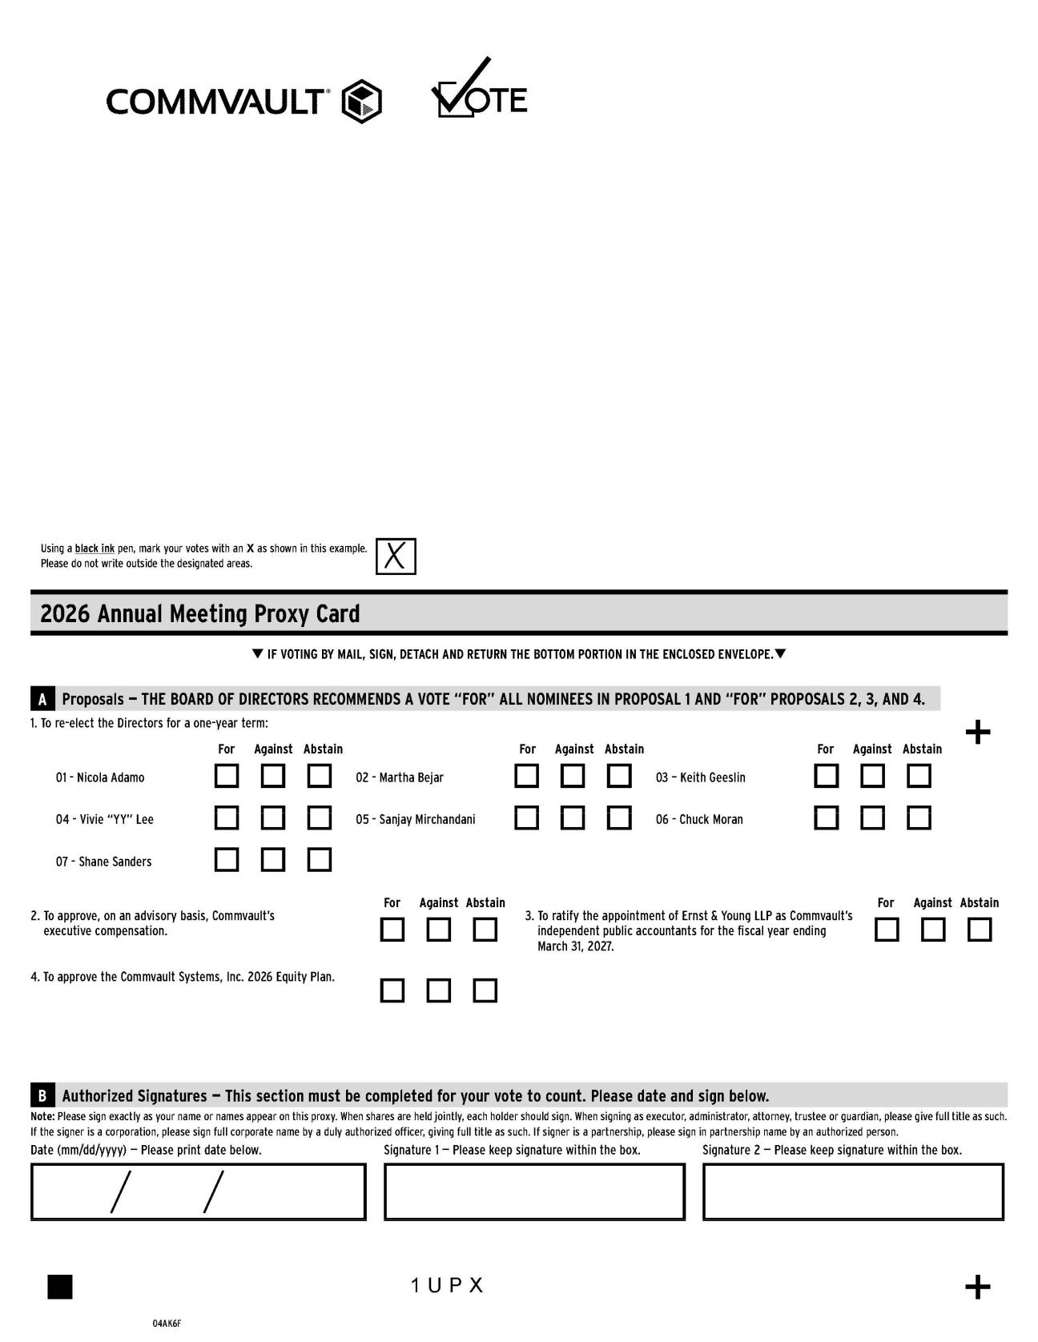

69 COMMVAULT SYSTEMS, INC. | 2026 PROXY STATEMENT

Table of Contents
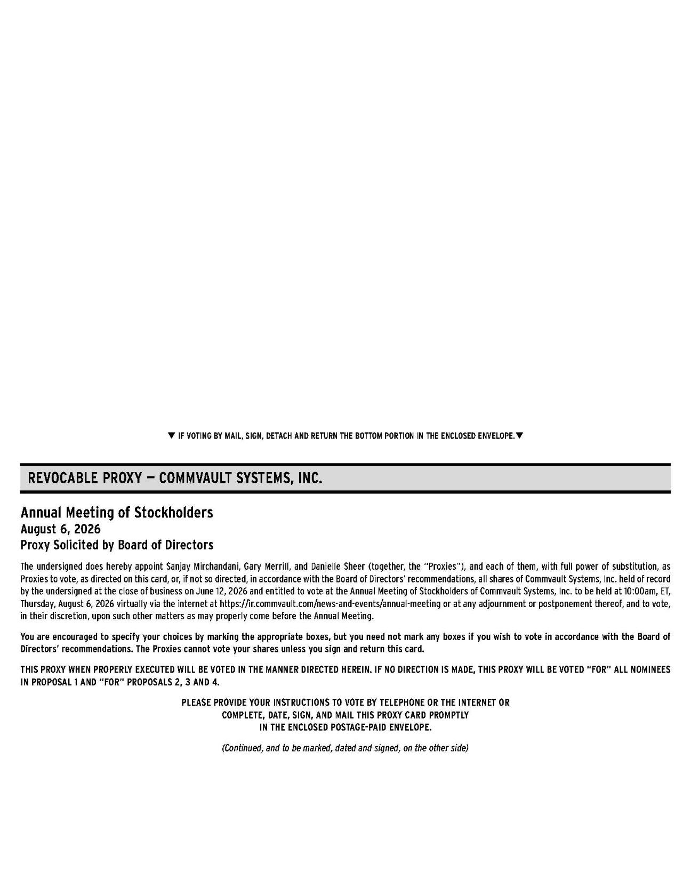

70 COMMVAULT SYSTEMS, INC. | 2026 PROXY STATEMENT

Table of Contents
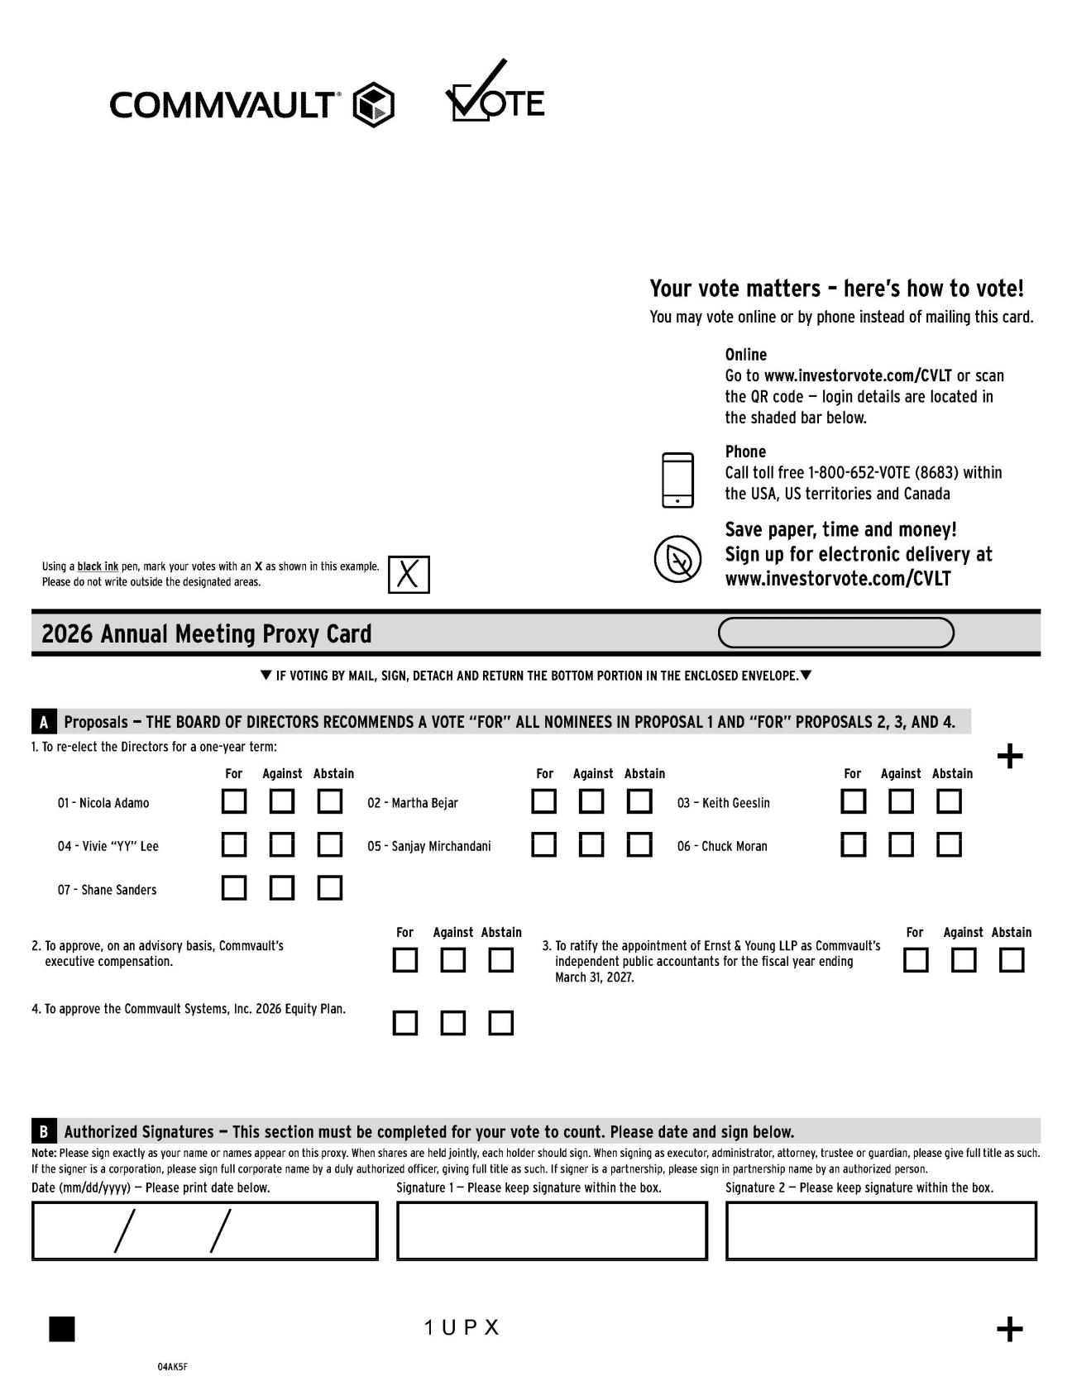

71 COMMVAULT SYSTEMS, INC. | 2026 PROXY STATEMENT

Table of Contents
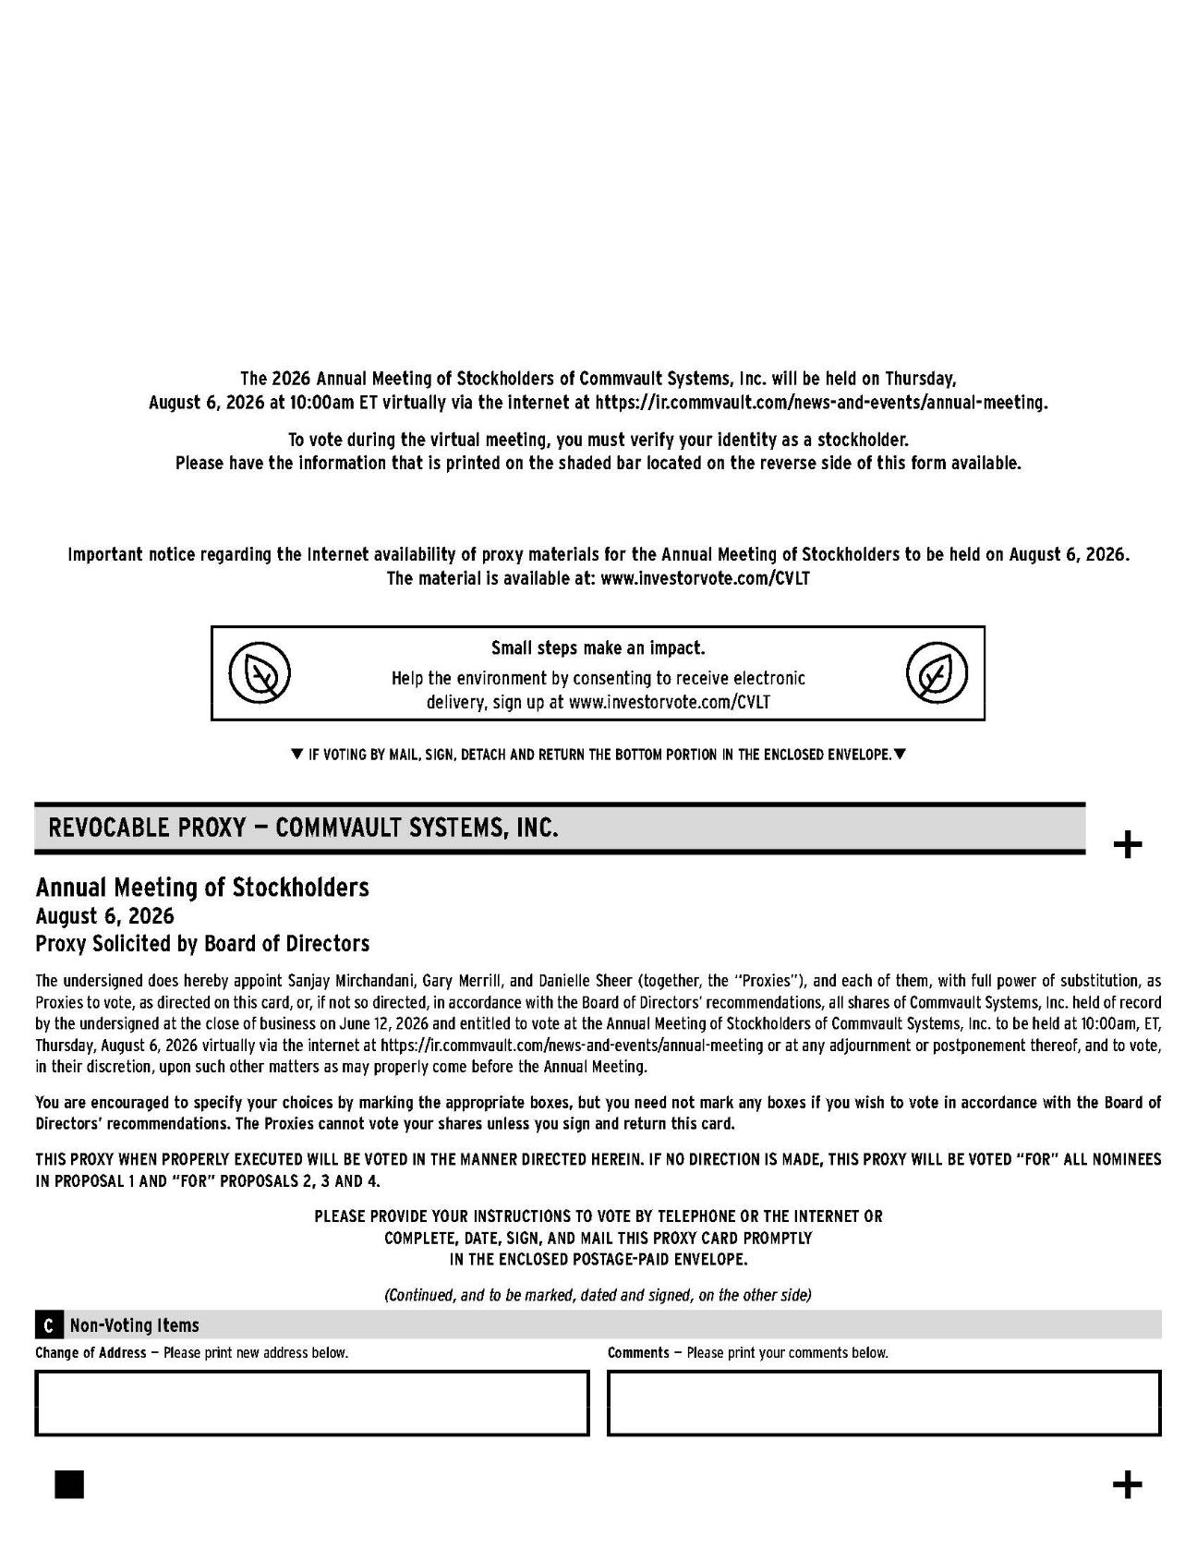

72 COMMVAULT SYSTEMS, INC. | 2026 PROXY STATEMENT

commvault.com | 888.746.3849 | ir@commvault.com

EXHIBIT 1

COMMVAULT SYSTEMS, INC.

2026 EQUITY PLAN

- PURPOSE. Commvault Systems, Inc. (the “Company”) has established the Commvault Systems, Inc. 2026 Equity Plan (the “Plan”) to (a) attract and retain employees, directors and other persons providing services to the Company and its Related Companies (as defined herein); (b) advance the interests of the Company and its stockholders by providing employees, directors and other persons providing services to the Company and its Related Companies, upon whose judgment, initiative and efforts the Company largely depend, with appropriate incentives to perform in a superior manner and achieve long-range goals, (c) to provide incentive compensation opportunities that are competitive with other similar companies, and (d) to further align the interests of Participants’ (as defined herein) with those of the Company’s stockholders, and to thereby promote the long-term financial interests of the Company and the Related Companies, including the growth in value of the Company’s equity and long-term stockholder return.

- DEFINITIONS. As used in the Plan, the following defined terms have the meanings indicated below:

2.1 “Agreement” has the meaning set forth in subsection 9.8.

2.2 “Award” means any award permitted to be granted pursuant to the provisions of the Plan.

2.3 “Board” means the Board of Directors of the Company.

2.4 “Cash Incentive Award” has the meaning set forth in subsection 7.1(b).

2.5 “Cause” means, unless otherwise provided by the Committee or as set forth in a separate agreement between the Company and the Participant, a Participant’s termination of employment or other services for gross negligence, personal dishonesty, incompetence, willful misconduct, any breach of fiduciary duty involving personal profit, intentional failure to perform stated duties, or the willful violation of any law, rule or regulation (other than traffic violations or similar offenses).

2.6 “Code” means the Internal Revenue Code of 1986, as amended. Any reference to a specific provision of the Code includes the successor provision(s) and the regulations promulgated.

2.7 “Committee” has the meaning specified in subsection 3.1.

2.8 “Common Stock” means the common stock of the Company.

2.9 “Company” has the meaning set forth in Section 1.

2.10 “Disability” shall mean, unless otherwise provided by the Committee, that an individual is unable to engage in any substantial gainful activity by reason of any medically determinable physical or mental impairment which can be expected to result in death or which has lasted or can be expected to last for a continuous period of not less than twelve (12) months. Whether an individual has a “Disability” shall be determined in a manner that is consistent with Code Section 22(e)(3). Notwithstanding the foregoing, if a Participant has an employment agreement with the Company or Related Company and such employment agreement defines “disability”, then “Disability used herein shall have the meaning as set forth in such employment agreement.

2.11 “Effective Date” has the meaning set forth in subsection 9.1.

2.12 “Eligible Individual” means any officer, director or other employee of the Company or a Related Company, consultants, independent contractors or agents of the Company or a Related Company, and persons who are expected to become officers, employees, directors, consultants, independent contractors or agents of the Company or a Related Company (but effective no earlier than the date on which such person begins to provide services to the Company or a Related Company), including, in each case, Outside Directors.

2.13 “Exchange Act” means the Securities Exchange Act of 1934, as amended. Any reference to a specific provision of the Exchange Act includes the successor provision(s) and the regulations promulgated thereunder.

2.14 “Expiration Date” has the meaning set forth in subsection 6.10 of the Plan.

2.15 “Fair Market Value” of a share of Common Stock means, as of any date, the value determined in accordance with the following rules:

- If the Common Stock is at the time listed or admitted to trading on any stock exchange, then the Fair Market Value shall be the closing price per share of Common Stock on such

2

date on the principal exchange on which the Common Stock is then listed or admitted to trading or, if no such sale is reported on that date, on the last preceding date on which a sale was so reported.

- If the Common Stock is not at the time listed or admitted to trading on a stock exchange, the Fair Market Value shall be the closing average of the closing bid and asked price of a share of Common Stock on the date in question in the over-the-counter market, as such price is reported in a publication of general circulation selected by the Committee and regularly reporting the market price of Common Stock in such market.

- If the Common Stock is not listed or admitted to trading on any stock exchange or traded in the over-the-counter market, the Fair Market Value shall be as determined by the Committee in good faith.

2.16 “Full Value Award” has the meaning set forth in subsection 7.1(a).

2.17 “Incentive Stock Option” means an Option that is intended to satisfy the requirements applicable to an “incentive stock option” described in Code Section 422.

2.18 “Non-Qualified Stock Option” means an Option that is not intended to be an Incentive Stock Option.

2.19 “Option” has the meaning set forth in subsection 6.1(a) of the Plan.

2.20 “Outside Director” means a director of the Company who is not an officer or employee of the Company or the Related Companies.

2.21 “Participant” means an Eligible Individual who receives an Award under the Plan as described in Section 5.

2.22 “Performance Criteria” may include one or more of the following criteria (i) earnings including operating income, net operating income, earnings before or after taxes, earnings before or after interest, depreciation, amortization, or extraordinary or special items or book value per share (which may exclude nonrecurring items) or net earnings; (ii) pre-tax income or after-tax income; (iii) earnings per share (basic or diluted); (iv) operating profit; (v) revenue, revenue growth or rate of revenue growth; (vi)

3

return on assets (gross or net), return on investment (including cash flow return on investment), return on capital (including return on total capital or return on invested capital), or return on equity; (vii) returns on sales or revenues; (viii) operating expenses; (ix) stock price appreciation; (x) cash flow (before or after dividends), free cash flow, cash flow return on investment (discounted or otherwise), net cash provided by operations, cash flow in excess of cost of capital or cash flow per share (before or after dividends); (xi) implementation or completion of critical projects or processes; (xii) economic value created; (xiii) cumulative earnings per share growth; (xiv) operating margin or profit margin; (xv) stock price or total stockholder return; (xvi) cost targets, reductions and savings, productivity and efficiencies; (xvii) strategic business criteria, consisting of one or more objectives based on meeting specified market penetration, geographic business expansion, customer satisfaction, employee satisfaction, human resources management, supervision of litigation and other legal matters, information technology, and goals relating to contributions, dispositions, acquisitions, development and development related activity, capital markets activity and credit ratings, joint ventures and other private capital activity including generating incentive and other fees and raising equity commitments, and other transactions, and budget comparisons; (xviii) personal professional objectives, including any of the foregoing performance targets, the implementation of policies and plans, the negotiation of transactions, the development of long term business goals, formation and reorganization of joint ventures and other private capital activity including generating incentive and other fees and raising equity commitments, research or development collaborations, and the completion of other corporate transactions; (xix) economic value added (or an equivalent metric); (xx) stock price performance; (xxi) improvement in or attainment of expense levels or working capital levels; (xxii) operating metrics including projects added, construction value added, active projects and number of organizations, (xxiii) contract value or bookings, or (xxiv) any combination of, or a specified increase in, any of the foregoing. Where applicable, the performance targets may be expressed in terms of attaining a specified level of the particular criteria or the attainment of a percentage increase or decrease in the particular criteria, and may be applied to one or more of the Company, a Related Company, or a division or strategic business unit of the Company, or may be applied to the performance of the Company relative to a market index, a group of other companies or a combination thereof, all as determined by the Committee. The performance targets may include a threshold level of performance below which no payment will be made (or no vesting will occur), levels of performance at which specified payments will be made (or specified vesting will occur), and a maximum level of performance above which no additional payment will be made (or at which full vesting will occur).

4

2.23 “Plan” has the meaning set forth in Section 1.

2.24 “Prior Plan” means the Commvault Systems, Inc. Omnibus Incentive Plan.

2.25 “Related Company” shall mean any corporation, partnership, joint venture or other entity during any period in which (i) the Company, directly or indirectly, owns at least 50% of the combined voting power of all classes of stock of such entity or at least 50% of the ownership interests in such entity or (ii) such entity, directly or indirectly, owns at least 50% of the combined voting power of all classes of stock of the Company.

2.26 “SAR” or “Stock Appreciation Right” means the grant of an Award under the Plan that entitles the Participant to receive, in cash or shares of Common Stock (as determined in accordance with the terms of the Plan) value equal to the excess of: (i) the Fair Market Value of a specified number of shares of Common Stock at the time of exercise; over (ii) an Exercise Price established by the Committee at the time of grant.

2.27 “SEC” means the United States Securities and Exchange Commission.

2.28 “Stockholders’ Meeting” means the first regular annual meeting of the Company’s stockholders that occurs after the Effective

Date.

2.29 “Subsidiary” shall mean a corporation that is a subsidiary of the Company within the meaning of Code Section 424(f).

2.30 “Substitute Award” means an Award granted or shares of Common Stock issued by the Company in assumption of, or in substitution or exchange for, an award previously granted, or the right or obligation to make a future award, in all cases by a company acquired by the Company or any Related Company or with which the Company or any Related Company combines. In no event shall the issuance of Substitute Awards change the terms of such previously granted awards such that the change, if applied to a current Award, would be prohibited under subsection 6.8.

5

2.31 “Termination Date” means the date on which a Participant both ceases to be an employee of the Company and the Related Companies and ceases to perform material services for the Company and the Related Companies (whether as a director or otherwise), regardless of the reason for the cessation; provided that a “Termination Date” shall not be considered to have occurred during the period in which the reason for the cessation of services is a leave of absence approved by the Company or the Related Company which was the recipient of the Participant’s services; and provided further that, with respect to an Outside Director, “Termination Date” means date on which the Outside Director’s service as an Outside Director terminates for any reason.

- ADMINISTRATION.

3.1 General. The authority to control and manage the operation and administration of the Plan shall be vested in the committee described in subsection 3.2 (the “Committee”) in accordance with this Section 3. If the Committee does not exist, or for any other reason determined by the Board, the Board may take any action under the Plan that would otherwise be the responsibility of the Committee.

3.2 Selection of Committee. So long as the Company is subject to Section 16 of the Exchange Act, the Committee shall be selected by the Board and shall consist of not fewer than two members of the Board or such greater number as may be required for compliance with Rule 16b-3 issued under the Exchange Act and shall be comprised of persons who are independent for purposes of applicable stock exchange listing requirements. Notwithstanding any other provision of the Plan to the contrary, with respect to any Awards to Outside Directors, the Committee shall be the Board.

3.3 Powers of Committee. The authority to manage and control the operation and administration of the Plan shall be vested in the

Committee, subject to the following:

- Subject to the provisions of the Plan, the Committee will have the authority and discretion to (i) select Eligible Individuals who will receive Awards under the Plan, (ii) determine the time or times of receipt of Awards, (iii) determine the types of Awards and the number of shares of Common Stock covered by the Awards, (iv) establish the terms, conditions, performance targets, restrictions, and other provisions of Awards, (v) modify the terms of, cancel or suspend Awards, (vi) reissue or repurchase Awards, and (vii) accelerate the exercisability or vesting of any Award. In making such Award determinations, the Committee may take into account the nature of services rendered by

6

the respective employee, the individual’s present and potential contribution to the Company’s or a Related Company’s success and such other factors as the Committee deems relevant.

- Subject to the provisions of the Plan, the Committee will have the authority and discretion to determine the extent to which Awards under the Plan will be subject to Performance Criteria, and to take such action, establish such procedures, and impose such restrictions at the time such Awards are granted as the Committee determines to be necessary or appropriate.

- Subject to the provisions of the Plan, the Committee will have the authority and discretion to conclusively interpret the Plan, to establish, amend and rescind any rules and regulations relating to the Plan, to determine the terms and provisions of any agreements made pursuant to the Plan and to make all other determinations that may be necessary or advisable for the administration of the Plan.

- Any interpretation of the Plan by the Committee and any decision made by it under the Plan is final and binding on all persons.

- Except as otherwise expressly provided in the Plan, where the Committee is authorized to make a determination with respect to any Award, such determination shall be made at the time the Award is made, except that the Committee may reserve the authority to have such determination made by the Committee in the future.

3.4 Delegation by Committee. Except to the extent prohibited by applicable law or the rules of any stock exchange on which the Common Stock is listed, the Committee may allocate all or any portion of its responsibilities and powers to any one or more of its members and may delegate all or any part of its responsibilities and powers to any person or persons selected by it. Any such allocation or delegation may be revoked by the Committee at any time.

3.5 Information to be Furnished to Committee. The Company and the Related Companies shall furnish the Committee such data and information as may be required for it to discharge its duties. The records of the Company and the Related Companies as to an employee’s or Participant’s employment or provision of services, termination of employment or cessation of the provision of services, leave of

7

absence, reemployment and compensation shall be conclusive on all persons unless determined to be incorrect. Participants and other persons entitled to benefits under the Plan must furnish the Committee such evidence, data or information as the Committee consider desirable to carry out the terms of the Plan.

3.6 Limitation on Liability and Indemnification of Committee. No member or authorized delegate of the Committee shall be liable to any person for any action taken or omitted in connection with the administration of the Plan unless attributable to his own fraud or willful misconduct; nor shall the Company or any Related Company be liable to any person for any such action unless attributable to fraud or willful misconduct on the part of a director or employee of the Company or Related Company. The Committee, the individual members thereof, and persons acting as the authorized delegates of the Committee under the Plan, shall be indemnified by the Company against any and all liabilities, losses, costs and expenses (including legal fees and expenses) of whatsoever kind and nature which may be imposed on, incurred by or asserted against the Committee or its members or authorized delegates by reason of the performance of a Committee function if the Committee or its members or authorized delegates did not act dishonestly or in willful violation of the law or regulation under which such liability, loss, cost or expense arises. This indemnification shall not duplicate but may supplement any coverage available under any applicable insurance.

- STOCK RESERVED AND LIMITATIONS.

4.1 Shares and Other Amounts Subject to the Plan. The shares of Common Stock for which Awards may be granted under the Plan shall be subject to the following:

- The shares of Common Stock with respect to which Awards may be made under the Plan shall be shares currently authorized but unissued or currently held or subsequently acquired by the Company as treasury shares, including shares purchased in the open market or in private transactions.

- Subject to the provisions of subsection 4.2, the number of shares of Common Stock which may be issued with respect to Awards under the Plan shall be equal to the number of shares of Common Stock approved by the Company's stockholders from time to time, which number shall include (i) any shares remaining available for issuance under the Prior Plan as of the Effective Date that are not then subject to outstanding awards, and (ii) any shares subject to outstanding awards under the Prior Plan as of the Effective Date

8

that, after the Effective Date, expire, are forfeited, are cancelled, or are terminated without issuance of shares of Common Stock. Except as otherwise provided herein, any shares of Common Stock subject to an Award under the Plan which for any reason is forfeited, expires or is terminated without issuance of shares of Common Stock (including shares that are attributable to Awards that are settled in cash) shall thereafter be available for further grants under the Plan. Shares of Common Stock that are tendered or withheld in payment of the Exercise Price of an Option or shares of Common Stock that are withheld in payment of taxes payable with respect to the exercise of an Option or SAR or the vesting or settlement of a Full Value Award shall not be available for further grants under the Plan.

- Substitute Awards shall not reduce the number of shares of Common Stock that may be issued under the Plan.

- Except as expressly provided by the terms of this Plan, the issue by the Company of stock of any class, or securities convertible into shares of stock of any class, for cash or property or for labor or services, either upon direct sale, upon the exercise of rights or warrants to subscribe therefor or upon conversion of stock or obligations of the Company convertible into such stock or other securities, shall not affect, and no adjustment by reason thereof, shall be made with respect to Awards then outstanding hereunder.

- To the extent provided by the Committee, any Award may be settled in cash rather than in Common Stock.

- Subject to the terms and conditions of the Plan, the maximum number of shares of Common Stock that may be delivered to Participants and their beneficiaries with respect to Incentive Stock Options under the Plan shall be 3,374,000; provided, however, that to the extent that shares not delivered must be counted against this limit as a condition of satisfying the rules applicable to Incentive Stock Options, such rules shall apply to the limit on Incentive Stock Options granted under the Plan.

9

- In the case of any Award to an Outside Director, in no event shall the dollar value of the Award granted to any Outside Director for any calendar year (determined as of the date of grant) exceed $500,000, except for the initial year of directorship in which the dollar value shall not exceed $1,000,000.

4.2 Adjustments to Shares of Common Stock. In the event of a stock dividend, stock split, reverse stock split, extraordinary cash dividend, recapitalization, reorganization, merger, consolidation, split-up, spin-off, exchange of shares, sale of assets or subsidiaries, combination, or other corporate transaction that affects the Common Stock such that the Committee determines, in its sole discretion, that an adjustment is warranted in order to preserve the benefits or prevent the enlargement of benefits of Awards under the Plan, the Committee shall, in the manner it determines equitable in its sole discretion, (a) adjust the number and kind of shares which may be delivered under the Plan (including adjustments to the number and kind of shares that may be granted to an individual during any specified time as described in subsection 4.1); (b) adjust the number and kind of shares subject to outstanding Awards; (c) adjust the Exercise Price of outstanding Options and SARs; and (d) make any other adjustments that the Committee determines to be equitable (which may include, without limitation, (i) replacement of Awards with other awards which the Committee determines have comparable value and which are based on stock of a company resulting from the transaction, and (ii) cancellation of the Award in return for cash payment of the current value of the Award, determined as though the Award is fully vested at the time of payment, provided that in the case of an Option or SAR, the amount of such payment may be the excess of value of the shares of Common Stock subject to the Option or SAR at the time of the transaction over the exercise price).

- PARTICIPATION. For purposes of the Plan, a “Participant” is any person to whom an Award is granted under the Plan. Subject to the terms and conditions of the Plan, the Committee shall determine and designate, from time to time, from among the Eligible Individuals those persons who will be granted one or more Awards under the Plan and, subject to the terms and conditions of the Plan, a Participant may be granted any Award permitted under the provisions of the Plan and more than one Award may be granted to a Participant. Except as otherwise agreed by the Company and the Participant, or except as otherwise provided in the Plan, an Award under the Plan shall not affect any previous Award under the Plan or an award under any other plan maintained by the Company or the Related Companies.

10

- STOCK OPTIONS AND STOCK APPRECIATION RIGHTS. 6.1 Definitions.

- The grant of an “Option” under the Plan entitles the Participant to purchase shares of Common Stock at an Exercise Price established by the Committee at the time the Option is granted. Options granted under this Section 6 may be either Incentive Stock Options or Non-Qualified Stock Options, as determined in the discretion of the Committee; provided, however, that Incentive Stock Options may only be granted to employees of the Company or a Subsidiary. An Option will be deemed to be a Non-Qualified Stock Option unless it is specifically designated by the Committee as an Incentive Stock Option.

- A grant of a “Stock Appreciation Right” or “SAR” entitles the Participant to receive, in cash or shares of Common Stock (as determined in accordance with the terms of the Plan) value equal to the excess of: (i) the Fair Market Value of a specified number of shares of Common Stock at the time of exercise; over (ii) an Exercise Price established by the Committee at the time of grant.

6.2 Eligibility. The Committee shall designate the Participants to whom Options or SARs are to be granted under this Section 6 and shall determine the number of shares of Common Stock subject to each such Option or SAR and the other terms and conditions thereof, not inconsistent with the Plan. Without limiting the generality of the foregoing, the Committee may not grant dividend equivalents (current or deferred) with respect to any Option or SAR granted under the Plan.

6.3 Limits on Incentive Stock Options. If the Committee grants Incentive Stock Options, then to the extent that the aggregate fair market value of shares of Common Stock with respect to which Incentive Stock Options are exercisable for the first time by any individual during any calendar year (under all plans of the Company and all Subsidiaries) exceeds $100,000, such Options shall be treated as Non-Qualified Stock Options to the extent required by Code Section 422. Any Option that is intended to constitute an Incentive Stock Option shall satisfy any other requirements of Code Section 422 and, to the extent such Option does not satisfy such requirements, the Option shall be treated as a Non-Qualified Stock Option.

11

6.4 Exercise Price. The “Exercise Price” of an Option or SAR shall be established by the Committee at the time the Option or SAR is granted; provided, however, that in no event shall such price be less than 100% of the Fair Market Value of a share of Common Stock on such date (or, if greater, the par value of a share of Common Stock on such date).

6.5 Exercise/Vesting. Except as otherwise expressly provided in the Plan, an Option or SAR granted under the Plan shall be exercisable in accordance with the following:

- The terms and conditions relating to exercise and vesting of an Option or SAR shall be established by the Committee to the extent not inconsistent with the Plan, and may include, without limitation, conditions relating to completion of a specified period of service, achievement of performance standards prior to exercise or the achievement of stock ownership guidelines by the Participant.

- No Option or SAR may be exercised by a Participant prior to the date on which it is exercisable (or vested) or after the Expiration Date applicable thereto.

6.6 Payment of Exercise Price. The payment of the Exercise Price of an Option granted under this Section 6 shall be subject to the following:

- Subject to the following provisions of this subsection 6.6, the full Exercise Price of each share of Common Stock purchased upon the exercise of any Option shall be paid at the time of such exercise (except that, in the case of an exercise through the use of cash equivalents, payment may be made as soon as practicable after the exercise) and, as soon as practicable thereafter, a certificate representing the shares of Common Stock so purchased shall be delivered to the person entitled thereto or shares of Common Stock so purchased shall otherwise be registered in the name of the Participant on the records of the Company’s transfer agent and credited to the Participant’s account.

- Subject to applicable law, the Exercise Price shall be payable in cash or cash equivalents, by tendering, by actual delivery or by attestation, shares of Common Stock valued at Fair Market Value as of the day of exercise or by a combination thereof; provided, however, that shares of Common Stock may not be used to pay any portion of the Exercise Price unless the holder thereof has good title, free and clear of all liens and encumbrances.

12

6.7 Post-Exercise Limitations. The Committee, in its discretion, may impose such restrictions on shares of Common Stock acquired pursuant to the exercise of an Option as it determines to be desirable, including, without limitation, restrictions relating to disposition of the shares and forfeiture restrictions based on service, performance, Common Stock ownership by the Participant, conformity with the Company’s recoupment or clawback policies and such other factors as the Committee determines to be appropriate.

6.8 No Repricing. Except for either adjustments pursuant to subsection 4.2 (relating to the adjustment of shares), or reductions of the Exercise Price approved by the Company’s stockholders, the Exercise Price for any outstanding Option or SAR may not be decreased after the date of grant nor may an outstanding Option or SAR granted under the Plan be surrendered to the Company as consideration for the grant of a replacement Option or SAR with a lower exercise price or a Full Value Award. Except as approved by the Company’s stockholders, in no event shall any Option or SAR granted under the Plan be surrendered to the Company in consideration for a cash payment if, at the time of such surrender, the Exercise Price of the Option or SAR is greater than the then current Fair Market Value of a share of Common Stock.

6.9 Tandem Grants of Options and SARs. An Option may but need not be in tandem with an SAR, and an SAR may but need not be in tandem with an Option (in either case, regardless of whether the original award was granted under this Plan or another plan or arrangement). If an Option is in tandem with an SAR, the exercise price of both the Option and SAR shall be the same, and the exercise of the corresponding tandem SAR or Option shall cancel the corresponding tandem SAR or Option with respect to such share. If an SAR is in tandem with an Option but is granted after the grant of the Option, or if an Option is in tandem with an SAR but is granted after the grant of the SAR, the later granted tandem Award shall have the same exercise price as the earlier granted Award, but in no event less than the Fair Market Value of a share of Common Stock at the time of such grant.

6.10 Expiration Date. The “Expiration Date” with respect to an Option or SAR means the date established as the Expiration Date by the Committee at the time of the grant (as the same may be modified in accordance with the terms of the Plan); provided, however, that the Expiration Date with respect to any Option or SAR shall not be later than the earliest to occur of the ten-year anniversary of the date on which the Option or SAR is granted or the following dates, unless the following dates are determined otherwise by the Committee:

13

- if the Participant’s Termination Date occurs by any reason other than termination for Cause, the thirtieth (30th) day after the Termination Date; or

- if the Participant’s Termination Date occurs for reasons of Cause, the Termination Date.

In no event shall the Expiration Date of an Option or SAR be later than the ten-year anniversary of the date on which the Option or SAR is granted (or such shorter period required by law or the rules of any stock exchange on which the Common Stock is listed).

- FULL VALUE AWARDS AND CASH INCENTIVE AWARDS. 7.1 Definitions.

- A “Full Value Award” is a grant of one or more shares of Common Stock or a right to receive one or more shares of Common Stock in the future (including restricted stock, restricted stock units, deferred stock units, performance stock and performance stock units). Such grants may be subject to such conditions, restrictions and contingencies, as determined by the Committee, including provisions relating to dividend or dividend equivalent rights and deferred payment or settlement. Notwithstanding the foregoing, dividends or dividend equivalent rights on any Award that is not yet vested shall not be paid or settled until such Award vests, and shall be subject to the same vesting and forfeiture conditions as the underlying Award.

- A “Cash Incentive Award” is the grant of a right to receive a payment of cash (or in the discretion of the Committee, shares of Common Stock having value equivalent to the cash otherwise payable) that is contingent on achievement of performance objectives over a specified period established by the Committee. The grant of Cash Incentive Awards may also be subject to such other conditions, restrictions and contingencies, as determined by the Committee, including provisions relating to deferred payment.

7.2 Special Vesting Rules. Except for awards granted under the Plan with respect to, shares of Common Stock which do not exceed, in the aggregate, five percent of the total number of shares of Common Stock reserved for issuance pursuant to subsection 4.1(b), a Participant’s right to become vested in a Full Value Award, an Option or SAR is conditioned on the completion of a specified period of

14

service with the Company or the Related Companies of at least one year, except if accelerated in the event of the Participant’s death or Disability.

7.3 Performance-Based Awards. The Committee may condition the grant, vesting, exercisability, settlement or payment of any Full Value Award or Cash Incentive Award upon the achievement of one or more Performance Criteria over a performance period determined by the Committee. The Performance Criteria, the length of the performance period, and the measure of whether and to what degree such Performance Criteria have been attained shall be determined by the Committee.

- CHANGE IN CONTROL.

8.1 Definitions. For purposes of this Section 8, the term “Change in Control” means (a) the acquisition by any person, entity or group of persons or entities, directly or indirectly, acting in concert of securities representing fifty percent (50%) or more of the combined voting power of the Company’s then outstanding securities, whether acquired in one transaction or a series of transactions, (b) a merger, consolidation or similar transaction which results in the Company’s shareholders immediately prior to such transaction not holding securities representing fifty percent (50%) or more of the total voting power of the outstanding securities of the surviving corporation, or (c) a sale of all or substantially all of the Company’s assets (other than to an entity owned by the Company or under common ownership with the Company).

8.2 Vesting of Awards Upon Change in Control. Subject to the provisions of subsection 4.2 (relating to the adjustment of shares), if a Change in Control occurs prior to the date on which an Award is vested and prior to the Participant’s separation from service, if such Award remains outstanding following the Change in Control (whether by substitution with another award or otherwise), and if the Participant’s service is involuntarily terminated by the Company or a Related Company (or any successor thereto), other than for cause, on or within two years following the Change in Control, then:

- All outstanding Options (regardless of whether in tandem with SARs) shall become fully exercisable.

- All outstanding SARs (regardless of whether in tandem with Options) shall become fully exercisable.

15

- All Full Value Awards shall become fully vested and the Committee shall determine the extent to which performance conditions are met, taking into account actual performance and/or the passage of time, in accordance with the terms of the Plan and the applicable Award Agreement.

Notwithstanding anything in this Plan or any Award Agreement to the contrary, to the extent any provision of this Plan or an Award Agreement would cause a payment of deferred compensation that is subject to Code Section 409A to be made upon the occurrence of a Change in Control, then such payment shall not be made unless such Change in Control also constitutes a “change in ownership”, “change in effective control” or “change in ownership of a substantial portion of the Company’s assets” within the meaning of Code Section 409A. In addition, if an Award does not remain outstanding following a Change in Control, the Committee shall determine the vesting and other terms and conditions of the Award in connection with the Change in Control in accordance with the terms of the Plan.

- MISCELLANEOUS.

9.1 Effective Date and Effect on Prior Plan. This Plan shall be effective as of the date that it is approved by the Board (the date on which such approval is completed being referred to herein as the “Effective Date”); provided, however, that no Awards granted under the Plan after the Effective Date prior to the Stockholders’ Meeting will vest or become exercisable prior to the date of the Stockholders’ Meeting (and only if the Plan is approved by the stockholders at the Stockholders’ Meeting) and all such Awards shall be forfeited as of the date of the Stockholders’ Meeting if the Plan is not approved by the Company’s stockholders at the Stockholders Meeting. The Plan shall be unlimited in duration and, in the event of Plan termination, shall remain in effect as long as any shares of Common Stock awarded under it are outstanding and not fully vested; provided, however, that no new Awards will be made under the Plan on or after the tenth anniversary of the Effective Date. Any awards made under the Prior Plan prior to the Effective Date shall continue to be subject to the terms and conditions of the Prior Plan. Following the Effective Date and if the Plan is approved at the Stockholders’ Meeting, no further awards will be made under the Prior Plan.

9.2 Limit on Distribution. Distribution of Common Stock or other amounts under the Plan shall be subject to the following:

16

- Notwithstanding any other provision of the Plan, the Company shall have no liability to deliver any Common Stock under the Plan or make any other distribution of benefits under the Plan unless such delivery or distribution would comply with all applicable laws and the applicable requirements of any securities exchange or similar entity.

- In the case of a Participant who is subject to Section 16(a) and 16(b) of the Exchange Act, the Committee may, at any time, add such conditions and limitations to any Award to such Participant, or any feature of any such Award, as the Committee, in its sole discretion, deems necessary or desirable to comply with Section 16(a) or 16(b) and the rules and regulations thereunder or to obtain any exemption therefrom.

- To the extent that the Plan provides for issuance of certificates to reflect the transfer of Common Stock, the transfer of such Common Stock may be effected on a non-certificated basis, to the extent not prohibited by applicable law or the rules of any stock exchange on which the Common Stock is listed.

9.3 Liability for Cash Payments. Subject to the provisions of this Section 9, each Related Company shall be liable for payment of cash due under the Plan with respect to any Participant to the extent that such payment is attributable to the services rendered for that Related Company by the Participant. Any disputes relating to liability of a Related Company for cash payments shall be resolved by the Committee.

9.4 Withholding. All Awards and other payments under the Plan are subject to withholding of all applicable taxes, which withholding obligations may be satisfied, with the consent of the Committee, through the surrender of Common Stock which the Participant already owns or to which a Participant is otherwise entitled under the Plan; provided, however, previously-owned Common Stock that has been held by the Participant or Common Stock to which the Participant is entitled under the Plan may only be used to satisfy tax withholding obligations in an amount not to exceed the applicable maximum statutory tax rates in the Participant's applicable jurisdictions (or such lesser rates as would avoid a negative accounting impact).

9.5 Transferability. Awards under the Plan are not transferable except as designated by the Participant by will or by the laws of descent and distribution or, if provided by the Committee, pursuant to a qualified domestic relations order (within the meaning of the Code and applicable rules thereunder). To

17

the extent that Participant who receives an Award under the Plan has the right to exercise such Award, the Award may be exercised during the lifetime of the Participant only by the Participant. Notwithstanding the foregoing provisions of this subsection 9.5, if provided by the Committee, Awards may be transferred to or for the benefit of the Participant’s family (including, without limitation, to a trust or partnership for the benefit of a Participant’s family), subject to such procedures as the Committee may establish. In no event shall an Incentive Stock Option be transferable to the extent that such transferability would violate the requirements applicable to such option under Code Section 422.

9.6 Notices. Any notice or document required to be filed with the Committee under the Plan will be properly filed if delivered or mailed by registered mail, postage prepaid, to the Committee, in care of the Company or the Related Company, as applicable, at its principal executive offices. The Committee may, by advance written notice to affected persons, revise such notice procedure from time to time. Any notice required under the Plan (other than a notice of election) may be waived by the person entitled to notice.

9.7 Form and Time of Elections. Unless otherwise specified herein, each election required or permitted to be made by any Participant or other person entitled to benefits under the Plan, and any permitted modification or revocation thereof, shall be in writing filed with the applicable Committee at such times, in such form, and subject to such restrictions and limitations, not inconsistent with the terms of the Plan, as the Committee shall require.

9.8 Agreement With the Company. At the time of an Award to a Participant under the Plan, the Committee may require a Participant to enter into an agreement with the Company (the “Agreement”), in a form specified by the Committee, agreeing to the terms and conditions of the Plan and to such additional terms and conditions, not inconsistent with the Plan, as the Committee may, in its sole discretion, prescribe.

9.9 Limitation of Implied Rights.

- Neither a Participant nor any other person shall, by reason of the Plan, acquire any right in or title to any assets, funds or property of the Company or any Related Company whatsoever, including, without limitation, any specific funds, assets, or other property which the Company or any Related Company, in its sole discretion, may set aside in anticipation of a liability under the Plan. A Participant shall have only a contractual right

18

to the amounts, if any, payable under the Plan, unsecured by any assets of the Company and any Related Company. Nothing contained in the Plan shall constitute a guarantee by the Company or any Related Company that the assets of such companies shall be sufficient to pay any benefits to any person.

- The Plan does not constitute a contract of employment or continued service, and selection as a Participant will not give any employee the right to be retained in the employ or service of the Company or any Related Company, nor any right or claim to any benefit under the Plan, unless such right or claim has specifically accrued under the terms of the Plan. Except as otherwise provided in the Plan, no Award under the Plan shall confer upon the holder thereof any right as a stockholder of the Company prior to the date on which he fulfills all service requirements and other conditions for receipt of such rights and shares of Common Stock are registered in his name.

9.10 Evidence. Evidence required of anyone under the Plan may be by certificate, affidavit, document or other information which the person acting on it considers pertinent and reliable, and signed, made or presented by the proper party or parties.

9.11 Action by the Company or Related Company. Any action required or permitted to be taken by the Company or any Related Company shall be by resolution of its board of directors or governing body or by action of one or more members of the board or governing body (including a committee of the board or governing body) who are duly authorized to act for the board or, in the case of any Related Company which is a partnership, by action of its general partner or a person or persons authorized by the general partner, or (except to the extent prohibited by applicable law or the rules of any stock exchange on which the Common Stock is listed) by a duly authorized officer of the Company.

9.12 Gender and Number. Where the context admits, words in any gender shall include any other gender, words in the singular shall include the plural and the plural shall include the singular.

9.13 Applicable Law. The provisions of the Plan shall be construed in accordance with the laws of the State of Delaware, without giving effect to choice of law principles.

9.14 Foreign Employees. Notwithstanding any other provision of the Plan to the contrary, the Committee may grant Awards to eligible persons who are foreign nationals on such terms and conditions

19

different from those specified in the Plan as may, in the judgment of the Committee, be necessary or desirable to foster and promote achievement of the purposes of the Plan. In furtherance of such purposes, the Committee may make such modifications, amendments, procedures and subplans as may be necessary or advisable to comply with provisions of laws in other countries or jurisdictions in which the Company or a Related Company operates or has employees. The foregoing provisions of this subsection 9.14 shall not be applied to increase the share limitations of Section 4 or to otherwise change any provision of the Plan that would otherwise require the approval of the Company’s stockholders.

9.15 Clawback and Recoupment. All Awards granted under the Plan shall be subject to recoupment in accordance with any clawback policy that the Company is required to adopt pursuant to the listing standards of any national securities exchange or association on which the Common Stock is listed or as is otherwise required by the Dodd-Frank Wall Street Reform and Consumer Protection Act or other applicable law and any clawback policy that the Company otherwise adopts, to the extent applicable and permissible under applicable law.

9.16 Electronic Delivery and Participation. Any reference in the Plan or any Award Agreement to a “written” agreement or document shall include any document delivered electronically or posted on an electronic medium controlled by the Company. By accepting any Award, the Participant consents to electronic delivery of documents and electronic participation in the Plan. The form of delivery of any Common Stock shall be determined by the Company.

- TERMINATION AND AMENDMENT OF THE PLAN. The Board may, at any time, amend or terminate the Plan, and the Board or the Committee may amend any Agreement, provided that no amendment or termination may, in the absence of written consent to the change by the affected Participant (or, if the Participant is not then living, the affected beneficiary), adversely affect the rights of any Participant or beneficiary under any Award granted under the Plan prior to the date such amendment is adopted by the Board (or the Committee, if applicable); and further provided that adjustments pursuant to subsection 4.2 shall not be subject to the foregoing limitations of this Section 10; and further provided that the provisions of subsection 6.8 (relating to Option and SAR repricing) cannot be amended unless the amendment is approved by the Company’s stockholders; and provided further that, no other amendment shall be made to the Plan without the approval of the Company’s stockholders if such approval is required by law or the rules of any stock exchange on which the Common Stock is listed. It is the intention of the Company that, to the extent that any provisions of this Plan or any Awards granted hereunder are subject

20

to Code Section 409A, the Plan and the Awards comply with the requirements of Code Section 409A and that the Board shall have the authority to amend the Plan or any Award as it deems necessary or desirable to conform to Code Section 409A without regard to the foregoing provisions (other than the provisions requiring stockholder approval). Notwithstanding the foregoing, the Company does not guarantee that Awards under the Plan will comply with Code Section 409A and the Committee is under no obligation to make any changes to any Award to cause such compliance.

21

